|  |  |
| --- | --- |
| C:\Users\kpatkins\AppData\Local\Microsoft\Windows\INetCache\Content.MSO\F76A607A.tmp | Energy Pricing  The latest information on pricing for financial year 2022/23 |
|  |  |
|  | Energy Updates  Business managers conference and energy webinar |
|  |  |
|  | New service:  Power down Pete goes back in time to connect with the World War II curriculum |
|  |  |
| C:\Users\rstacey\AppData\Local\Microsoft\Windows\INetCache\Content.Outlook\5DAER5W7\Healthy School NY Logo Generic.png | Healthy Schools training |

# 



# Energy pricing for 2022/23 financial year

**Electricity**

The electricity prices have been finalised and are in line with the expected increase of 110% over last year’s prices.

Because unit prices (p/kWh) are vary depending on your supply profile, we cannot provide you with a figure here; but they will show on your next invoices for April’s consumption, due in the next week or two.

**Gas**

The gas prices are not yet confirmed, but are expected to be in line with the predicted increase of 110%. Remember that unit price is only part of the picture, as standing charges make up a substantial part of the bill. Your standing charge is unique to your supply and the new charge will show on your next invoices for April consumption, due in the next week or two.

**Oil**

The pricing for this fuel is undertaken differently to gas and electricity, prices being set on a daily basis. However, it is subject to the same market pressures as are effecting the prices of gas and electricity. We have been advised by YPO (our energy brokers for gas and electricity and also who procures our heating oil/kerosene contract) that schools should budget for a 100%+ increase in heating oil/kerosene prices for the coming financial year.

The NYCC heating oil/kerosene contract is there for you to use but, now more than ever, getting a range of prices before you order is important.

**Water**

Water prices are set by the wholesaler. You can check the 2022/23 prices on their websites:

Yorkshire Water: [Yorkshire Water - Our wholesale charges](https://imsva91-ctp.trendmicro.com:443/wis/clicktime/v1/query?url=https%3a%2f%2fwww.yorkshirewater.com%2fbusiness%2fwholesale%2dcharges&umid=FC61D0D9-DE42-3705-965D-A731A2A7B274&auth=de41389fcd07b045c2bf0b8b6a6bb2cde097bfb7-abd3bf1989c7d6e1c6204f648e86f53c9bcf0aea)

Northumbrian Water: [Wholesale charging 2022/23 (nwl.co.uk)](https://www.nwl.co.uk/services/wholesale-services/wholesale-charges/wholesale-charging-2022-23/)

Return to top

# Energy Updates: Business managers’ conference and Energy Webinar coming your way soon

Due to the exceptional circumstances we find ourselves in, the energy team are in the process of putting together a webinar that will cover areas such as: knowing your buildings, heating controls and energy supplies; measuring your consumption; behavioural change; identifying where you can make savings; practical suggestions; possible improvements and funding.

Watch out for dates and further details on SLA Online and direct to your admin in-box.

We will also be providing updates at the Business Manager Conferences on 15th and 16th June.

**Background information**

Energy bills are made up of two main type of charges:

* The commodity cost - the gas or oil used to produce much of our electricity, and
* Non-commodity charges – such as costs involved in supporting the infrastructure, and taxes.

Non-commodities have been increasing for a number of years, and will continue to rise, in part due to the “green” taxes the government has introduced to pay for investment in the development of renewable energy sources.

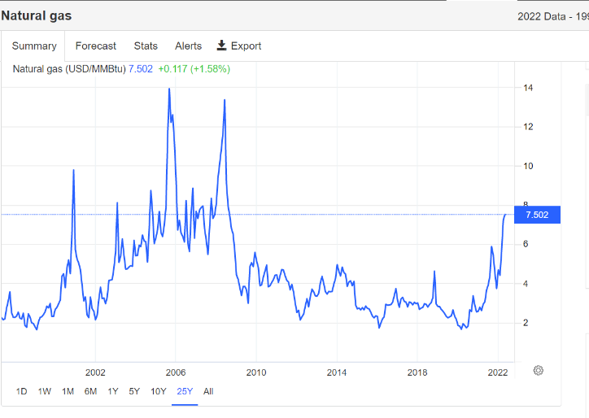Commodity costs are also at a higher level than we have seen for some years, due to extreme volatility in the global market place affected by factors such as the war in Ukraine. However these charges as not as high as we have seen in the relatively recent past – as these 25-year graphs show:

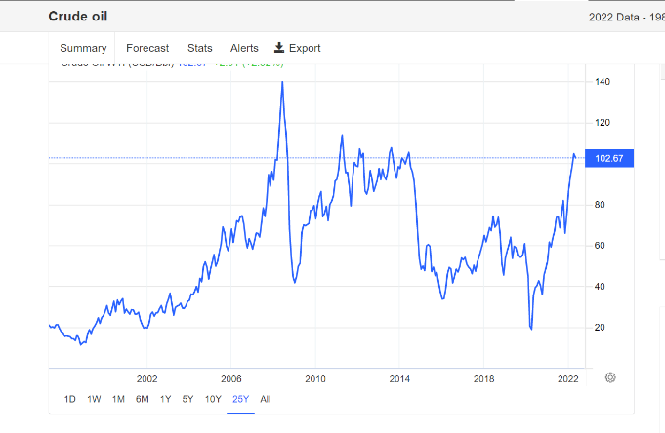

Graphs from Trading Economics commodity website <https://tradingeconomics.com/commodity>

Return to top

# Put out that light! with ARPete

## **Power down Pete goes back in time to connect with the World War II curriculum.**

Carbon reduction officer Peter Bell is always looking to connect in new and innovative ways the challenges that face our planet with the school’s curriculum. What better way is there to enthuse the future generations than to look back at the actions we successfully took in the past, particularly during World War II?

Whilst we no longer recycle aluminium for Spitfires, it is still vital to look after our dwindling natural resources, raising awareness of the energy used to make them into today’s products. “Put out that light!” was a regular cry of the ARP warden during the days of the blackout in WWII. However, we should have energy monitors in every classroom to allow the children to take responsibility for turning off lights when the class leaves the room. We should be “digging for victory”, providing the school canteen with fresh fruit and vegetables with no carbon footprint. We should be turning down heating systems to save fuel, just as we had to save oil and gas to be used in factories on the home front. The climate emergency needs our attention as a new “home front” is developed, starting in the classroom.

ARPete sessions were recently delivered in a Harrogate school with children switching off the classroom lights at regular intervals, pulling on their cut out gas masks and dressing up as evacuees. They were even introduced to squander bug, the character portrayed as Hitler’s friend that encouraged people to be wasteful.

The teacher at that school clearly saw the benefits of the sessions:

“It was brilliant. The children loved the interactive activities and the eco message was very cleverly linked to WW2.”

The connections are clear, and we need to empower the future generations with the knowledge, skills and understanding they will need to solve the issues facing the planet. The lessons of History pass through time.

*History, in illuminating the past, illuminates the present, and in illuminating the present, illuminates the future*. — Benjamin Cardozo U.S. Supreme Court judge.

ARPete is available to schools who take the Primary Package part of our service by simply contacting [Peter.Bell@northyorks.gov.uk](mailto:Peter.Bell@northyorks.gov.uk) for available dates and further details. He is also available to schools who do not take Primary package as a one-off booking via NYES SLA Online.

Return to top

# Healthy Schools training

To apply for any of the training below please go to North Yorkshire Education Services (NYES) <http://www.nyestraining.co.uk/>

**Getting started on the North Yorkshire Healthy schools award (cross-phase)**

Monday 23rd June 2022, 2:00pm – 3:00pm

Course code: SI-0622-T023

The course will provide schools with information to enable them to effectively get started on the North Yorkshire Healthy schools award and work towards the Bronze, Silver and Gold awards.

This course would also be suitable for schools who initially registered with a scheme but need a refresher on how to get started.

**Getting ready to submit for a Healthy Schools award (cross-phase)**

Tuesday 24th May 2022, 2:00-3:00pm

Course code: SI-0522-T018

The course will provide schools with information to enable them to effectively submit for a North Yorkshire Healthy schools award covering an effective action plan, pupil voice evidence and supporting evidence- This course is aimed at staff who have already attended the getting started training (progressed with the award) and are now ready to submit for an award.

Return to top