EHCP Annual Review Process and Timeline

Purpose
To outline the procedures and responsibilities involved in conducting Education, Health, and Care Plan (EHCP) annual reviews.
SEND Code of Practice (2014), states that at a minimum of every 12 months, the local authority must review an Education, Health, and Care Plan (EHCP). As part of this review process, the local authority would typically request that the EHCP holders, who are usually the school, nursery, or college attended by the young person, hold a meeting annual review meeting. This meeting allows for the EHCP holders to provide input, feedback, and updates on the young person's progress and any changes in their needs. It also ensures that the EHCP remains relevant and tailored to the young person's current requirements. Therefore, it is essential for EHCP holder, to collaborate closely with parents and health providers. The goal is to ensure that the review process comprehensively addresses the holistic needs of the young person.
The first review must be held within 12 months of the date it was issued, and then within 12 months of any previous review.

Responsibilities
The SEND Code of Practice (2014) outlines that the local authority should provide a list of all children and young people with EHCP reviews in the forthcoming term to the Integrated Care Board. This will enable health professionals to plan attendance at review meetings and/or provide advice or information about the child or young person where necessary. These lists should also indicate which reviews must be focused on transition and preparation for adulthood.
Education Providers: Education providers are responsible for coordinating the EHCP annual review process, including the dissemination of the health questionnaire and inviting health providers to participate. A list of the Single Point of Contact email addresses for health services can be requested from: hnyicb-ny.send@nhs.net
Parents: To complete the health questionnaire and return to education providers to inform the education setting about the current health providers involved in child's care.

Health Providers: Must actively contribute to EHCP reviews and provide relevant information and insights into the young person's health needs, outcomes, and provision.
**Where a Child or Young person in not in education setting or Electively Home Educated, the Local Authority will conduct the EHCP Annual review**.

Process
The SEND regulations (2014), states that the person arranging the review meeting must obtain advice and information about the child or young person and must circulate it at least two weeks in advance of the review meeting. Therefore, the NHS Humber and North Yorkshire Integrated Care Board (HNY ICB) recommend providing eight weeks' notification or request for advice to ensure sufficient time for planning and coordination.
Dissemination of Health Questionnaire: Education providers are responsible for facilitating the dissemination of the health questionnaire to parents. This ensures that pertinent health providers are identified and involved in the review process.
Content of Health Questionnaire: The health questionnaire should encompass current health involvement and the nature of support or health input related to the young person's special educational needs. It is crucial to include any long-term and chronic diagnoses received from health services, distinguishing them from short-term conditions.
Clarification of Discharge: When a health provider is aware that a young person has an Education, Health, and Care Plan (EHCP) and is being discharged from their care, it is important for the health provider to notify the designated local authority about the discharge. Additionally, if the child is currently in education, the health provider should also notify the education provider. This ensures that all relevant parties are informed about the discharge and can consider this information during the next EHCP review.
Timeline for Requests: Education providers should send requests to health providers at least six weeks (we recommend 10 weeks) in advance to facilitate their attendance and/or provision of a report at EHCP annual review meetings.

Health Information in EHCP Annual Review
In Section C of the EHCP, consideration should be given to any new diagnoses or ongoing investigations, as well as amendments to ongoing health conditions the current EHCP. It is important to seek new health advice covering any emerging health needs and incorporate it into the EHCP as appropriate to ensure is reflective of the child or young person current health needs.
Regarding Section G, provisions should be made to meet the needs outlined in Section C. Any additional health provisions required agreement from the Integrated Care Board (ICB). 9.71 of the Sen code of Practice state that the health care provision specified in section G of the EHC plan must be agreed by the ICB (or where relevant, NHS England) and any health care provision should be agreed in time to be included in the draft EHC plan sent to the child’s parent or to the young person. Any provision which is considered to 'educate or train' should be included in Section F e.g., speech and language provision. This ensures that all necessary support and services are adequately addressed and documented within the EHCP.

Interim Reviews for Young Children
For children under five years old, interim reviews should be considered every three to six months, as recommended by the SEND Code of Practice. These interim reviews should complement the annual review process.
While full involvement with wider professions may not always be necessary, families must be consulted during the review process. Recommendations for changes in all professions should be included in the statutory annual review.

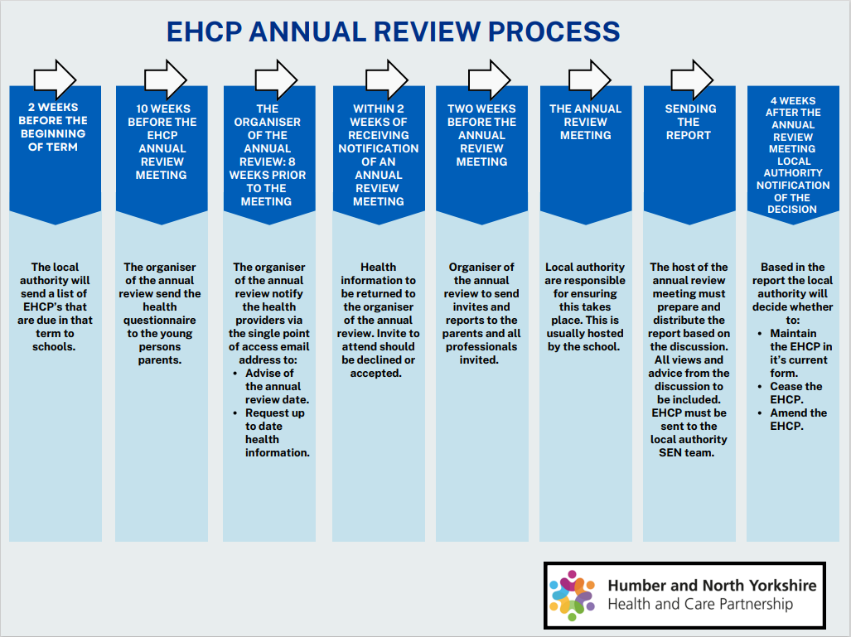
Print Version Click Here:
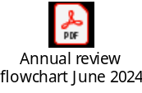

Phase Transfer Considerations
A ‘phase transfer’ is a transferring between key phases of education. For example, nursery to reception; first school to middle school; primary school to secondary school.
EHCPs must be reviewed and amended by 31st March if the transfer is from secondary school to a post-16 setting and by 15th February in any other case.

Request for Early Review
A parent, education setting, or young person can request an annual review if they perceive sudden or significant changes in the young person's needs or provisions.
If a child or young person with an EHCP is at risk of permanent exclusion, an early review should be held to address concerns promptly.

Post-16 Transition
EHCPs for young people moving from one post-16 institution to another post-16 institution must be reviewed and amended at least five months before the transfer to ensure a smooth transition.

Special Considerations
Unique situations, such as children not attending school or being released from prison, require specific review considerations to accommodate their circumstances.
In cases where a child or young person is listed on the care, dynamic support register, or section 117 of the mental health services, or is looked after, the annual review process should ensure that a wider network is involved in planning and coordinating their care.

Focus of EHCP Annual Review
The primary focus of the review should be on assessing the child's progress towards achieving the outcomes set out in the EHCP.

Decision Making
During the review, careful consideration should be given to whether the targets set in the EHCP are still appropriate. This includes determining if the child still requires EHCP support, if amendments are necessary, or if the EHCP should cease if the young person no longer requires it.

Review Content
The annual review should consider the young person's progress towards achieving their specific outcomes in the EHCP and determine if the outcomes remain appropriate. Any necessary changes or new goal targets should be included in the EHCP as appropriate.

Preparation for Adulthood
EHCP reviews for children in year nine and beyond should focus on preparing for adulthood, including considerations for employment, independent living, and community inclusion, as outlined in the SEND Code of Practice.
These guidelines adhere to the principles outlined in the SEND Code of Practice and aim to ensure that EHCP annual reviews are conducted effectively and in the best interests of children and young people with special educational needs and disabilities in North Yorkshire and York Place.

The annual review meeting and any other actions should allow the Local Authority to meet the 12 months deadline to complete the review. In practice this means that the Annual Review meeting date must be no later than 10 months after the EHCP issue date or previous review date.

