Accessing the Keyworker Service
Enquiries are welcomed from young people and their families alongside queries from professionals.

The Lead Professional involved in the child or young person’s care can make a referral by completing the referral form and consent form this will be available on the Local Offer.

Our service will be flexible to meet individual needs:
- We can arrange for an interpreter if you or your family need one.
- Let us know if you want or need information in a certain way and we will try and do this.
- Our service is confidential. We will discuss with you who we share your information with. If we are concerned about the safety of a child/ young person we have a duty to report this. The Keyworker service is committed to working with the Safeguarding Children’s Board. Guidelines and the Principles of the Children Act 1989 (updated 2004).
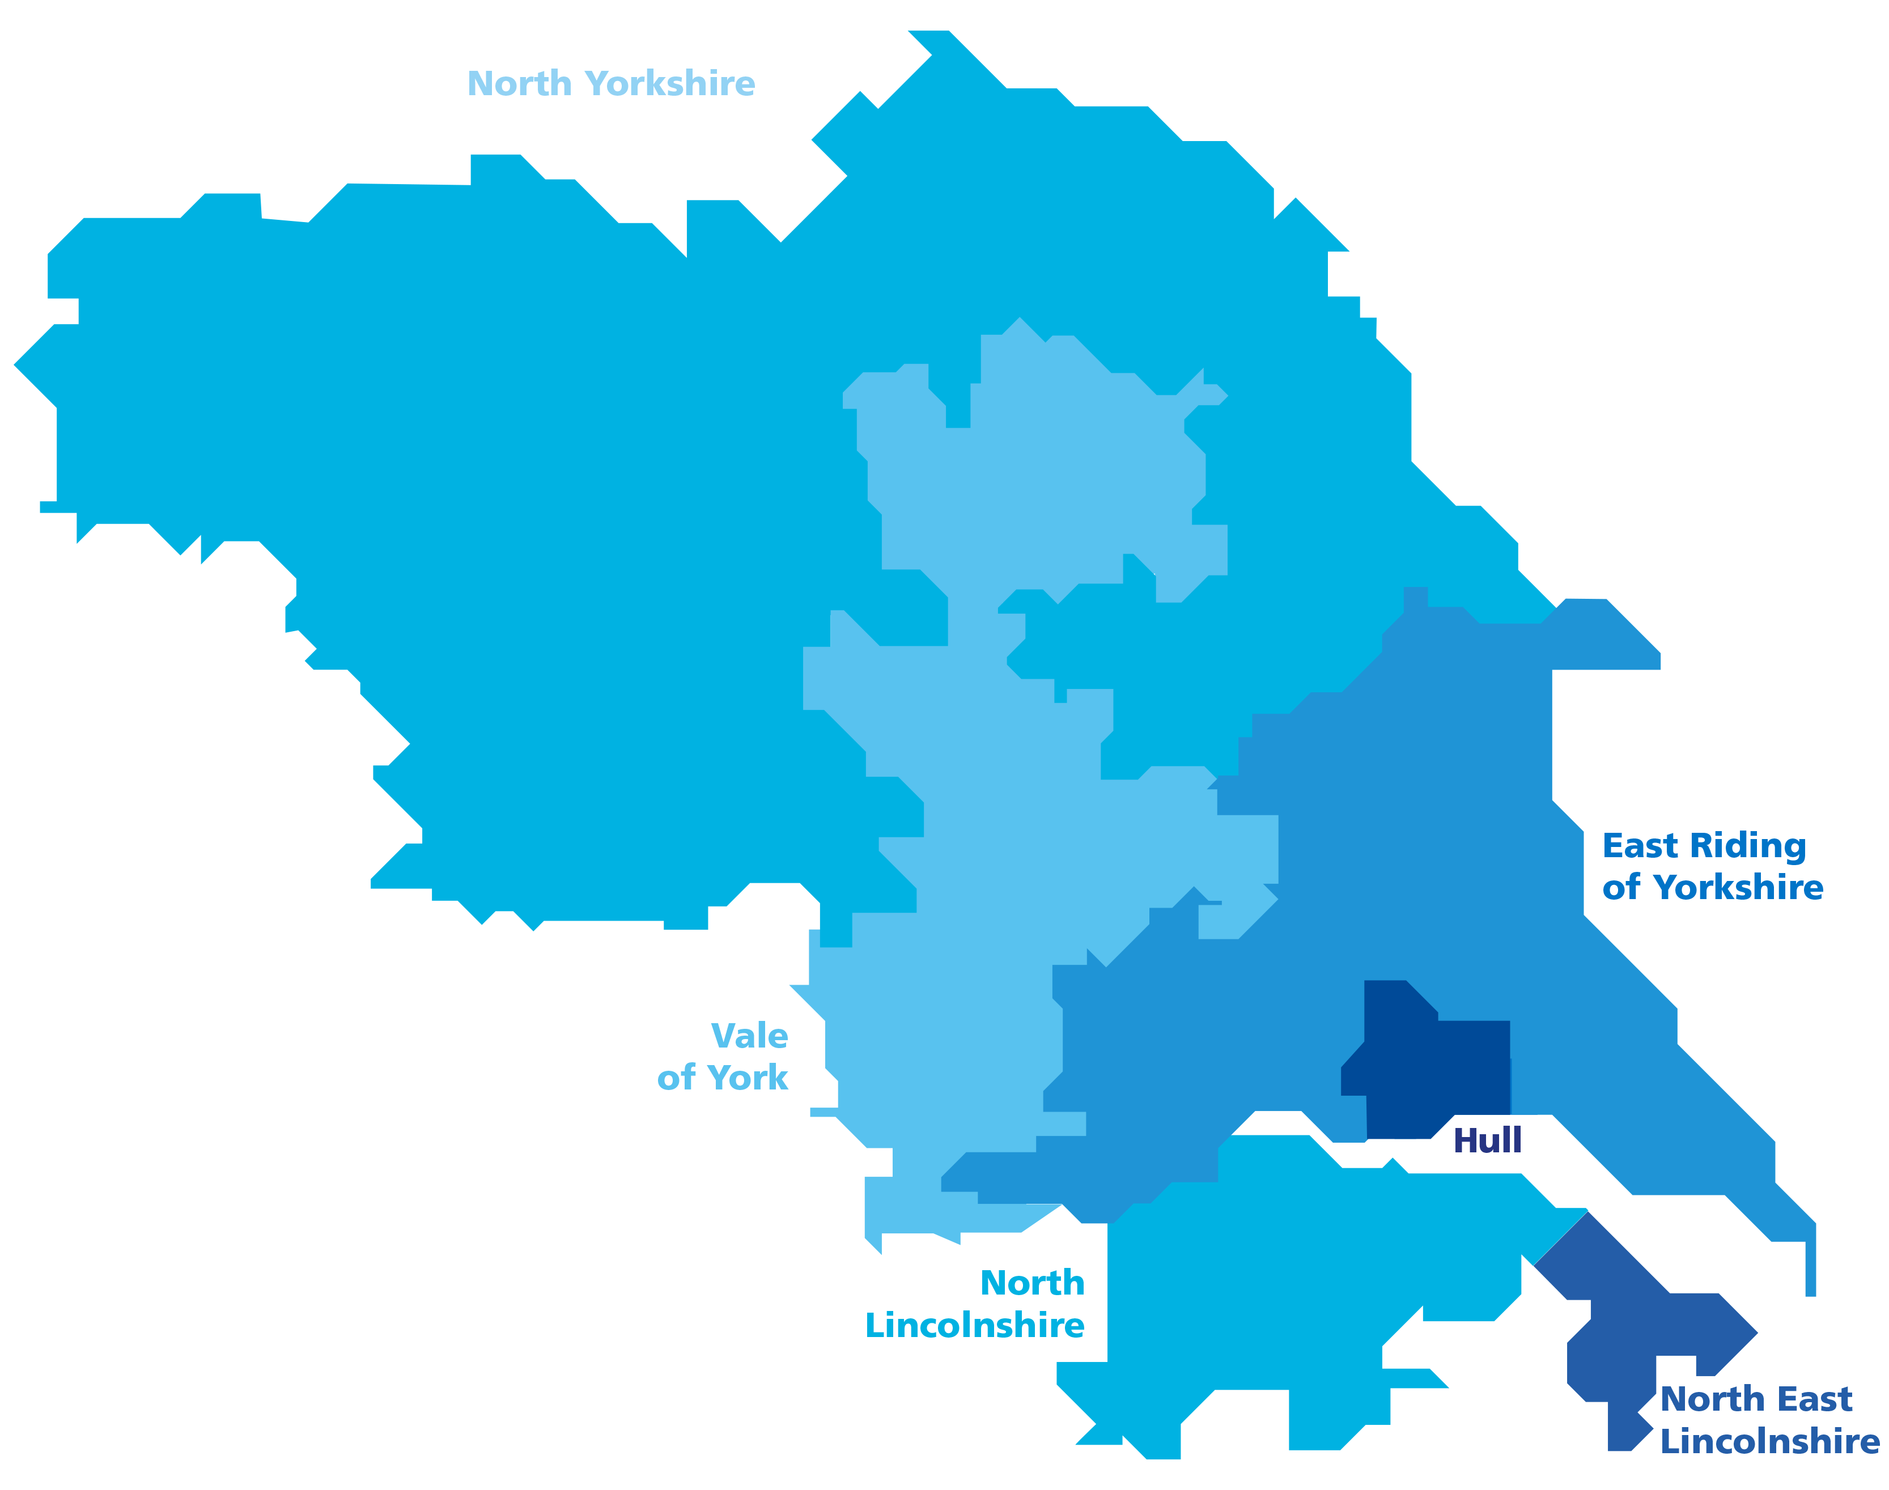
Contact Us: Keyworker Service:
Humber Coast and Vale Keyworker Service, Trust Headquarters, Willerby Hill, Beverley Road, Willerby, Hull, HU10 6ED
Tel. 01482 205425 / Email: hnf-tr.keyworkerenquiries@nhs.net

Your feedback is important to us, we would really like to ask you a few questions based on your experience of our services. To take part in our Friends and Family Test Survey (also available in Easy Read Format) please follow the link and enter the Team Code KS112 when prompted: Friends and Family Test (humber.nhs.uk)

Complaints:
Complaints can be contacted on:
Tel. 01482 303930 / Email. HNF-TR.complaints@nhs.net

Humber, Coast and Vale
Keyworker Service

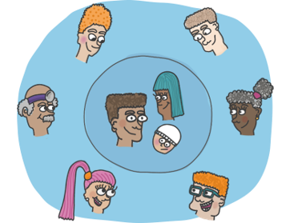


Putting children and young people and their families
at the centre of everything we do
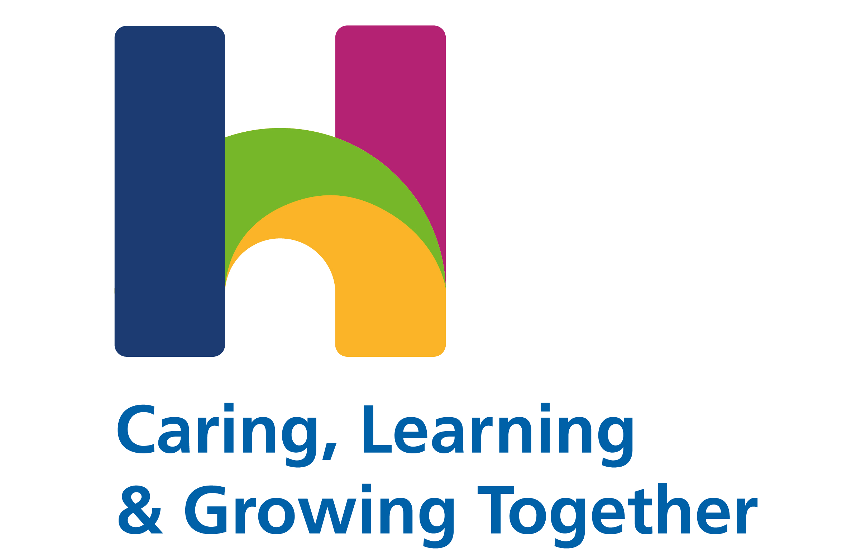
Publication Date: December 2021
Review Date: December 2022

What is the Humber, Coast & Vale Keyworker Service?
- The new Keyworker service is being developed as a response to the NHS England long term plan commitment that by 2023/24 children and young people with a learning disability, autism, or both, with the most complex needs will have a designated Keyworker.
- The Keyworking function is an important response to ensuring children, young people and families get the right support at the right time, and that local systems are responsive to meeting their needs in a holistic and joined up way.
- The initial phase of this work 2021-2023 is focused on “children and young people who are inpatients or at risk of being admitted to hospital”.

Why and how can a Keyworker help?

- Many children and young people with a learning disability, autism or both, struggle to get the help they need from the system.

- Children, young people, and their families are often disappointed by a lack of coordination between system services.

- The system processes supporting children, young people and families can be complex and not joined-up or adaptable.

- Keyworking is an opportunity to address these issues and improve outcomes for children, young people, and families.

- Keyworkers are central to ensuring that children, young people, and their families can navigate the complexities of the system.

- A core role for Keyworkers is to facilitate the co-production of this personalised approach.

What will a Keyworker do?
- Act as the main point of contact for children and young people and their family.

- Build and maintain positive, trusting, and appropriate relationships with children and young people and their families / carers during the supportive period aimed at avoiding admission or facilitating discharge and strengthening links with relevant services.

- Work on behalf of children and young people and their family/carers towards unblocking challenges and barriers.

- Ensure all children/young people have a clear personalised plan to promote their development.

- To ensure that Care Education and Treatment Review recommendations / actions are completed in a timely manner and that there are updates to the Dynamic Support Register to reflect this.

- The Keyworker will ensure continuity of care for the child/young person, and work across systems and services to ensure they respond and react to child/young person’s needs as required.
Who can have a Keyworker?

The criteria for access to a Keyworker is as follows
- A diagnosis of a learning disability, autism or both.

- 0-25 years of age, although our primary focus is under 18.

- Potential risk of inpatient admission or are currently in hospital.

- The child/young person is on the Dynamic Support Register (DSR). Priority Referrals are with those at Red & Amber and at crisis point. Those at Green currently do not receive an allocated Keyworker, however, may receive signposting or consultation.

- Reside in the geographical area of Humber Coast and Vale which includes Hull, East Riding, North Lincolnshire, North East Lincolnshire, York, and North Yorkshire.

