Speech, Language and Communication Advice
Would you like to discuss your child’s speech, language, or communication development?

Bring your child along to our drop-in session to meet with our Speech and Language Therapists, discuss any concerns, and receive advice and information about local support and services. Booking is essential.

Where & When
October 14th 2026
November 18th 2026
December 9th 2026
10 am to 12 noon
at Selby Library and Visitor Information Centre, 52 Micklegate, Selby YO8 4EQ
Who will be there?
Linda Dalgliesh – North Yorkshire Council Speech & Language Therapist
Lisa Bairstow -North Yorkshire Council Speech & Language Therapy Assistant
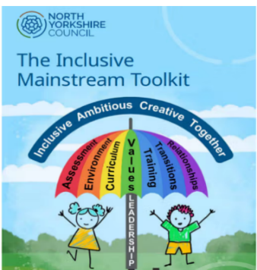
PLEASE EMAIL TO BOOK A 15 MINUTE SLOT
Lisa.bairstow@northyorks.gov.uk
Thank you.

