Speech, Language and Communication Advice
Hambleton and Richmond - Leyburn
Would you like to discuss your child’s speech, language, or communication development?

Bring your child along to our drop-in session to meet with our Speech and Language Therapist, discuss any concerns, and receive advice and information about local support and services. Booking is essential.

Where & When
- Monday 5th October 2026, 09.30am to 12.30pm
- Thornborough Hall Oak Room, Leyburn, DL8 5AB
Who will be there?
Linda Dalgliesh - North Yorkshire Council Speech & Language Therapist
Liz Wilson - North Yorkshire Council Speech & Language Therapy Assistant
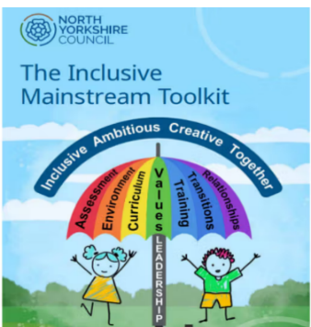
PLEASE EMAIL TO BOOK A 15 MINUTE SLOT
liz.wilson@northyorks.gov.uk
Thank you

