Speech, Language and Communication Advice
Hambleton and Richmond - Colburn
Would you like to discuss your child’s speech, language, or communication development?

Bring your child along to our drop-in session to meet with our Speech and Language Therapist, discuss any concerns, and receive advice and information about local support and services. Booking is essential.

Where & When
- Friday 20th November 2026, 10am to 12pm
- Colburn Children’s Centre, Catterick Garrison, DL9 4RF
Who will be there?
Amancay Topping - North Yorkshire Council Speech & Language Therapist
Stephanie Payne - North Yorkshire Council Speech & Language Therapy Assistant
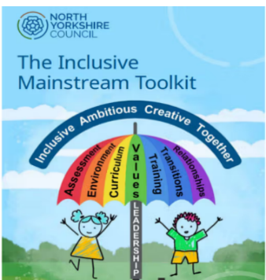
PLEASE EMAIL TO BOOK A 15 MINUTE SLOT
stephanie.payne@northyorks.gov.uk
Thank you.

