Speech, Language and Communication Advice
Hambleton and Richmond - Northallerton
Would you like to discuss your child’s speech, language, or communication development?

Bring your child along to our drop-in advice session to meet with our Speech and Language Therapist, discuss any concerns, and receive advice and information about local support and services. Booking is essential.

Where & When
- Thursday 3rd December 2026, 09.30am to 12.00pm,
- Alverton Children Centre, Mount Road, Northallerton, DL6 1RB
Who will be there?
Emma Pollock - North Yorkshire Council Speech & Language Therapist
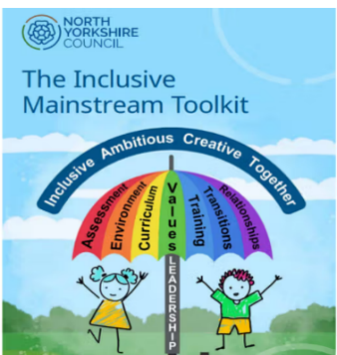
Rachael Hussain - North Yorkshire Council Speech & Language Therapy Assistant
PLEASE EMAIL TO BOOK A 15 MINUTE SLOT
rachael.hussain@northyorks.gov.uk
Thank you

