York and North Yorkshire Combined Authority Serious Violence Survey 2026 Tool Kit
Introduction
Under the Serious Violence Duty introduced by the Government in January 2023, the York and North Yorkshire Combined Authority have a statutory duty to convene partners to address levels of violence.
The partnership includes North Yorkshire Police, North Yorkshire Fire and Rescue Service, Probation services, North Yorkshire Council, City of York Council and the NHS Humber and North Yorkshire Integrated Care Board. The Partnership refreshed the Strategic Needs Assessment in April this year.
On Monday 17 August 2026 this year’s Serious Violence Survey was launched for a six-week consultation period where we are wanting the public to share their views on violence and community safety in York and North Yorkshire.
In last year’s survey, 76% of respondents’ selections were that they felt most safe in their local area. The most experienced crime was Anti-Social Behaviour with fear of serious violence, with 19% of selections.
This year’s survey includes specific questions about online safety and Violence Against Women and Girls, and the findings will be used to continue shaping our local approach to reducing violence in the future.
Every response will help us to do more to keep people safe in our region.
The survey is open until 11pm Sunday 27 September 2026.
This toolkit includes -
- Website copy
- Internal Comms Copy
- Social media copy
- Newsletter copy
- Press release

Please share any information with your networks, colleagues and staff.
If you have any questions, please contact news@yorknorthyorks-ca.gov.uk
Thank you

Website Copy – Long and Short Versions
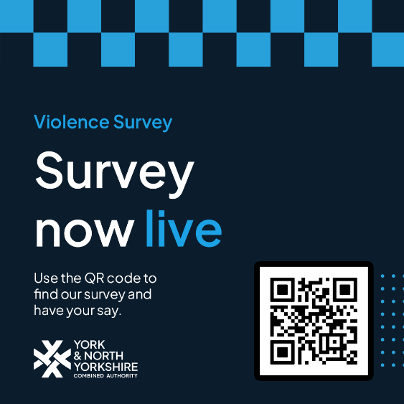
Shorter version:
Have Your Say on Violence and Community Safety in York and North Yorkshire
Residents across York and North Yorkshire are being encouraged to take part in this year's Serious Violence Survey.
🔗Survey Link: https://yorknorthyorks-ca.gov.uk/serious-violence-survey-2026/
The survey asks about community safety, experiences of violence, online safety and Violence Against Women and Girls (VAWG). The findings will help partners better understand local concerns and inform future work to prevent violence and support safer communities.
📆Closes 11pm Sunday 27 September 2026
Longer version:
Have Your Say on Violence and Community Safety in York and North Yorkshire
Residents across York and North Yorkshire are being encouraged to take part in this year's Serious Violence Survey.
🔗Survey Link: https://yorknorthyorks-ca.gov.uk/serious-violence-survey-2026/
The survey is open until 11pm on Sunday 27 September 2026 and includes questions about community safety, experiences of violence, online safety and Violence Against Women and Girls (VAWG). The findings will help partners across York and North Yorkshire better understand local concerns and inform future work to prevent violence, support victims and build safer communities.
Jo Coles, York and North Yorkshire Deputy Mayor for Policing, Fire and Crime, said:
"Serious violence has a devastating impact on victims, their families and our communities. Please take a few minutes to tell us how safe you feel and whether you've been affected by violent crime over the last year. Every response will help us do more to keep people safe across York and North Yorkshire."
📆Closes 11pm Sunday 27 September 2026
Internal Comms Copy
Have your say on community safety
Residents, workers and communities across York and North Yorkshire are being encouraged to take part in this year's Serious Violence Survey.
The confidential survey takes just a few minutes to complete and includes questions on violence, community safety, online safety and Violence Against Women and Girls (VAWG). The results will help inform work to make our communities safer.
📆It closes 11pm Sunday 27 September 2026
Take part here:
🔗 https://yorknorthyorks-ca.gov.uk/serious-violence-survey-2026/
Newsletter Copy
York & North Yorkshire Residents - Share Your Views on Violence and Community Safety
How safe do you feel in your community?
Jo Coles, York and North Yorkshire Deputy Mayor for Policing, Fire and Crime, is encouraging residents to take part in a new survey on violence and community safety.
The survey seeks views from anyone who has experienced violence, felt unsafe, or been affected by violent crime. This year's questionnaire also includes specific questions about online safety and Violence Against Women and Girls.
The feedback gathered will help inform local efforts to prevent violence, support victims and improve safety across York and North Yorkshire.
Last year's survey found that 76% of respondents felt safe in their local area. The latest survey will provide valuable insight into current experiences and concerns, helping partners target support where it is needed most.
Complete the survey by 11pm Sunday 27 September 2026: https://yorknorthyorks-ca.gov.uk/serious-violence-survey-2026/

Social Media Copy Options
Social Media Handles to include/tag in your social posts:
Deputy Mayor for Policing, Fire and Crime: Facebook/ Instagram
Combined Authority: Facebook / X / LinkedIn
Image:
Facebook
How safe do you feel in York and North Yorkshire?
Each year, the Government asks local areas to gather feedback from residents about how safe they feel, helping to assess whether national efforts to tackle serious violence are making a difference.
While York and North Yorkshire remain generally safe places to live and work, violence continues to affect some individuals and communities. Residents are being encouraged to take part in York and North Yorkshire Combined Authority’s annual survey and contribute to the national picture of public safety.
Last year's survey found that 76% of respondents across York and North Yorkshire felt safe in their local area. Every response to this year's survey will help build a better understanding of local experiences and inform future work to keep communities safe.
✅ The survey is confidential
🕰️ It takes just a few minutes to complete
📆It closes 11pm Sunday 27 September 2026
Take part here:
🔗 https://yorknorthyorks-ca.gov.uk/serious-violence-survey-2026/
LinkedIn
Have your say on violence and community safety in York and North Yorkshire
Jo Coles, Deputy Mayor for Policing, Fire and Crime, is encouraging residents, workers and communities across York and North Yorkshire to take part in a survey exploring experiences of violence and perceptions of safety.
The survey will help build a clearer picture of how safe people feel in their local area and identify where further action, support and prevention activity may be needed. This year's survey also includes specific questions on online safety and Violence Against Women and Girls (VAWG).
Anyone who has experienced violence, been affected by violent crime, felt unsafe, or wants to share their views is encouraged to take part.
Last year's survey found that 76% of respondents felt safe in their local area. The findings from this year's survey will help inform the partnership work taking place across York and North Yorkshire to reduce violence and support safer communities.
✅ The survey is confidential
🕰️ It takes just a few minutes to complete
📆It closes on 11pm Sunday 27 September 2026
Take part here:
🔗 https://yorknorthyorks-ca.gov.uk/serious-violence-survey-2026/
Every response helps us better understand the issues affecting our communities and supports efforts to keep York and North Yorkshire safe for everyone.
Instagram
How safe do you feel in your community?
York and North Yorkshire Combined Authority are inviting people across the county share their views on violence and community safety.
Your feedback will help us better understand local concerns and shape future work to prevent violence, support victims and keep communities safe.
✅ The survey is confidential
🕰️ It takes just a few minutes to complete
📆It closes on 11pm Sunday 27 September 2026
Every response matters.
🔗 https://yorknorthyorks-ca.gov.uk/serious-violence-survey-2026/
Nextdoor
How safe do you feel in your local area?
Jo Coles, Deputy Mayor for Policing, Fire and Crime, is encouraging residents across York and North Yorkshire to take part in a survey about violence and community safety.
The survey asks about people's experiences of safety in their communities and includes questions on online safety and Violence Against Women and Girls. Whether you've experienced violence, felt unsafe, or simply want to share your views, your feedback can help shape future work to keep our communities safe.
Last year's survey found that 76% of respondents felt safe in their local area. This year's results will help partners better understand local concerns and identify where support and action are needed.
✅ The survey is confidential
🕰️ It takes just a few minutes to complete
📆It closes on 11pm Sunday 27 September 2026
Have your say:
🔗 https://yorknorthyorks-ca.gov.uk/serious-violence-survey-2026/
Every response helps us build a clearer picture of community safety across York and North Yorkshire.
X (Twitter) or BlueSky Message
How safe do you feel in your community?
People across York and North Yorkshire are being asked to complete this year's Serious Violence Survey.
This year's survey includes questions on online safety and Violence Against Women and Girls. Complete it by 11pm 27 September: 🔗 https://yorknorthyorks-ca.gov.uk/serious-violence-survey-2026/
What’s App Message:
How safe do you feel in your community - Take part in the York and North Yorkshire Serious Violence Survey by 11pm on 27 September and share your views on issues including online safety and violence against women and girls: https://yorknorthyorks-ca.gov.uk/serious-violence-survey-2026/

Press Release
17 August 2026
Residents invited to help shape a safer York and North Yorkshire
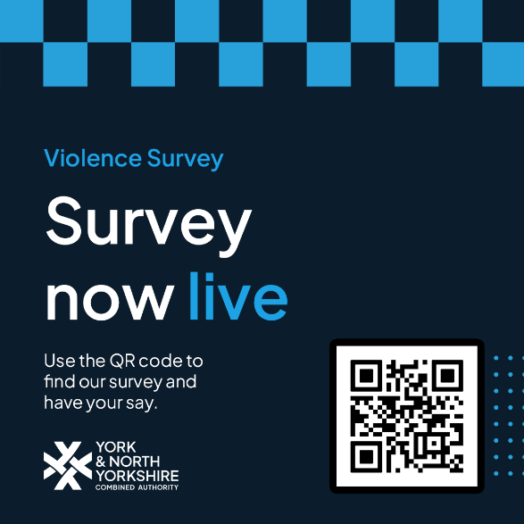
Jo Coles, York and North Yorkshire Deputy Mayor for Policing, Fire and Crime, is calling on the public to share their views on violence and community safety in York and North Yorkshire. This year’s survey also includes specific questions about online safety and Violence Against Women and Girls.
Anyone who has been a victim of violence, felt or feels unsafe or has been affected by violent crime can take part in the survey to help improve services and support going forward.
The survey is open until Sunday 27 September 2026 and can be accessed here:
https://www.smartsurvey.co.uk/t/T0IEJ1/
In last year’s survey, 76% of respondents’ selections were that they felt most safe in their local area. The most experienced crime was Anti-Social Behaviour with fear of serious violence, with 19% of selections. This year’s survey will be used to continue to inform our local approach and to reduce violence in the future.
Under the Serious Violence Duty introduced by the Government in January 2023, the York and North Yorkshire Combined Authority has a statutory duty to convene partners to address levels of violence. The partnership includes North Yorkshire Police, North Yorkshire Fire and Rescue Service, Probation services, North Yorkshire Council, City of York Council and the NHS Humber and North Yorkshire Integrated Care Board. The Partnership refreshed the Strategic Needs Assessment in April this year.
Jo Coles, Deputy Mayor for Policing, Fire and Crime said:
“Serious violence has a devastating impact on victims, their families and our communities. While levels of serious violence in York and North Yorkshire remain relatively low, every incident is one too many and has a lasting effect on those involved. Over the past year, David Skaith, the Mayor and I have continued to work with partners to understand and tackle the causes of violence, helping to keep our communities safe. The Government has set an ambitious target to halve serious violence and having an accurate picture of what is happening in our area is important to ensuring we play our part in achieving that goal. Please take a few minutes to tell us how safe you feel, wherever you live or work in our county and whether you've been affected by violent crime over the last year. Every response will help us to do more to keep people safe in our region."
Additional information
The definition of serious violence for York and North Yorkshire reflects issues identified within the local area, and the impact and prevalence of different types of serious violence.
Therefore, the following crimes are included in our definition of serious violence and were used to inform our Serious Violence Strategy: homicide; violence with injury (attempted murder, endangering life, grievous bodily harm, actual bodily harm, administering poison with intent to injure, non-fatal strangulation and suffocation); domestic abuse; rape and sexual offences; weapon related violence, including weapon possession; arson endangering life; and stalking and harassment.
Violence against women and girls includes crimes such as domestic abuse, rape, sexual violence, abuse and exploitation, and stalking which most often affect women and girls and are typically committed by men. However, it’s vital to ensure all voices of victims of violence, no matter who they are, are listened to and believed. Men, boys, and non-binary people can also be victims, and women can be perpetrators too.
The Mayor’s Police and Crime Plan for 2025 – 2029, sets out the strategic direction of North Yorkshire Police by identifying four key priorities over the next four years, these are:
- Focus on Prevention and Early Intervention
Tackling the root causes of crime in York and North Yorkshire through education, community programmes, and early intervention to prevent crime before it occurs and intervene early when it does.
- Protect the Public
Protecting the public of York and North Yorkshire and improving trust and confidence in policing by focusing on specific crime outcomes/themes that the public said were most important.
- Work with Partners
Working with our partners to ensure a collaborative approach to identifying and protecting the most vulnerable people in York and North Yorkshire and to ensure all victims of crime receive appropriate care and support.
- Build Stronger Communities
Focusing on creating safer communities throughout York and North Yorkshire through proactive policing, partnerships with local organisations, and community engagement.
ENDS
For further information: news@yorknorthyorks-ca.gov.uk
Notes to editors
Community Safety Serious Violence Fund
York and North Yorkshire Combined Authority is committed to a commissioning approach to Community Safety and Serious Violence funding, investing in evidence-based local initiatives that help reduce serious violence and deliver positive outcomes for individuals and communities.
The fund supports projects that take a proactive, sustainable and outcomes-focused approach to prevention, early intervention and diversion from anti-social behaviour and crime, including serious violence. Funded initiatives should contribute to reducing offending and reoffending, preventing victimisation and revictimisation, and addressing local Community Safety and Serious Violence priorities.
Applications are open to community groups, organisations and individuals linked to an organisation.
The maximum grant available through this fund is £30,000 per application.
Find out more: https://www.northyorkshire-pfcc.gov.uk/for-you/partnership/non-commissioned-community-safety-services/
About York and North Yorkshire Combined Authority
The York and North Yorkshire Combined Authority has been created by the City of York Council and North Yorkshire Council and is a legally recognised, single body. Our role is to use some of the money and powers, that up to now have been held by central government, and work with local leaders and communities to invest in ways that will help to make York and North Yorkshire a better place for you to live, work and do business. The Combined Authority is led by David Skaith, Mayor of York and North Yorkshire.
Deputy Mayor Facebook/ Instagram
Combined Authority website / Facebook / X / LinkedIn / YouTube

