

Dear Headteacher,

RE. Opportunity to take part in a national study about the National Child Measurement Programme (NCMP) ** £150 Incentive is available for each school **

We are writing to invite your school to take part in an exciting new research study led by UCL, Durham, and Newcastle Universities, in partnership with North Yorkshire council. It will provide your year 6 pupils with the opportunity to share their experiences of being weighed and measured as part of the NCMP, which will help to improve the service for children in the future.

The study was commissioned by the Department of Health and Social Care and funded by the NIHR. It is evaluating the National Child Measurement Programme (NCMP), with one strand focusing specifically on how acceptable children find the height and weight measurement process.

What would participation involve?
- Year 6 pupils would be invited to complete a very short survey immediately after their NCMP measurement.
- The survey should take no more than 5 minutes to complete.
- Schools to provide access to a school tablet/PC in a quiet area with the survey downloaded for the children to complete.
- It is delivered by the NIHR Research Delivery Network team
- Parental consent is opt-out, and all information sheets will be provided in advance.
We hope you will consider joining us in this important work to support children’s health and wellbeing. If you would like to find out more, please contact Lauren Stanton lauren.stanton@nihr.ac.uk. If Lauren Stanton is unavailable, please contact Tom Smith tom.smith@nihr.ac.uk or Laura Wendon laura.wendon@nihr.ac.uk. We will be happy to provide further information and can offer an informal online meeting to discuss if preferred.

Warm regards,
Sarah Marriott
On behalf of the IMPACT-NCMP research team, University College London Sarah.marriott.24@ucl.ac.uk

NIHR Research Delivery Network team:
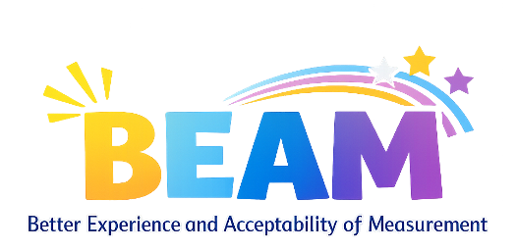
Lauren Stanton lauren.stanton@nihr.ac.uk
Tom Smith tom.smith@nihr.ac.uk
Laura Wendon laura.wendon@nihr.ac.uk

