Speech, Language and Communication Advice
Harrogate, Ripon, Knaresborough, Craven
Would you like to discuss your child’s speech, language, or communication development?

Bring your child along to our drop-in session to meet with our Speech and Language Therapists, discuss any concerns, and receive advice and information about local support and services. Booking is essential.

Where & When
- Thursday 5th November 2026 9.30 – 11.30 at Brougham Street Nursery School, Skipton

Who will be there?
Emma Pollock – North Yorkshire Council Speech & Language Therapist
Carol Moxon -North Yorkshire Council Speech & Language Therapy Assistant
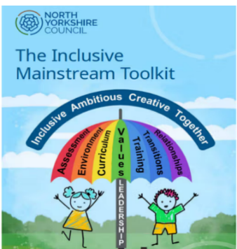
PLEASE EMAIL TO BOOK A 15 MINUTE SLOT
carol.moxon@northyorks.gov.uk
Thank you.

