Dear Colleagues,
Soon it will be Interfaith Week 2025 (9–16th November) which is an ideal opportunity to engage pupils in respectful dialogue and celebrate diversity. We encourage schools to take part through assemblies, creative projects, or community partnerships. If this is something your school would like to get involved in follow the link here: https://www.interfaithweek.org/resources/schools
In celebration of Inter Faith Week (9–16 November), the Faith & Belief Forum is inviting schools to two free, online events designed to deepen how we cultivate belonging, connection, and collaboration in schools and communities. All sessions take place on Zoom.
Working with Local Community Groups to Enhance Classroom Learning Wednesday 12 November, 4:30 – 5:30 pm
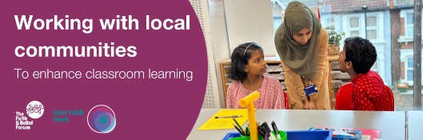
Led by our Education & Learning Team, this session distils lessons from decades of interfaith education and community engagement. We’ll explore how schools and local faith/community organisations can partner to enrich learning, amplify student voice, and strengthen local connectedness.
Amy Ark is Senior Programme Manager of the Education and Learning Team at The Faith & Belief Forum. She has over 20 years of experience working in the charity sector on both formal and informal education in the U.K.  Register here
Belonging in the Classroom — Author Q&A with Zahara Chowdhury Thursday 13 November, 4:30 – 5:30 pm
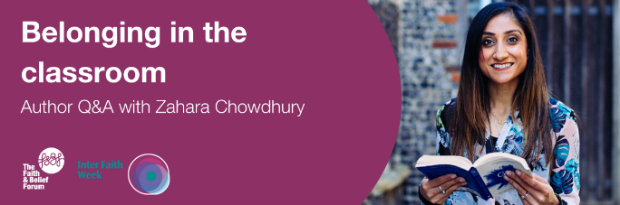
In conversation with Carrie Alderton, CEO of the Faith & Belief Forum, Zahara Chowdhury will explore her new book Creating Belonging in the Classroom, a hands-on guide for educators seeking to foster inclusion, build psychological safety, and navigate “brave conversations” around identity, difference and equity.
Zahara is a former Head of English, DEI lead, education consultant, and founder of School Should Be.  Register here
In addition, to assist colleagues, we are sharing links to organisations offering training and resources on identifying wider forms of prejudice. In North Yorkshire we recognise that our school staff need support to recognise and respond to these issues. This includes understanding how prejudice manifests and how to challenge it effectively.
Training & Support Organisations
1. Educate Against Hate https://educateagainsthate.com Government-backed site offering practical advice, classroom resources, and training links for tackling extremism and hate.
2. REHubs https://www.re-hubs.uk/upskill/controversial-issues-in-re gives staff a large selection of resources and links that help to deal well with controversial and challenges issues in RE, including prejudice and discrimination.
3. The Anne Frank Trust UK https://annefrank.org.uk Offers workshops and school programmes focused on challenging prejudice through the story of Anne Frank.
4. Solutions Not Sides https://solutionsnotsides.co.uk Provides educational programmes that address antisemitism and Islamophobia through conflict resolution and dialogue.
5. Facing History and Ourselves UK https://www.facinghistory.org/uk Offers teacher training and resources to help students explore identity, prejudice, and moral choices.
6. Faith & Belief Forum https://faithbeliefforum.org Delivers interfaith workshops and training to promote understanding and reduce prejudice in schools.
7. Tell MAMA (Measuring Anti-Muslim Attacks) https://tellmamauk.org Offers support and guidance on tackling Islamophobia, including school engagement and reporting tools.
8. Community Security Trust (CST) https://cst.org.uk Provides antisemitism awareness training and safeguarding advice for schools and communities.
9. NSPCC How to have difficult conversations How to have difficult conversations with children | NSPCC Learning
10. RED Cross
Red Cross: Talking with children about a major emergency (5-11) Talking about a major emergency | Primary teaching resources
Red Cross: Talking with young people about a major emergency (11-19) Talking about major emergency | Secondary teaching resources
11. Culham St. Gabriels Trust (CSTG) Freedom of Religion and Belief short course can be accessed here (users need to create a free login to access it): https://courses.cstg.org.uk/ . Other useful FORB resources on the site: https://www.reonline.org.uk/?s=Freedom+of+Religion+and+belief
12. Hindu Education Board https://www.hindueducationboarduk.org/Resources
13.Henry Jackson society and the Charlotte Littlewood report on anti-Hindu hate in schools https://henryjacksonsociety.org/publications/anti-hindu-hate-in-schools/

Sent on behalf of North Yorkshire SACRE

With grateful thanks to Newham and Norfolk SACREs and NYC SACRE Professional RE adviser for their support in curating the resources.

