Harrogate District Hospital
Lancaster Park Road
Harrogate
HG2 7SX
T: 07392194148
E: carly.dodsworth@nhs.net
1st September 2025

PRIVATE AND CONFIDENTIAL
North Yorkshire Schools
Dear Head Teacher
Disclosure and Barring Service checks
Harrogate & District NHS Foundation Trust
HDFT Health Professionals working within Schools
In line with the statutory guidance Keeping Children Safe in Education (July 2025, DfE) Harrogate and District NHS Foundation Trust ensures all employment checks are carried out in accordance with the relevant Codes of Practice, including enhanced checks through the Disclosure and Barring Service (DBS).
Checks on all our staff have been made against the Childrens and Adults Barring list to ensure that they are able to undertake unsupervised activities in schools.These checks are in accordance with the Trust’s Management of Employment Procedure.
Our Trust guidance is that staff do not carry DBS certificates, however they must have their Trust ID Badge and show this. In addition, schools can contact any of our Service Managers as required for spot checks, confirmation of staff member and role or additional information.
Elizabeth Archer 07919493244
Adele Ameer-Beg 07741 700487
Nosheen Ali 07741185952

Yours Faithfully
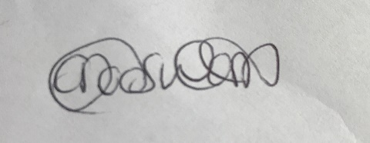
Carly Dodsworth
Head of Public Health Nursing and Operations for North Yorkshire
Children and Young People’s Public Health Directorate

