POSTER FOR ALL AUDIENCES / PRIMARY

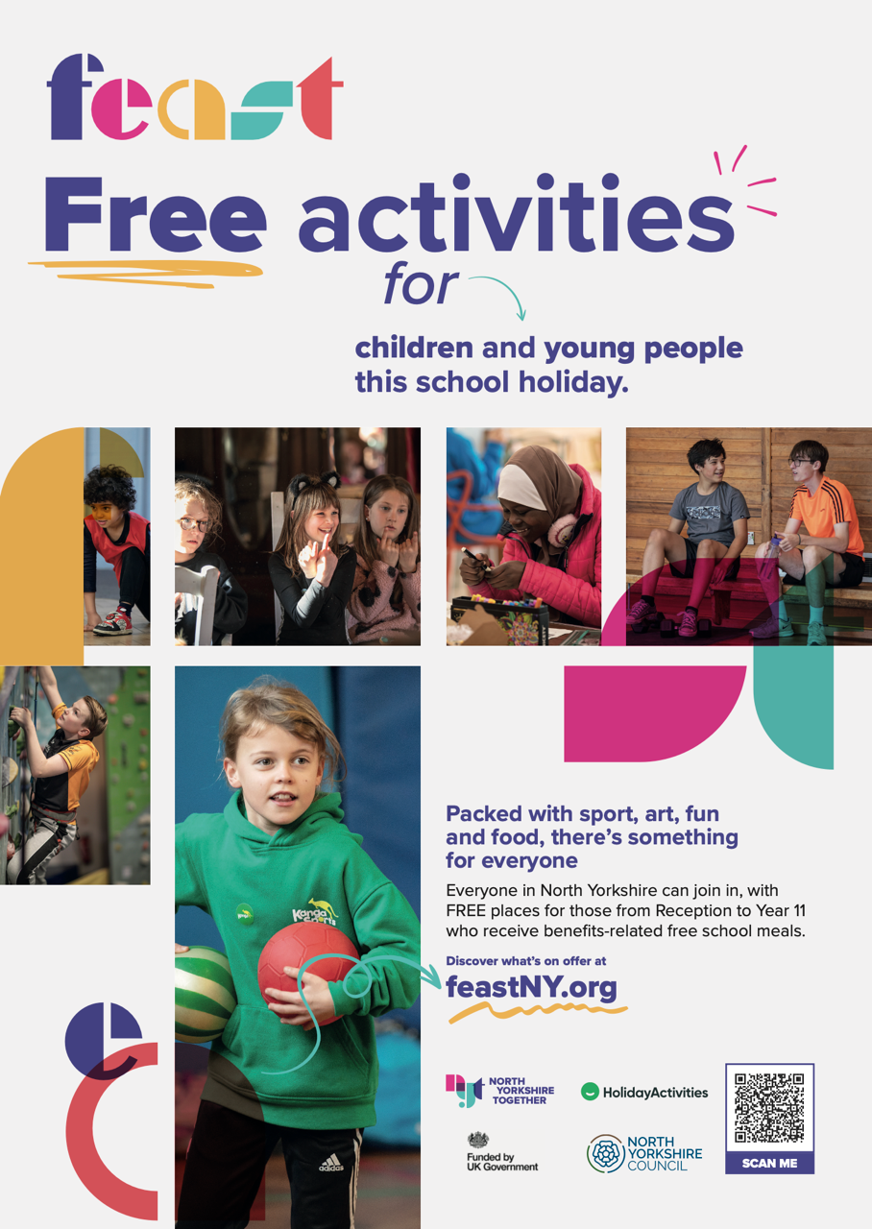
POSTER FOR SECONDARY AGE



IMAGE FOR SOCIAL MEDIA



SLIDE FOR SCHOOL SCREENS



