Humber and North Yorkshire
Children and Young People's Health Newsletter
Autumn 2024

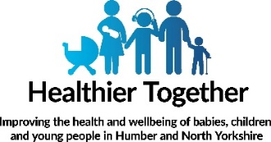

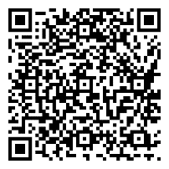

What can I expect
with my child's development?

Healthier Together is our local website, providing consistent and high-quality advice from local health professionals on children and young people's health.

You'll find clear information on common childhood illnesses, including advice on what 'red-flag' signs to look out for, where to find help, and if children and young people should go to school.

Healthier Together is a partnership project which continues to grow by putting children, young people and family’s needs at its heart, in one easy to navigate place. The information on the website is checked by clinicians and developed with experts.

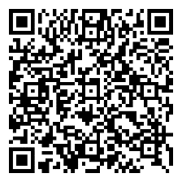

Should my child
go to
school/nursery today?

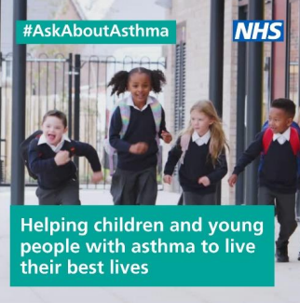
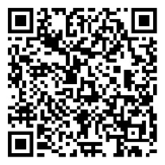
#AskAboutAsthma 2024: helping children and young people to live their best lives
#AskAboutAsthma 2024 takes place from 9-15 September. This year’s campaign is focusing on helping children and young people with asthma to live their best lives.
Good asthma control means having no symptoms and can be achieved by following these four asks:
1. get an asthma action plan in place,
2. understand how to use inhalers correctly,
3. schedule an asthma review – every year and after every attack,
4. consider air pollution and its impact on lung health.
Visit the 2024 campaign webpage for more information and resources to help you share the campaign.

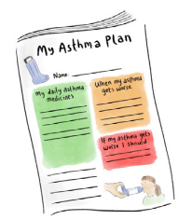
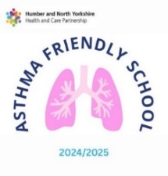
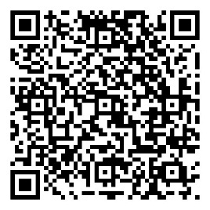
Focus on Personalised Asthma Action Plans

Having a personalised asthma action plan means you are four times less likely to have an asthma attack that requires emergency hospital treatment.
A personalised asthma action plan tells you:
- Which medication to take every day
- What to do if your asthma symptoms get worse
- What to do if you have an asthma attack
- Includes information about your asthma triggers
If you haven't got a personalised asthma action plan, you can ask your asthma nurse or GP for one. You should share you asthma plan it with school, so everyone who cares for you can help to support you with your asthma.

Follow the QR code to find out more about becoming an asthma friendly school.
Are you an Asthma Friendly School?
If you are worried about your/yours childs asthma, please contact your GP or Asthma Nurse and book an asthma review.

