Arbor Finance (RM Finance)

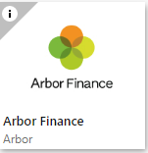

Closing down the 2024/25 financial year and starting the 2025/26 financial year

and

Preparing and producing a CFR Return

Information provided by the FMS Team

fmshelpline@northyorks.gov.uk

General Information

The Arbor Finance software is web based which means that reports can be generated to screen and then saved to a folder on your computer. You can then attach the reports from the folder to an email to:

schoolsfinanceteam@northyorks.gov.uk

You can set up your folder on any computer drive to suit you and with any name you choose but for the purposes of these notes I would suggest the name ‘Yearend Returns 24-25’ and will refer to this name going forward.

Contents:

Content | Page
Actions in February and March | 3 & 4
Actions after the end of the Financial Year | 5 - 9
Appendix 1 Capital Expenditure | 10 - 11
Appendix 2 Direct Revenue Financing | 12
Appendix 3 Local Income Report | 13 - 14
Appendix 4 Preparing and Producing a CFR Return | 15 - 23
Appendix 5 School Fund closedown using ‘new’ Arbor Finance online | 24 - 30

February

- Set up a folder (on a drive/area to suit you) called Yearend Returns 24-25

- Reconcile your Bank Statement to 28/02/2025 and produce a VAT claim to 28/02/2025 and submit via Anycomms+. These can only be submitted on Anycomms+ until the 7th March 2025 after that date they will need to be emailed in PDF format to the schools finance team (schoolsfinanceteam@northyorks.gov.uk)

- Period 12 VAT runs from 01/03/2025 to 31/03/2025 and will be submitted via email.

- You could check the “mapping” of your Budget Codes in Arbor Finance in preparation for producing your CFR Return in May – see Appendix 4 Preparing and Producing a CFR Return.

March

- Complete and return the Capital Balance Estimates form by 07/03/2025 via email to the schoolsfinanceteam@northyorks.gov.uk

- Print off any un-reconciled bank transactions on Arbor Finance and check for validity – tidy up any zero transactions. (Out of date cheques or ‘mistakes’ from the current budget year can be reversed whilst transactions from previous budget years need an ‘opposite’ credit/debit transaction which can be ‘paired off’ with the original and reconciled).

A list of un-reconciled transactions is obtained by:

Transactions – Bank Processing – choose the School Bank a/c (probably the default account) and click on the Printer icon on the right of the screen.

- Print off all outstanding orders and check for validity.
To obtain a list of outstanding orders:-

Reporting – Transactions – Purchase Orders (middle of the General list). No need to change any of the screen options.

If you know that some of these orders are no longer valid, they should be completed.

This is done by going to Transactions, Expenditure and the Search/Process tab. Click on the action tab and then Complete the order.

- Make sure you do not have any outdated or incorrect items on the Cheque Print Payment screen Transactions, Payments, Print Payments e.g. a transaction from a previous financial year. Advice can be sought from the FMS Team help line if necessary.

- Enter March Remittance and VAT reimbursement.

- Enter details from February ORACLE.

- Check for any un-reconciled ORACLE transactions.

- Produce a February Monitoring Statement and when you are happy with the content run Period end (now in Period 12).

- Check that you have coded any expenditure that exceeds £2,000, and qualifies as a capital purchase, to a Capital Expenditure code.
For more information see Appendix 1.

- If you need to move money between your Revenue Budget to your Capital Budget make the necessary internal charge.
For more information see Appendix 2.

- Your final 2024/25 Staff Absence claim must be produced by Monday 31st March 2025.

- Bear in mind that you can use codes in Arbor Finance which you have created to suit your own purposes (e.g. Learning Resources codes etc.) rather than those on the ‘official’ LA coding structure list but you need to be aware that they won’t be recognised by the central ORACLE system and your ‘individual’ codes can’t be used for Debtor/Creditor etc. journals.

- Very Important – Order a Bank Statement to the end of the financial year, if you don’t have access to on-line statements. Ideally the Bank Statement should also show 1st April to ensure all transactions to the end of March were processed by the Bank. You will need to receive your bank statement as soon as possible to enable you to meet the closedown timetable. If the Bank sends a statement not showing the beginning of April please use the statement up to and including the 31st March and send in your next statement showing the start of April as soon as possible. A transaction report, available over the Bank counter is acceptable but must also be followed up with a copy of the actual bank statement.

- Make sure you have ‘marked’ your Central Fund within Arbor Finance on Line before moving into the next financial year (see Page 7).

- Check that your display is set to include Unprinted Cheques

System, System Setup, Options, Display

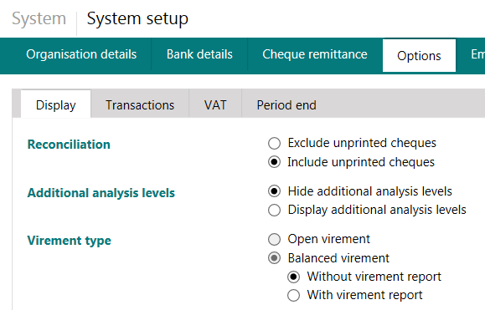

Reconcile Bank transactions up to (and including) 31/03/2025, do not reconcile any transactions processed after this date.

Actions after the end of the 2024/25 Financial Year

Produce/Print

You will probably want to print a copy of your yearend returns for your records.
For submission to the LA you should generate and save an ‘e’ copy of the return to a Yearend Returns 24-25 folder and then attach the documents to an email to the schoolsfinanceteam@northyorks.gov.uk

To Save Returns from Arbor Finance on Line

When you send a report to ‘print’ it first appears on screen and you are able to see the icons below:



Click on the ‘save’ icon and choose
a ‘PDF’ format.

You will then see:

(If you have any problems seeing the ‘save as’ option make sure you have accessed the software using Internet Explorer/Microsoft Edge rather than Chrome).

Use the ‘drop down’ alongside Save to choose Save As.

Change the name of the file so all of your reports have the DfE number as the first four digits e.g. 1111 Full Year VAT Return –where 1111 is the DfE number.

Save the files to your Yearend Returns 24-25 folder.

Produce and Save the following

(you may also want a printed copy for your records)

    - A copy of your un-reconciled Bank transactions – check these figures. The figures should be checked against the totals for un-presented income and un-presented expenditure on your Bank Reconciliation statement (see below). If they don’t match, check your Payments screen for transactions and contact the FMS team if necessary. (e.g. 1111 Unreconciled Bank Transactions)

- A copy of your Bank Reconciliation statement (Reporting, Custom, Bank Balance and highlight account(s).

If you operate more than one BAFS account (e.g. current and deposit) you must send information about all accounts.
(e.g. 1111 Bank Reconciliation (account 1, 2 etc if you have more than one account)
    - 3 VAT Returns - one for the last VAT period (01/03/2025-31/03/2025) and two for the full year, a summary and a full detail. Please leave dates blank for the Full Year returns.
(e.g. 1111 Period 12 VAT Return, 1111 Full Year summary VAT Return and 1111 full year full detail VAT return)

    - Do NOT enter any Bank transactions into the ‘old year’ on Arbor Finance after producing your final Bank Reconciliation and VAT Returns

    - Produce an Income Report for all local Bank receipts. See Appendix 3.

    - Complete and send the Debtors/Creditors/Income in Advance Forms via email to schoolsfinanceteam@northyorks.gov.uk . Please read the Integrated Finance instructions carefully. In the subject line of the email please put the school name and DfE number.

    - Your Bank Statement should be scanned and saved into the same folder to be attached to the email to the schools finance team.

(Email is the most direct and immediate route of ensuring time critical documents reach the LA to meet deadlines).

    - Emails with returns attached should be sent to: (please put the school DfE number and name in the subject line of the email)

schoolsfinanceteam@northyorks.gov.uk

Attach: 1111 Unreconciled Bank Transactions
1111 Bank Reconciliation (one for each bank account if applicable)
1111 Period 12 VAT Return
1111 Full Year Summary VAT Return
1111 Full Year Detail VAT Return
1111 Local Income Report
1111 Scanned bank statements (one for each bank account if applicable)

(Where 1111 is your school DfE number)

    - Deadline Dates are:
Secondary Schools – Wednesday 23rd April 2025.
Primary Schools – Wednesday 23rd April 2025.

    - Bank transactions must not be processed or reconciled in the old financial year after the production of the final returns.

    - Download the March ORACLE Prints and enter the details onto Arbor Finance. This could be done before or after producing your final returns and before or after running a year end on Arbor Finance.

    - Do not enter any Bank transactions into the old year after producing and submitting your Year End returns.

Running a Year End on Arbor Finance

Before you run the Year End on Arbor Finance you must check the settings on the Reporting, Custom tab and Reporting Settings.

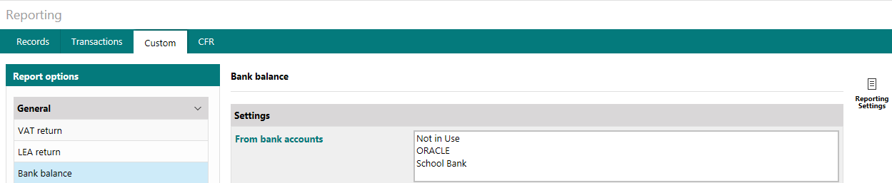

The Reporting Settings must show that the Central Fund is your ORACLE account. This is to ensure that your bank balance and unpresented transactions are carried forward into the new financial year and the ORACLE balance remains in the old year.

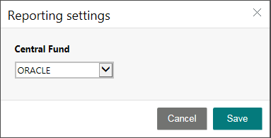

- You will see that instead of having a Period End option on your menu bar you now have

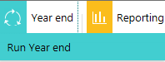
a Year end option.

- Run Year End.
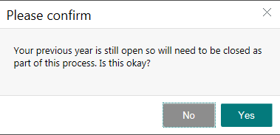

You will be asked about your Bank reconciliation and outstanding commitments. So long as you want the commitments to be carried into the new year and you have reconciled up to the end of the financial year you need to take no further action and can continue with the year end process. (Do not follow the message in the orange box suggesting you amend/process commitments or reconcile all Bank transactions).

- In the New Year check that the Bank Balance and unpresented cheques are showing on the Bank Reconciliation screen and that the Central (ORACLE) Account shows a zero on the Reconciliation screen.

Final ORACLE prints

- When the Final ORACLE Prints and final BAFS Remittance have been downloaded (Thursday 1st May 2025) go back to ‘last’ year’s data. To go back you need to select
System (on the top menu bar) – Switch the financial Year. The following codes should not be entered: 3694, 3695, 9093, 9094, 9095, 9097, 9098.

Enter the information from the ORACLE prints into the old year (your old year screens have an orange outline) being very careful to ‘pay’ the transactions from the ORACLE account and not the Bank Account.

- When you have entered information from the final print you will find you cannot reconcile your total in the ‘usual’ way. This is because the final print contains information about your bank balance, vat returns and previous years balance (these transactions should not be entered).

- Print off a Budget vs. Actual vs. Committed Report.

Reporting – Budgets - Budget vs. Actual vs. Committed Report –

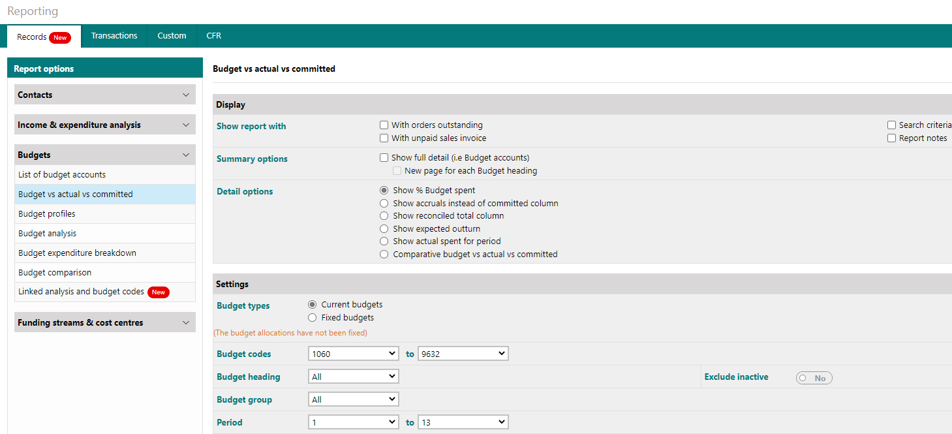

Take out the tick in with orders outstanding, with unpaid sales invoice and the ‘Show Full Detail’ box and limit the Budget codes to your first and last numeric codes.

- Check all budget codes are linked to a budget heading (and not ‘unattached’ at the top of the report).

- Check the report total agrees with the final Summary ORACLE print.

- Complete a BAFS Statement of Reconciliation– all should show the same figure. (You may need help from your FMS Support Officer at this stage) and return by Friday 23rd May 2025.

Divide your year-end balance between:

BO1 Committed Revenue Balances
BO2 Uncommitted Revenue Balances
BO3 Devolved Formula Capital Balances
BO5 Other Capital Balances
BO6 Community focused school Revenue Balances

- Produce a final Outturn Report for your Governors.

- Use the integral CFR Report (See APPENDIX 4) to send your CFR Return to the LEA

- All schools should submit their CFR data by Friday 23rd May 2025.

Appendix 1

Capital Expenditure

To begin with you need to decide which expenditure should be coded to the capital section of the budget.

Expenditure of £2,000 or more relating to the purchase or enhancement of land, buildings, roads, drives, car parks, vehicles, plant or machinery and computer hardware is capital.

(Projects can be capital even if the school isn’t using Devolved Capital Grant to pay for the work).

Just to muddy the waters some enhancements do not qualify as capital even if they cost more than £2000. Examples are given below.

Activity | Capital | Revenue
Decorating (internal & external) | No | Yes
Electrical re-wiring | No | Yes
Window Replacements | Yes | No
Re-roofing | Yes | No
Upgrade of heating system | No | Yes
Replacement of heating system | Yes | No

ICT and other purchases made from Revenue funding where a single purchases exceeds £2,000 needs to be coded against capital. You will then need to introduce an equal amount of Direct Revenue Financing.

(ICT purchases made from Devolved Capital funding should already be coded as Capital).

If a school is using Devolved Capital Grant then the expenditure is capital irrespective of the value of the invoice/s.

If you realise that invoices have been charged to Revenue when they should have been coded as Capital you can use the Internal Recharge option on Arbor Finance to move the expenditure from Revenue to Capital.

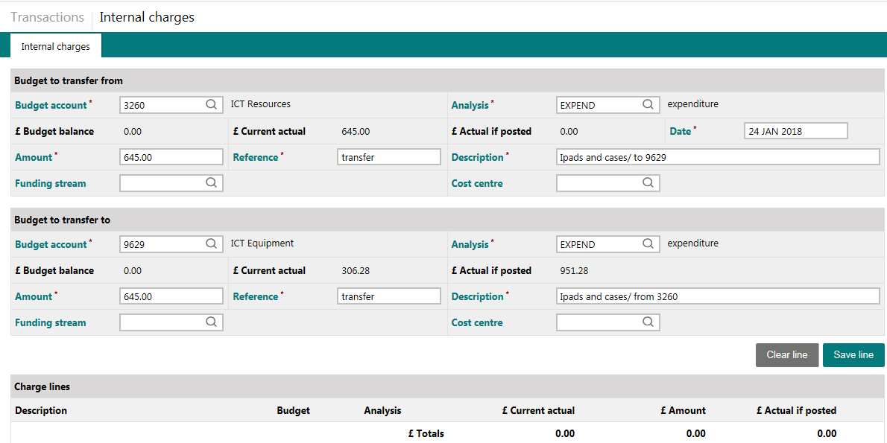

The Budget in the ‘transfer from’ in the example above is going to be ‘better off’ as we will be moving expenditure away from that account into the ‘transfer to’ account.

Save the line and then Post the transaction.

If you also need to move funding between Revenue and Capital and not just the transaction see Appendix 2

Appendix 2

Direct Revenue Financing

There may be times when you need to ‘move’ money between your Revenue Expenditure (normal school budget) and Capital Income budgets. It may be that you have a devolved capital project that needs a contribution from your revenue or you may have purchased something, which costs more than two thousand pounds and is also classified as capital.

To move money between Revenue expenditure and Capital income on Arbor Finance you need to use the Internal Charges option within Transactions.

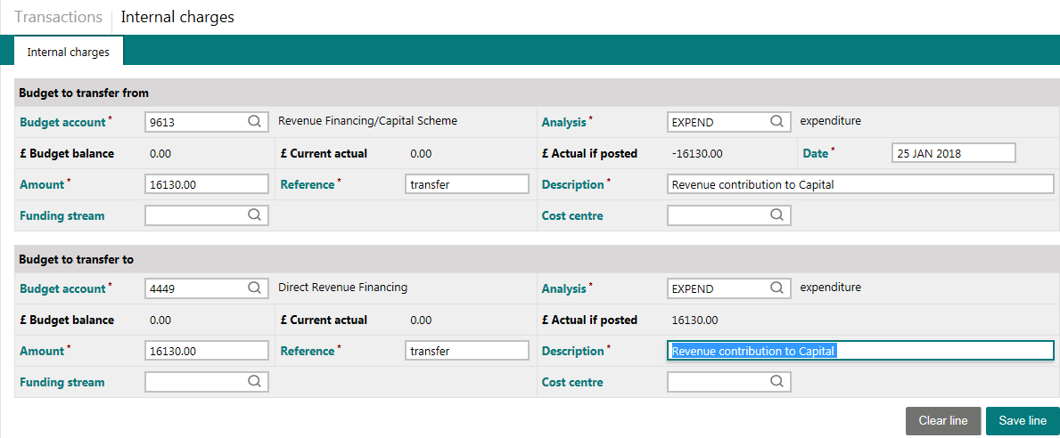

The example above shows a £16,130 contribution from the revenue expenditure budget to the capital income budget. (The transaction looks the ‘wrong way round’ because we are manipulating the Internal Charge facility to achieve our transfer of monies. The Budget to transfer from is 9613 and the Budget to transfer to is 4449).

The invoice for the goods should be charged against a Capital Expenditure code.

Appendix 3

Income Report

The Local Authority needs information about the amount of income that the school has received into the ‘local’ Bank Account (Central/ORACLE income is known).

To produce a report showing the value of ‘local Bank’ income please follow the instructions below:

- In Arbor Finance on Line go to Reporting and click on the Transactions tab. (All transactions will be already selected)
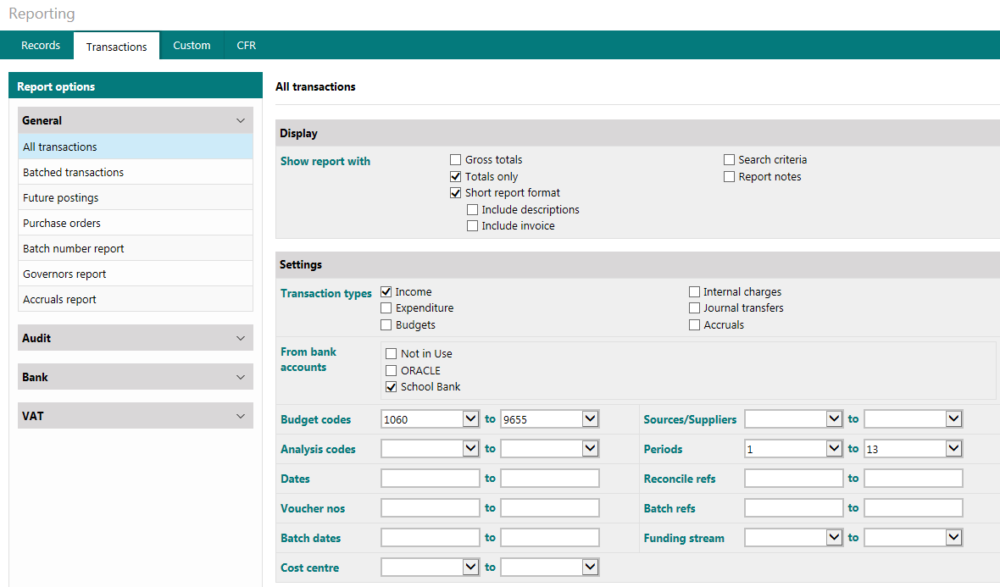

- Totals only and Short report format
- Select Transaction type Income
- Select the School Bank
- Use the drop down to select Budgets codes (first numeric to last numeric)
- Generate Report –
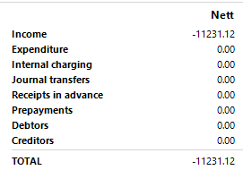
The majority of the page will be blank but there should be a total at the bottom of the sheet.

- Click on

Click on the ‘save’ icon and choose a ‘PDF
’ format.

You will then see:

Use the ‘drop down’ alongside Save to choose Save As.

Change the name of the file so all of your reports have the DfE number as the first four digits e.g. 1111 Local Income –where 1111 is the DfE number and save into your
Yearend Returns 24-25 folder
(e.g. 1111 Local Income Report)

Appendix 4 – Pease note that you may need to produce your CFR return using Chrome as in Microsoft edge it may block the file being produced.

Preparing and Producing a CFR Return
Mapping codes in preparation for submitting your CFR Return

In readiness for producing your CFR return you will need to ‘map’ your codes to the correct CFR heading within the Reporting section of the software.

- Select Reporting and then the CFR tab.
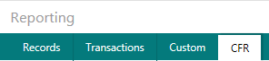

You can then complete your school details. Only federated schools that have joint budgets need to click on the federated submission and change it to yes. You also need to add in the DfE numbers of the other schools in the federation in the “LA-Establishment codes” section.
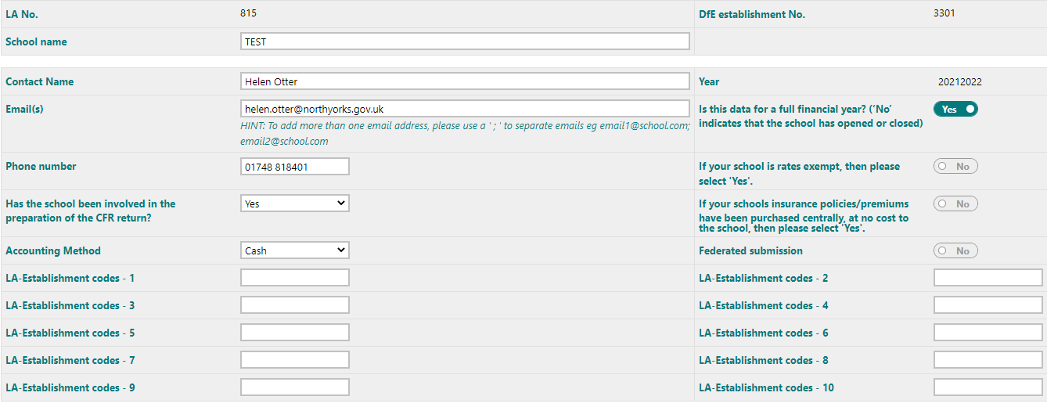
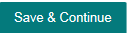
You must
If you have already mapped your budget codes you can click on the income tab and then click on load mappings and the values will appear against the different CFR codes. 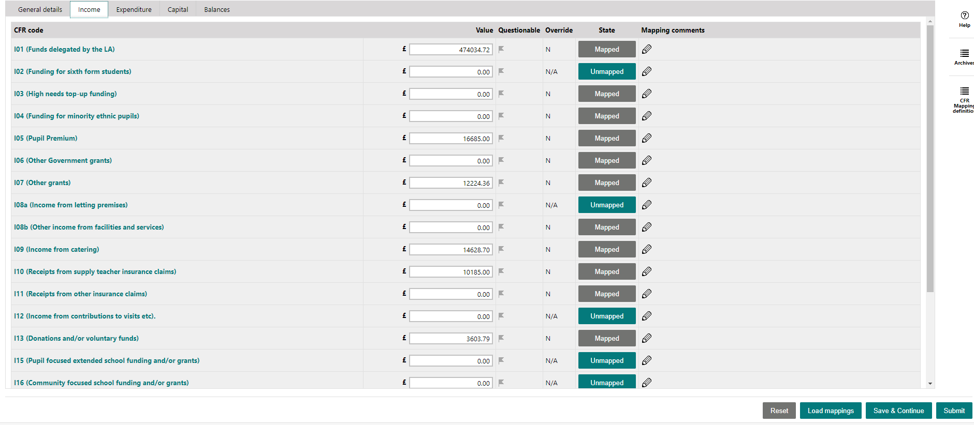

- To map different codes click on the Income tab and you will see the screen below:
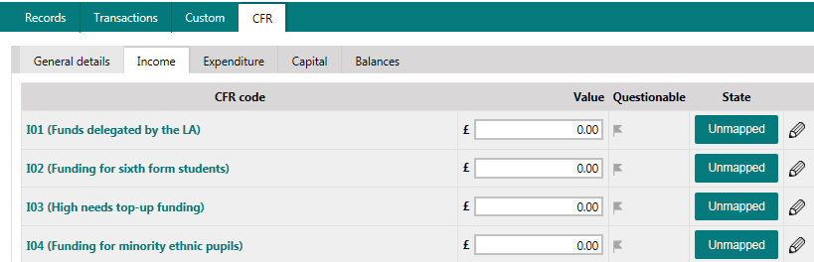

Click on the Unmapped button and select Budget Accounts in the selection type box

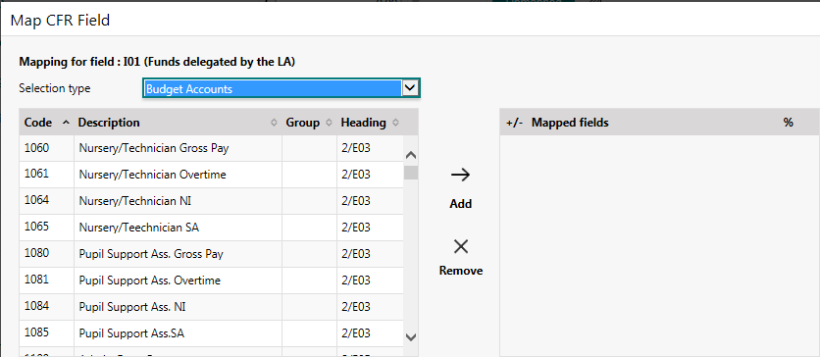

Click on the Heading – this will sort the transactions by Budget Heading which is also the correct CFR code.

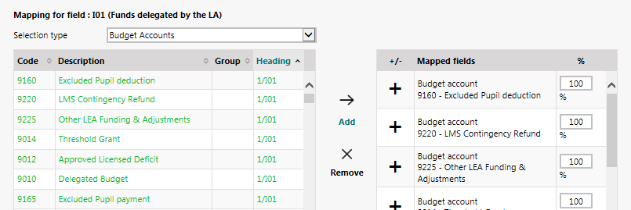

Click to highlight the budget codes which need to be mapped to the CFR Heading (1/I01in the example). You can highlight all of the transactions which have the 1/I01 Heading.

Click Add and don’t forget to Save. (The Remove button can be used to correct errors).

The Budget code will be green once it has been mapped and the CFR heading will show as ‘Mapped’.

Work through all of your Income CFR codes.
You will need to click the Heading button for each CFR code mapping.

- Click on the Expenditure tab and map the expenditure codes:

Don’t forget to change the Selection type to Budget Accounts and click on the Heading for each CFR code.

Map all of the Expenditure codes.
- Click on the Capital tab and map the capital codes

Don’t forget to change the Selection type to Budget Accounts and click on the Heading for each CFR code.

You are also asked to type in your De Minimis amount – this is £2,000 and this isn’t Mapped and you do need to click the button at the bottom of the screen to save the value.
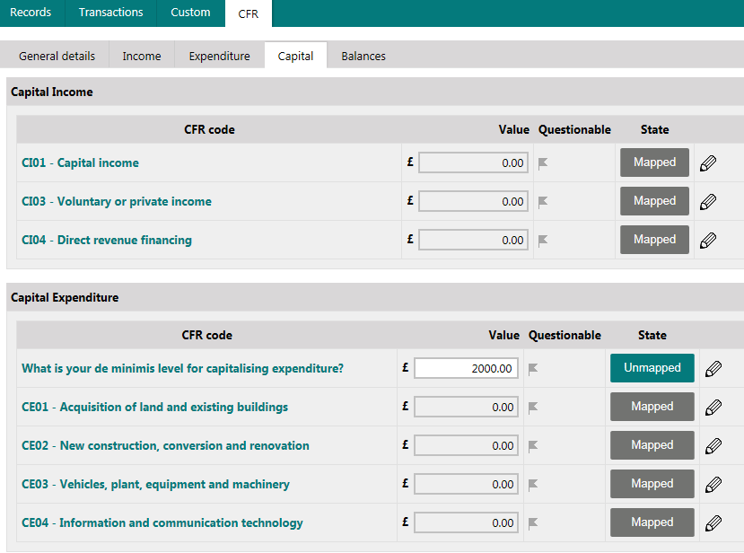

- Click on the Balances tab

Don’t forget to change the Selection type to Budget Accounts and click on the Heading for each CFR code.

You are only mapping the Opening Balances codes OB01, OB02 and OB03

OB01 = 9093 Committed Revenue Balance and 9094 Uncommitted Revenue Balance
OB02 = 9098 Community Focussed School Revenue Balance
OB03 = 9095 Devolved Formula Capital Balance and 9097 Other Capital Balance ***** ***** Please see below if you have a deficit balance *****
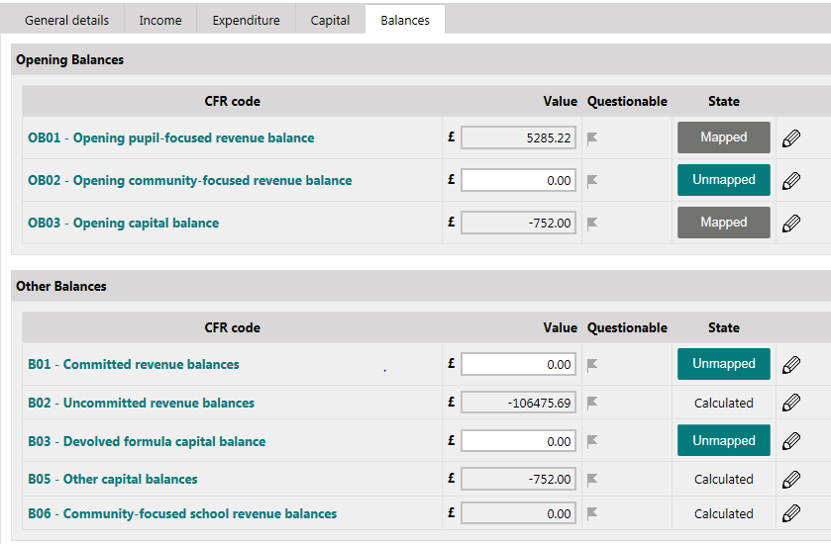

When you complete your CFR Return you will divide your closing Revenue balance between BO1 and BO2 and your Capital balance between BO3 and BO5.

***** If you have a deficit on any of your balance codes you will need to use the +/- to change the default from a plus to a minus to identify a deficit balance.*****

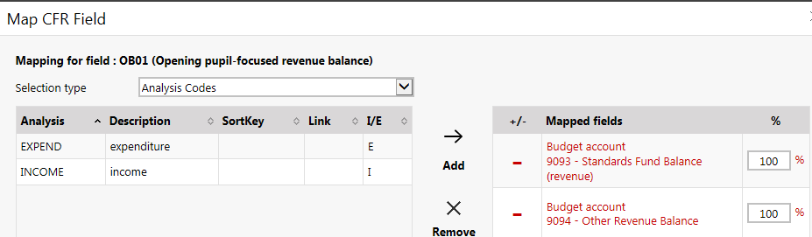

Producing your CFR Return

- Begin by checking all of your Budget codes are mapped (see pages 1-4). To check select Reports and the CFR tab and then the Income tab.
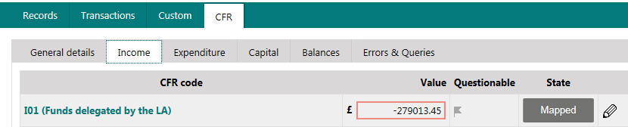

Click on the Mapped button, and then click on the Budget Accounts option

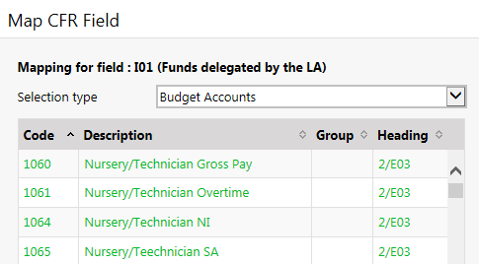

Check that all of your numeric budget codes are ‘green’ – you do not need to map ‘alpha’ codes like VATSUM, REMIT etc. Use the scroll bar to check all of your codes.

If a code is Red it means it has been mapped more than once. If this has happened begin by checking the code has been mapped against the correct Heading and then work your way through all of the other mapped budget headings until you find the rogue entry.
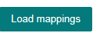
- Click on the button. You will see the following message

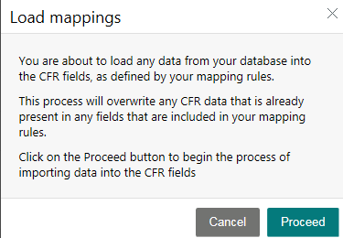
Click the Proceed button.

- Check that your General Details are complete, if not enter information and Save and Continue.

- Click on the Balances tab and check the Opening Balances.

- Divide your Closing Balances between:

BO1 and BO2 – when you enter a value into BO1 it will be deducted from BO2. (The codes do not need to be mapped)

BO3 and BO5 - when you enter a value into BO3 it will be deducted from BO5. It is essential that you are reflecting your correct Devolved Formula capital balance.

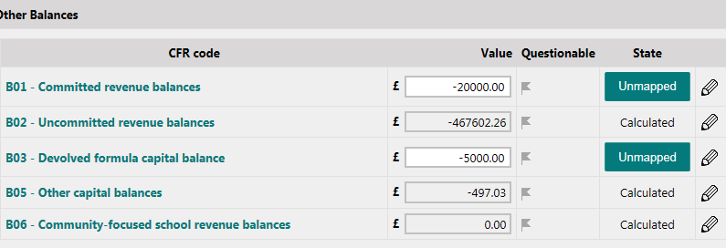

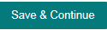
You must to save ‘the split’ of your balances.

- Click the Submit button

- You will see a message informing you whether you have any Errors and Queries- do not proceed until these have been corrected.

You will now have an additional ‘tab’ for Errors and Queries

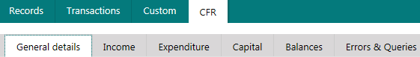

- You can use the ‘View’ button to see why there is an Error or Query and there is also a box to enter explanations.

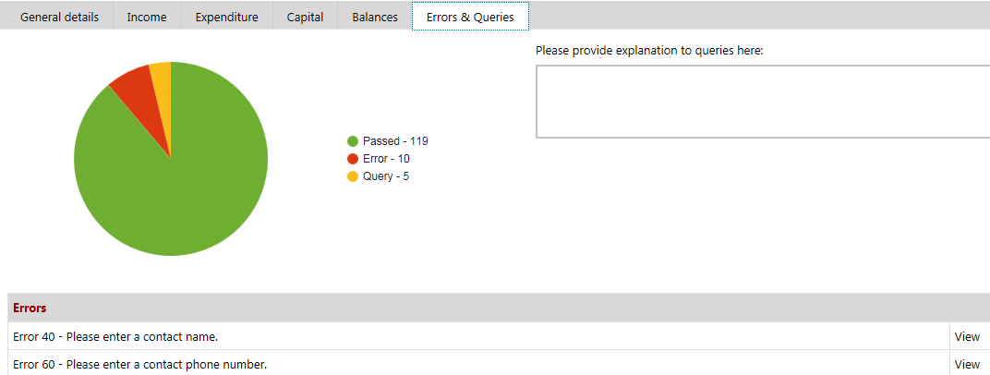

Don’t forget to when you have added your comments etc.

- You will now be able to

- When you see the screen below you are able to print off a copy of your CFR return for you to check and to keep for your records

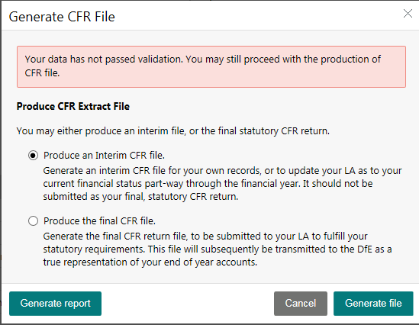

Generate report - print off and check. When you are satisfied move the dot to ‘Produce the final CFR file’ and Generate file

At the bottom of your screen you will see:

Use the ‘drop down’ by the Save button to see Save As

You need to save the file with its given name into the folder on computer drive and then attach it to an email to schoolsfinanceteam@northyorks.gov.uk

Appendix 5

School Fund Closedown using Arbor Finance on Line

IMPORTANT INFORMATION

The Year End procedures on Arbor Finance on Line enable schools to automatically carry forward their Bank balance and any unpresented cheques or income. This means that certain procedures must be followed at the end of the School Fund Year.

Please decide which of the Options below best suit your needs and then follow the instructions for that option.

The example of a set of accounts for a School Fund (applies to both options) is on Page 29

Option 1 - choose Option 1 if you wish to automatically carry forward the balance on your Bank Account(s) and any unpresented cheques and you do not want balances on any individual accounts i.e. you start the new year with a ‘clean sheet’. (Page 24-25)

Option 2 - choose Option 2 if you wish to automatically carry forward the balance on your Bank Account(s) and any unpresented cheques and you then want to enter balances on some or all of your individual accounts. (Page 26-28)

Option 1

- Check the Bank Details setting:

Reporting - Custom – Reporting Settings

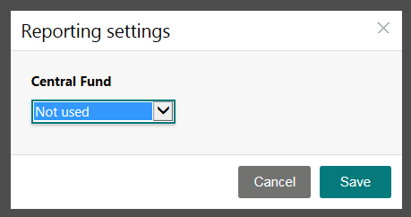

In the example above my ‘spare’ bank account is called ‘Not Used’ yours could be called Central Fund/ORACLE/Year End or some other name. The important factor is that there are no transactions against the account.

One account must be marked as staying behind in the ‘old’ year.

Balances on all of the other Bank Accounts will be carried forward.

Balances and unpresented cheques on the unmarked accounts will be carried forward into the new year.

- Print a Bank Reconciliation Statement for all of your Bank Accounts.

Reporting, Custom, Bank Balance and select Bank Account.

Repeat for each of the Bank Accounts/Petty Cash options which have been used during the financial year.

Print off a list of your unpresented cheques.

Transactions, Bank Processing, choose Bank Account, click on printer icon

- Budget Reports

Generate and then Print off a Budget Analysis report (there will be at least one sheet for each of your budget accounts).

Reporting - Budget Analysis, Time Period: Period to Date

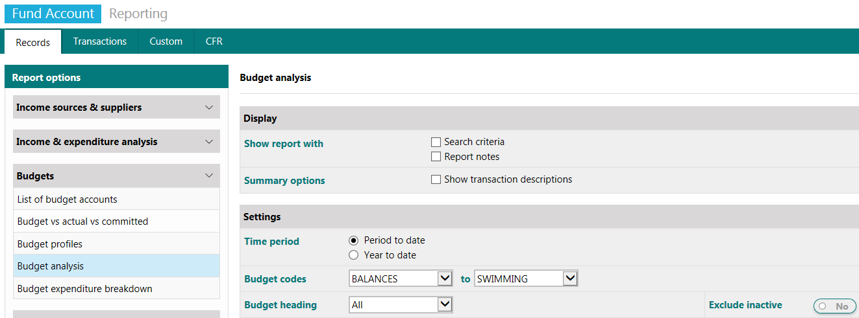

You will need these reports to prepare your end of year statement.

- Period End

Run several Period Ends until you are told you are about to enter a new year. Run the year end.

In the New Year Data File

- All of your Budget Accounts have been taken forward. Decide whether you want to remove some redundant accounts. To remove budget accounts:

Records – Budget Records - Budget Accounts - then find and delete as appropriate.

- Bank Reconciliation

Check each of your accounts show the same figures as they did in the old year.

- Run a Period End

When you are happy that the bank balances are correct and reconciled you should run a Period End (now in Period 2). There is no need to run another period end until you reach the end of your accounting year.

Complete the Year End Accounts – see example on Page 29

Option 2

- Check the Bank Details setting :

Reporting - Custom – Reporting Settings

In the example above my ‘spare’ bank account is called ‘Not Used’ yours could be called Central Fund/ORACLE/Year End or some other name. The important factor is that there are no transactions against the account.

One account must be marked as staying behind in the ‘old’ year.

Balances on all of the other Bank Accounts will be carried forward.

Balances and unpresented cheques on the unmarked accounts will be carried forward into the new year.

- Print a Bank Reconciliation Statement for all of your Bank Accounts.

Reporting, Custom, Bank Balance and select Bank Account.

Repeat for each of the Bank Accounts/Petty Cash options which have been used during the financial year.

Print off a list of your unpresented cheques.

Transactions, Bank Processing, choose Bank Account, click on printer icon

- Budget Reports

Generate and then Print off a Budget Analysis report (there will be at least one sheet for each of your budget accounts).

Reporting - Budget Analysis, Time Period: Period to Date

You will need these reports to prepare your end of year statement.

- Period End

Run several Period Ends until you are told you are about to enter a new year. Run the year end.

In the New Year Data File

- All of your Budget Accounts have been taken forward. Decide whether you want to remove some redundant accounts. To remove budget accounts:

Records – Budget Records - Budget Accounts - then find and delete as appropriate.

- Bank Reconciliation -Check each of your accounts show the same figures as they did in the old year.

- Entering Balances

All of your moneys and unpresented cheques (possibly on multiple accounts and petty cash) have been carried forward but there are no amounts showing against individual accounts.

If necessary set up a new Budget Account called Balances – you may already have one from previous year end procedures.Records - Budget Account - New and set up an account called Balances (you do not need a Budget Heading).

From the list of balances you printed out in the old year (step 3) you will see you have some positive and some negative balances.

Positive Balances

Use Internal Charges to transfer moneys between the Budget code where you want a positive balance and the Balances Account. (As this isn’t the primary function of Internal Charge follow the pictures)!!!!

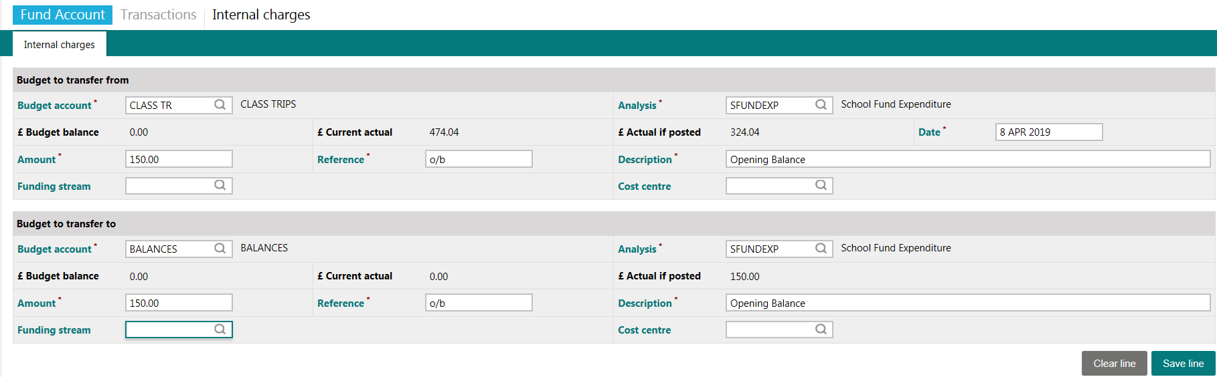

Negative Balances

Use Internal Charges to transfer moneys between the Balances code and the Budget code where you want a negative balance.

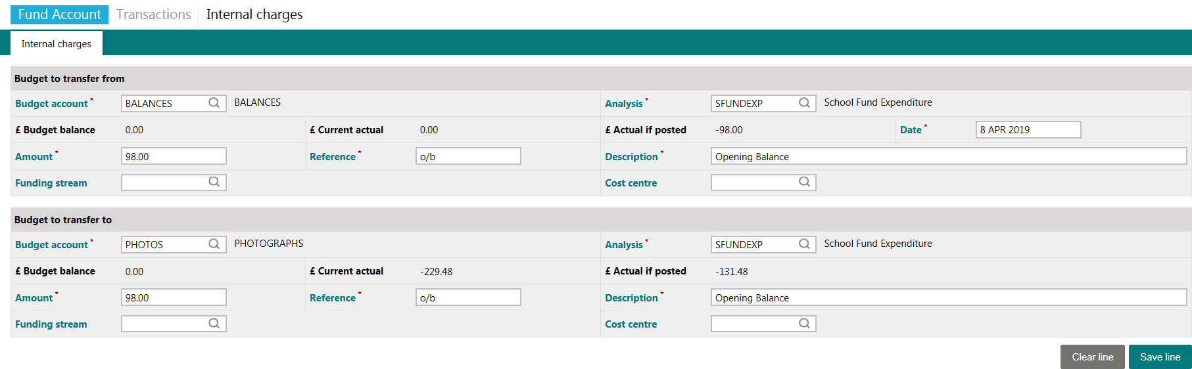

- Check the Balances
Make sure the value showing against the Balances account is the same as the total of the individual balances. Check that you have the correct balances against each account.
Reporting -Records – Budgets -List of Budget Accounts.

- Run a Period End
When you are happy that the individual account balances are correct you should run a Period End. There is no need to run another period end until you reach the end of your accounting year.

Complete the Year End Accounts – see example on Page 29

Example of a completed Receipts and Payments document
Take this information from the individual sheets that you have printed off in the old year.
Receipts Payments

Baking 65.50 5.36
Car Boot Sale 985.58
Football Club 555.55
Paris Trip 20.45
Minibus Running Costs 25.60
Skiing Trip 850.00 1028.64
Zoo Trip 369.75 500.00
------------- -------------
2826.38 1580.05
This could be a positive or negative figure and represents the value of the transactions processed during the year. The same figure appears on the bottom of the BUDVACCVCOMM report taken off RM Finance on Line
Excess of Receipts
over Payments 1246.33

------------- ---------------
2826.38 2826.38
======== =========

Balance Sheet
School Fund as at ..... Current 1154.50
( start of school fund year) less unpresented 150.00

1004.50
Deposit 7000.00
----------
8004.50
From above
Excess of Receipts over Payments 1246.33
-----------
9250.83
------------
Represented by :
Current A/C 2557.84
Bank balances as at 31 March
less unpresented cheques -970.45
plus unpresented income +621.05
----------
2208.44

Deposit A/C 7000.00
Petty Cash 42.39
-------------
9250.83
------

