Fixed Term Contract Guidance for Schools and Academies

Publication Date: September 2019

Section | Cccc cCghgj Contents | Page
1 | Introduction | 1
2 | When to use Fixed Term Contracts | 1-2
3 | Terminating Fixed Term Contracts | 2
4 | Flowchart for Fixed Term Contracts Approaching End Date | 2-3
5 | Frequently Asked Questions | 3-4
6 | Template Letters | 5-8

Guidance produced for Schools and Colleges under Local Management of Schools, together with Early Years providers and Academy Trusts under the HR service provision of North Yorkshire County Council.

Access: If you require this information in an alternative format, such as large type, audio cassette or Braille, please contact NYHR.

- Introduction

1.1 This guidance sets out relevant information relating to the use of fixed term contracts. It explains when to use fixed term contracts in schools and academies, the considerations in bringing fixed term contracts to an end and the relevant steps to take.

1.2 This guidance applies to all school based employees (teaching and support staff) under the Local Management of Schools arrangement and in Academy Trusts.

- When to use Fixed Term Contracts

2.1 Fixed term contracts can provide flexibility for employers. However, it is a common misconception that these contracts can be simply ended as a matter of course; the termination of a fixed term contract is still a dismissal in law and legislative changes made back in 2002 mean that employers need to carefully consider how they manage fixed term contracts.

2.2 There are certain scenarios when a fixed term contract might be appropriate. Examples of this include:

- A contract covering a permanent employee’s sickness, sabbatical or maternity leave which will terminate on the permanent employee returning to work.
- A contract linked to a specific funding stream, which is used to pay for the employee’s salary, where the contract will terminate on the expiry of the funding stream. (Note this is different to the situation where budgets are not predictable.)
- A contract due to expire on the completion of a particular task or project.
- A short-term seasonal contract designed to provide for additional demand or workload.

2.3 Fixed term contracts should not be used to offer employment on a trial basis. Any concerns relating to attendance, conduct or performance should be addressed through the relevant policy. If the basis for the contract being fixed term is flawed, it may make it difficult to dismiss the employee fairly. If you are unsure about whether a fixed term contract is suitable for a vacancy, you should consult your HR Advisor.

2.4 Employees on fixed term contracts accrue continuous service. This has implications for their employment rights after two years, such as the right to redundancy payments. Employees on fixed term contracts for four or more years may automatically become an established employee. You may also need to consider continuous service from previous NYCC posts or other posts within the Trust in the case of academies. See Continuous Service Guidance for Schools and Academies for further information.

2.5 An application for funding of redundancy costs on the expiry of a fixed term contract can be submitted using Appendix B of the Reorganisation, Redundancy and Redeployment Policy (Locally Maintained Schools only). Your HR Advisor can support with this.

- Terminating Fixed Term Contracts

3.1 Employers should take reasonable steps to ensure that fixed term contracts can be ended fairly. Consideration needs to be given as to whether the work will continue beyond the projected end date. If the work is still available and the fixed term contract is ended, the employee may be able to make a claim for unfair dismissal. This may also be the case if the termination constitutes a redundancy situation and qualifying criteria are met but a redundancy payment is not made.

3.2 The following should be taken into consideration before ending fixed term contracts:

- What was the basis for the contract being fixed term and is the projected end date still relevant to this reason?
- If the projected end date does not coincide with the reason for the work ending, could the contract be extended?
- Is there similar work available at the end of the fixed term contract that could warrant renewal of the contract or offer of redeployment?
- Does the employee have the qualifying continuous service to be considered for redundancy or to be considered as having established (permanent) status?

3.3 If the fixed term contract needs to be ended before the projected end date, HR advice should always be sought.

3.4 There are three key steps to follow when ending fixed term contracts:

- Meet the employee to discuss their fixed term contract coming to an end. This discussion should include whether there an extension is likely and if there are any other suitable posts (For Academies this should in include posts at other establishments within the Trust). It is advised that this meeting takes place at the start of the term that the fixed term contract is due to end.
- Summarise the outcome of this meeting in writing, using the appropriate template letter, providing the applicable notice.
- In circumstances where the fixed term contract will be ending and the employee will not be commencing another post, the right of appeal applies. The principles of the Hearings and Appeals Procedure should be followed and the outcome of the Appeal should be given in writing.

- Flowchart for Fixed Term Contracts Approaching End Date

4.1 It is advised that the following steps are followed when fixed term contracts are approaching their end date:
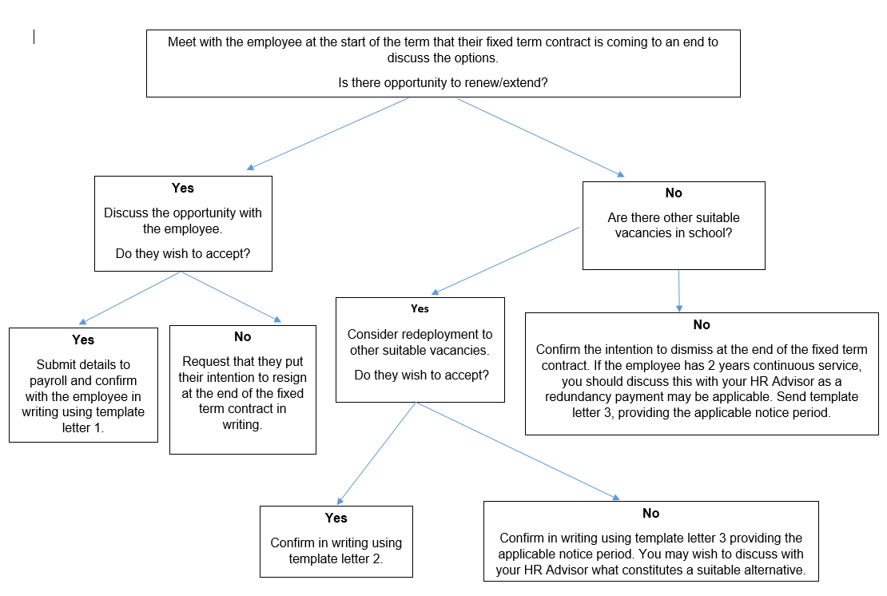
4.2 Always seek HR advice when ending the fixed term contract constitutes a redundancy.

4.3 It is not always a statutory requirement to provide a notice period where an end date has been previously agreed. However, it is good practice to observe notice periods wherever possible. Where redundancy payments apply, Local Authority redundancy notices are sent to Teachers by 31st May for 31st August dismissals (Locally Maintained Schools only). Therefore, it is advisable that you begin this process no later than the start of the summer term. If the situation changes, it may be possible to retract redundancy payments. Support staff notice is based on continuous service so less notice may be required. In any case, employees should be given written notice in line with the applicable notice period. In practice, you may need to allow additional time in order for any potential appeals to be heard in term time.

- Frequently Asked Questions

5.1 It is important to note that the particular circumstances for each case can have a bearing on the most appropriate course of action. However, these are some examples of common queries relating to fixed term contracts.

Q: I have a TA on a fixed term contract working with a specific child and that child is leaving. Can I end their contract?
A: If there is clear documentary evidence supporting the contract being linked to the child being in the school, then there should be substantial evidence to justify selecting the employee for redundancy at the end of their contract. However, if the individual can show that they have worked in another capacity in the school or there is not clear documentary evidence, you should always seek HR advice. If you need to end the contract before the fixed term end date it will also be necessary to ensure that the contract allows this and notice will be required.

Q: Can I end a fixed term contract at the end date because the employee has poor attendance?
A: It is very important to remember that there is a distinct process to deal with attendance management. If the school does not renew the FTC on the basis of the employee’s attendance, then this could give rise to a claim for unfair dismissal.

Unless there are good grounds for ending the FTC, which do not relate to attendance, there could be some risk to ending the fixed term contract.

Q: Can I employ a teacher on a fixed term contract to act as a probationary period for a year before deciding to take them on permanently?

A: Trade Unions take a firm stance that this is not acceptable. It is also not advisable, as it would not provide reasonable grounds for ending the contract. The relevant policy should be followed to address any concerns that arise during the course of employment.
Fixed Term Contract Template Letter 1 – extend/renew

[INSERT NAME]
[INSERT ADDRESS]

[INSERT DATE]

Dear [NAME],

I am pleased to confirm that I am able to extend OR renew your fixed term contract as [POST] which was due to end on [DATE].

Your contracted hours will remain the same OR Your new contracted hours will be [INSERT]. This will be on a fixed term basis until [DATE]. The reason for the post being fixed term [REMAINS UNCHANGED/IS DUE TO GIVE DETAIL E.G. MATERNITY COVER, SICKNESS COVER, EXTENDED GRANT FUNDING, WORKING WITH A NAMED PUPIL, ETC.]

Please return the completed slip below with the copy letter to confirm that you wish to accept. If you no longer wish to continue with post after the initial end date of [DATE] please let me know as soon as possible.

Yours sincerely,

Headteacher

Fixed Term Contract Template Letter 2 - Redeployment

[INSERT NAME]
[INSERT ADDRESS]

[INSERT DATE]

Dear [NAME],

As your fixed term contract as [INSERT POST] is due to end on [DATE], we have discussed suitable alternative positions within the school and I am pleased to offer you the following post:

[POST TITLE]
[SCHOOL]
[GRADE]
[CONTRACTED HOURS]

This post is offered on a fixed term basis until [DATE] OR This post is offered on a temporary basis until [DATE] OR This is an established post. [The reason for the post being FIXED TERM/TEMPORARY IS DUE TO GIVE DETAIL E.G. MATERNITY COVER, SICKNESS COVER, EXTENDED GRANT FUNDING, WORKING WITH A NAMED PUPIL, ETC.]

Please return the completed slip below with the copy letter to confirm that you wish to accept. If you no longer wish to accept the post please let me know as soon as possible.

Yours sincerely,

Headteacher

I acknowledge receipt of the letter dated [DATE].
I do*/do not* wish to accept the provisional offer of the post of [POST] with effect from [DATE].
* delete as appropriate
If you do not wish to accept this offer, please indicate the reason for this below:

I do not wish to accept this offer for the following reasons:

Name: ……………………………………….
Signed: ………………………………………
Date: …………………………………………

Fixed Term Contract Template Letter 3 – End of FTC

[INSERT NAME]
[INSERT ADDRESS]

[INSERT DATE]

Dear [NAME],

As your fixed term contract as [POST] is due to end on [DATE], we met on [DATE] to discuss your employment. I outlined the reasons why it is anticipated that your post will come to an end on [DATE] and explained that, at this time, there are no suitable alternative posts in school.

If suitable vacancies do become available during the time you are employed by the school, you will be made aware of these.

OPTIONAL PARAGRAPH - You may be entitled to a redundancy payment. This is estimated to be [insert amount].

You have the right to appeal against this decision within 10 working days of receiving this letter. You should put your reasons for appeal in writing to me. Your appeal would be heard by [INSERT NAME & POST]

Yours sincerely,

Headteacher

