OH PORTAL

TOP TIPS FOR USING THE OH PORTAL

Using the Portal
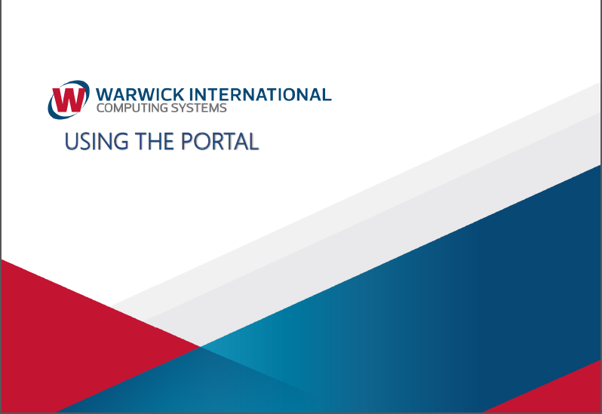 | Warwick International has produced an easy to follow step by step user guide for using the portal.  You should also refer to the guide “Sign up now” for first registration.
Creating a New Form
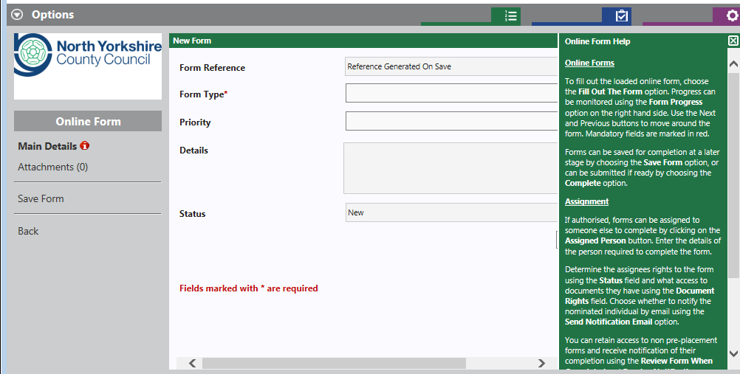 | Removing “Online Form Help” will make your screen view larger.
To bring back the online screen help click “Help”.

The two form types to use are Management Referral; or
Review Referral.

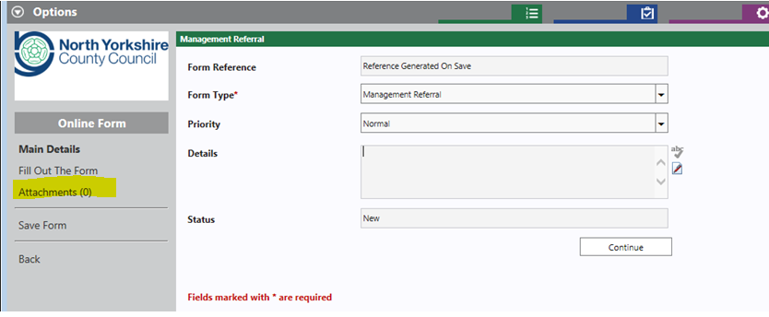 | Please ignore the “Details” box; it is a standard feature unnecessary for our needs and is therefore greyed out.  Once in a form there is a useful “Attachments” feature to enable you to attach relevant documents.
Attaching a relevant document
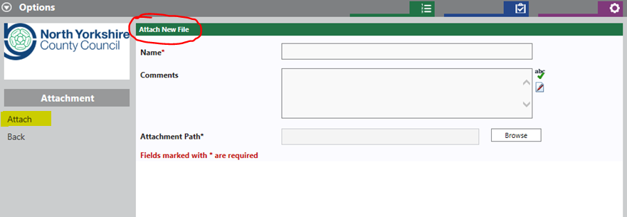 | Click on “Attach” to bring up the “Attach New File” option give the document a name add any relevant remarks in the comments box and browse for the file you want to attach with the referral.
Details of Referral
Question 16 asks for details of the “Employee Key Tasks & Duties” which is a free text box.
Please attach the job description and keep these notes brief and relevant to the key work related tasks to be highlighted for OH.
Absence details
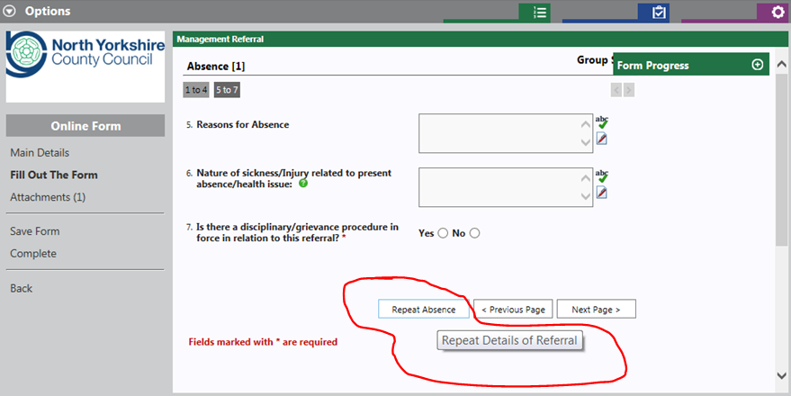 | There is a feature to enable you to add previous absence history by adding a “Repeat Absence”.  Alternatively, please attach a separate document detailing the relevant absence history.  NB absence history is helpful for the OHA
Form status
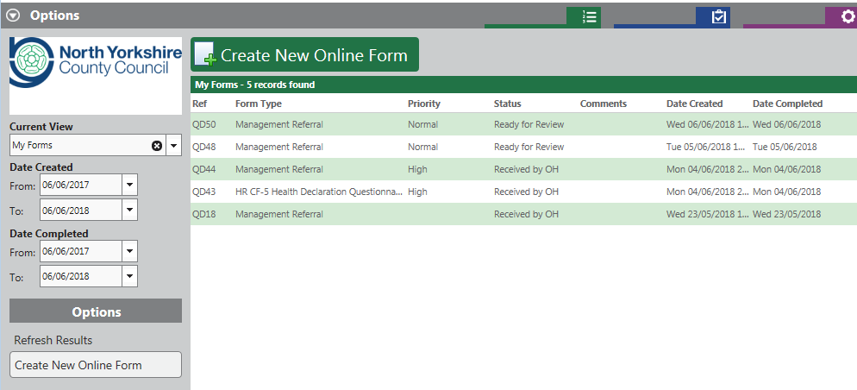 | Once you have completed the form you will see the status read “Ready for Review”.  This means that the referral is in the OH document queue.  Once the referral has been assessed at triage stage the status will change to read “Received by OH”.

Viewing a completed referral form
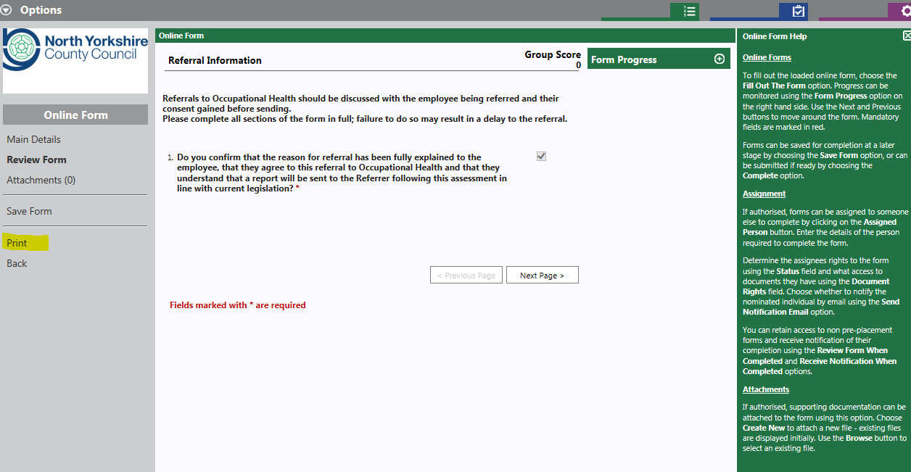 | The form can be viewed page by page of by clicking on “print” the view changes to a page by page “online print record”
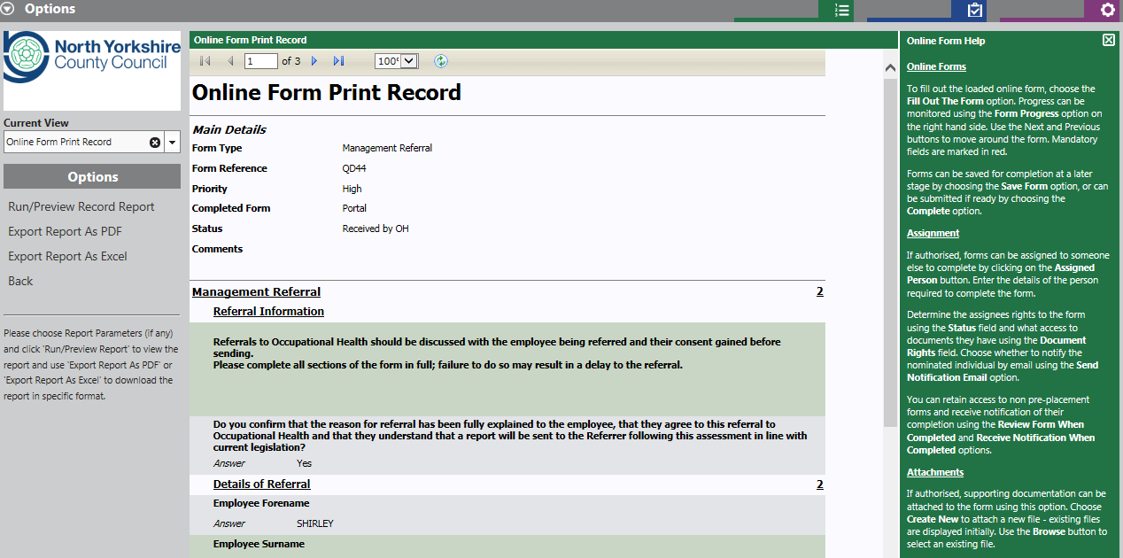 | From this screen it is also possible to export the referral form to PDF or Excel format.  NB due to data protection; it is inadvisable to permanently save this form in another location.
Viewing the OH Management Referral Report
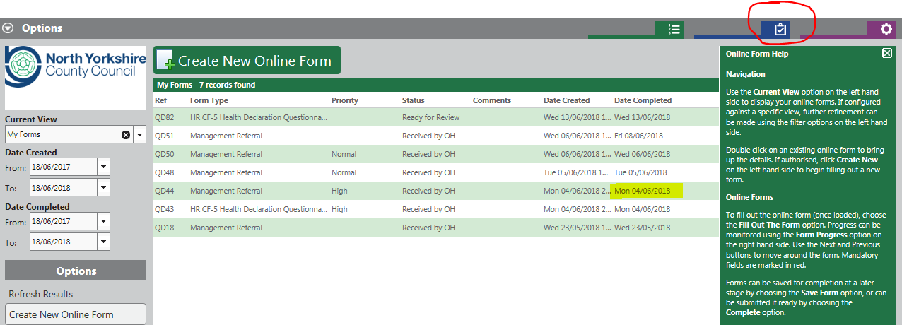 | You will receive an email from OH informing you that the management advice report is ready to review.  It is helpful to have to hand the date of when you made the referral to conduct the search.
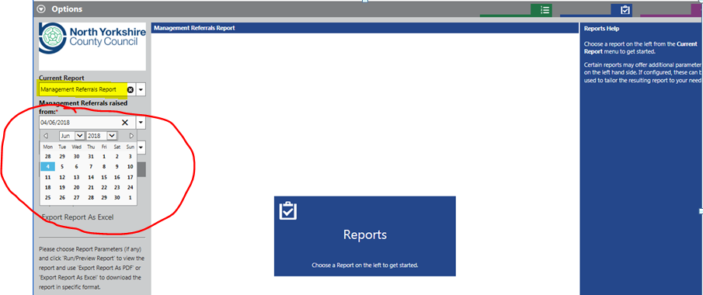 | Select Management Referral Report from the drop down list and enter date that the referral was made using the calendar.

Viewing the OH Management Referral Report
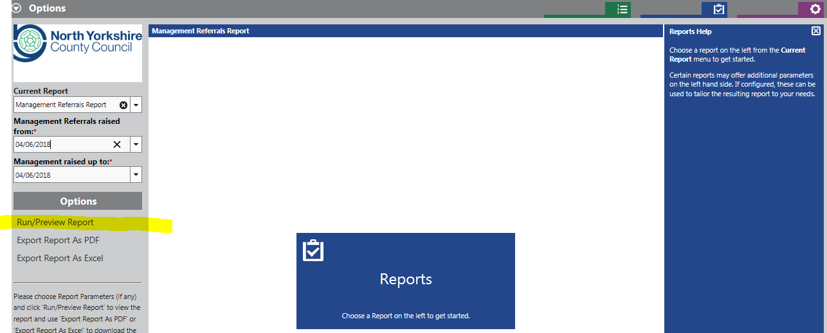 | Once dates are selected Run/Preview Report
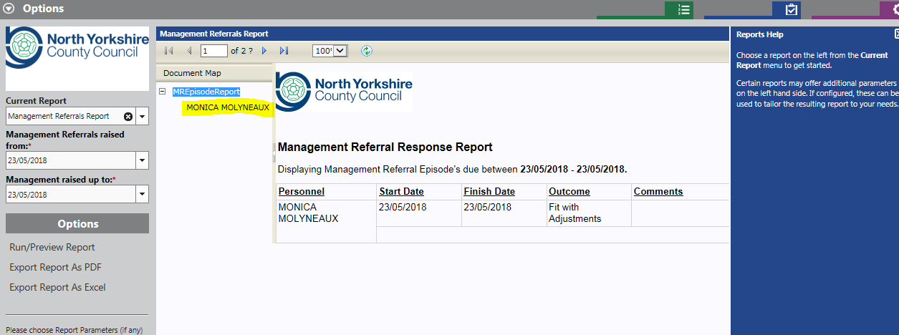 | This then shows the employee referred on the selected date; the referral report can be viewed online by selecting the employee name as highlighted or downloaded as a PDF file; or Excel file (not recommended).
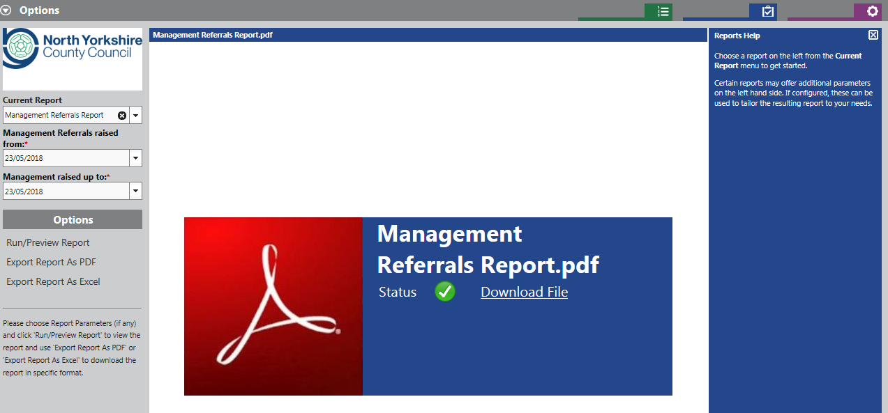 | NB due to data protection; it is inadvisable to permanently save this report in another location.

