OH PORTAL
Accessing the Management Referral Report

Accessing the Management Referral Report

After connecting to the Portal select the Reports tab at the top of right hand side your screen.
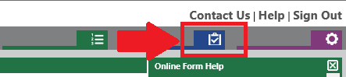
On the left hand side you will now be able to select “Management Referral Report” from the Current Report drop down list.
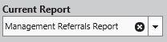
Use the Management Referral raised from and Management Referral raised up to fields to select the date range you wish to look at and then click the Run/Preview Report button.
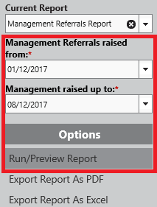
The report will display a grid showing all of your Management Referrals that fall within the date range you selected.
Selecting the Employee name on the left hand side will display the response that Occupational Health have made in relation to this case.
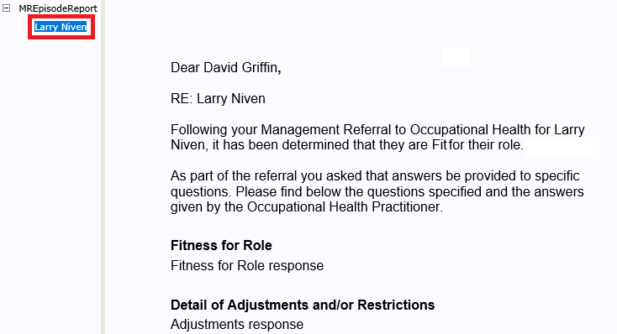
If you would like to print a copy of this response, select the Export Report as PDF button on from the left hand side.
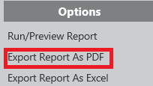
You will see a message on the main section of the screen, select Download File.
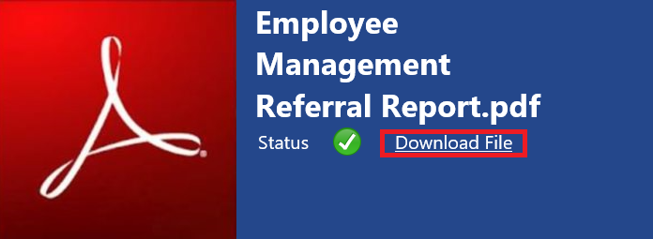
Once the report is opened in PDF format select the Bookmarks option on the left hand side. This will expand a panel where you can select the correctly named response.
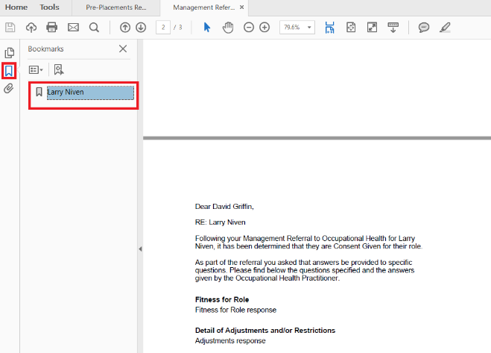
If you now select the Print option you can choose to print the current page.
