DBS POLICY
Staff, volunteers and NYCC contracted workers in the education and health and social care sectors work with vulnerable members of society. The law requires that appropriate checks are carried out to ensure that people who pose a threat to service users or staff are not given positions of trust where they could exploit children or vulnerable groups entrusted to their care.
This document outlines NYCC’s policy and guidance which may, at times go beyond the statutory minimum requirements. Our approach reflects part of our ongoing commitment to safeguarding children and vulnerable groups which includes, but is not limited to, ensuring that people who work with vulnerable groups are suitable.
As an employer the Council has a legal duty to not knowingly employ a barred person in ‘regulated activity’ (new definition) either in a paid or voluntary capacity. This includes contractors providing services to NYCC which involve working in regulated activity.
The policy should be read in conjunction with the Recruitment and Selection Policy and Procedure.

Definitions

Regulated activity – new definition from September 2012
Following a review in 2011 of the criminal records regime, the government scaled back regulated activity to more proportionate levels and now focuses on work which involves close and unsupervised contact with vulnerable groups and children. This has resulted in a reduced number of posts that meet the new definition and are eligible. Posts that meet their new definition are eligible for an enhanced DBS check plus a barred list check for the appropriate sector (children/ adults or both). Posts that do not meet the new definition but that met the old definition can still be checked, however these posts are eligible for an enhanced check ONLY – without the barred list check, (see 4.1.2 for detail). These changes are included in the Protection of Freedoms Act 2012. The new definitions of regulated activity are detailed below:

Relating to children:
- Unsupervised activities: teach, train, instruct, care for, or supervise children, or provide advice/guidance on well-being, or drive a vehicle only for children.
- Work for a limited range of establishments (‘specified places’) with opportunity for contact with children: for example schools, nurseries, pupil referral units, children’s centres, children’s homes, childcare premises. This definition does not include work by supervised volunteers. Further guidance regarding supervision is available in the Department for Education’s guidance on supervision
- Relevant personal care, for example washing or dressing or health care by or supervised by a professional.
- Registered childminding and or foster carers.
Note: Work under (1) or (2) is regulated activity only if done ‘regularly’ Please note – regularity no longer needs to take place at the same establishment and can take place at a number of different regulated establishments,( once a week or more often, or on 4 or more days in a 30 day period, or overnight).
School Governors are required to have a DBS check (without a barred list check) as detailed School Governance (Constitution and Federations) (England) (Amendment) Regulations 2016

Relating to adults
There are six categories of people who will fall within the new definition of regulated activity and this includes anyone who provides day to day management of supervision of those people.
A broad outline is set out below.
- Healthcare:
A regulated healthcare professional or an individual acting under the direction or supervision of one, e.g. doctors, nurses. Healthcare includes all forms of healthcare, whether relating to physical or mental health or palliative care.
- Personal care:
Assistance with washing and dressing, eating, drinking and toileting, oral care or care of the skin, hair or nails because of an adult’s age, illness or disability or teaching someone to do these tasks. This does not include physical assistance provided to an adult in relation to cutting their hair. This is not classed as regulated activity.
- Social work:
Provided by a social care worker and is required in connection with any health care or social services to an adult who is a client or potential client. Including assessing and reviewing the need for health and social care services.
- Assistance with general household matters:
Any person who provides day to day assistance to an adult because of their age, illness or disability and includes at least one of the following – managing a person’s cash, paying bills, or shopping on their behalf.
- Assistance with the conduct of an adult’s own affairs:
Anyone who provides various forms of assistance in the conduct of an adults own affairs. E.g. lasting or enduring power of attorney; or appointment as adults’ ‘deputy’ under the Mental Capacity Act 2005.
- Conveying:
Conveying adults for reasons of age, illness or disability to, from or between their place of residence and a place where they have or will be receiving healthcare, personal care or social work.
Note: Regulated activity for adults excludes any activity carried out in the course of family relationships, and personal, non-commercial relationships and does not have a frequency requirement.

Regulated activity – old definition prior to September 2012
Certain posts in schools do not meet the new definition of regulated activity but are still eligible for Enhanced only DBS checks under the old definition. Full details of this are available in appendix 7.

Levels of check
Enhanced DBS Checks contain all spent and unspent convictions, cautions and reprimands from the Police National Computer as well as relevant Police information held locally. Further information is available here.

Volunteer
The DBS definition of a volunteer is someone who spends unpaid time doing something which aims to benefit someone other than themselves. Therefore roles such as a student undertaking work experience, or a person attending school to gain experience with children with a view to completing a teaching course, or foster carers/foster carer support and babysitters are not volunteers for DBS purposes.

Rehabilitation of Offenders Act
The Rehabilitation of Offenders Act (ROA) 1974 is aimed to help people who have been convicted of a criminal offence and who haven’t re-offended since. From 10th March 2014, the rehabilitation periods after which criminal convictions become spent has reduced in England and Wales. (The Rules for Scotland are different and should be considered separately). Sections 139 and 141 and schedule 25 of the Legal Aid, Sentencing and Punishment of Offenders Act 2012 amends the Rehabilitation of Offenders Act 1974. The amendment extends the scope of the ROA so that custodial sentences of up to and including 4 years in length can become spent. The times at which convictions become spent are also amended, and in most cases the rehabilitation periods are reduced. Full details of Rehabilitation periods are available in Appendix 5.
The Department for Education guidance Keeping Children Safe in Education July 2015 provides specific guidance for schools and colleges. In particular there are changes to the requirements to DBS check contractors working in regulated establishments. Full guidance is available for in the School Contractor Guidance.

Policy
- Who should be checked?
Regulated activity is an exemption to the rule listed in the Exceptions Order to the Rehabilitation of Offenders Act, relating to work with children or other vulnerable groups. All positions listed on the Exceptions Order require a DBS check and applicants must declare both spent and unspent convictions. The exemption is applied by the employer requiring an individual who is over 16 to complete a DBS application and our policy on who should be checked is:
Non schools | Schools
Enhanced DBS Check + Barred List Check to be undertaken only on posts which meet the NEW definition of Regulated activity (Sept 12).  The only exception to this is for a limited, pre-agreed, number of senior and specialist safeguarding related positions, where an enhanced check without barred list check will be required.  There is no entitlement to include a Barred List Check when a post does not meet the NEW definition of Regulated activity. | Enhanced DBS Check + Barred List Check to be undertaken on posts which meet the NEW definition of Regulated Activity (Sept 12)  Enhanced DBS Check only (no barred list) to be undertaken on posts which do not meet the NEW definition but do meet the old definition.(See appendix 7) and school gevernors
In order to determine whether or not a post meets the definition of Regulated Activity, managers and Headteachers must consider the full definition which can be found above in the definitions section. Some case study examples are provided in section 7. Flow charts are provided in section 6 but must be read in conjunction with the full definitions.
Where a check is required, the employee must not commence in post until the appropriate clearance has been received.
- Checking volunteers
- Volunteers who are carrying out unsupervised regulated activity are required to undertake an enhanced DBS check + barred list check.
- Volunteers who are supervised regularly and at a reasonable level are only eligible for an enhanced DBS check which does not include a barred list check. This is because they are not deemed to be working in regulated activity as they are supervised.
- Governors are required to have an enhanced DBS check (without barred list check), if Governors undertake volunteering activity in addition to the governor duties, they should be treated like any other volunteer and it may be necessary to have an enhanced DBS including barred list check.
- Important note – in the event that a volunteer check is requested for a situation that does meet the definition of volunteering as defined by DBS, this may be viewed as fraudulent activity and NYCC could face severe consequences, loss of registered body status and counter-signatories could face prosecution. (See Section Volunteer)
- Re-checks
- NYCC will administer random rechecks across all posts eligible for DBS clearance, including schools.
- There will be a limited number of exclusions to the random re-check policy, namely contractors employed by Integrated Passenger Transport who convey children to school; Residential Fostering and Adoption; Residential Children’s Social Care, all of which will be subject to a re-check policy of every 5 years.
- Schools will have the discretion to:
- request more frequent re-checks at school level, where a risk is considered to be higher, for example in residential schools
- opt out of the re-check element of this policy
Any decision to exercise this discretion will need to be made following full Governing Body consideration. A record of the decision and the rationale, will need to be submitted to NYHR (NYHR@northyorks.gov.uk). In either instance, schools will be responsible for monitoring their own rechecks as NYCC will exclude those schools from the standard random recheck process.

Verifying documents
Under all circumstances managers must verify documents on a face to face basis using original evidence. Only documents included on the DBS identity check guidance provided by the Home Office can be accepted.

Portability
- It is NYCC Policy that DBS checks are not portable (transferrable) from other employers. All workers joining NYCC must undertake a new DBS check to ensure that they are suitable for the role prior to commencement.
- Volunteers who take up paid employment must undertake a new DBS check, as the level of responsibility is expected to be greater than that of a volunteer, and the DBS check may include additional information.
- Existing members of staff will be required to undertake a new check if their new role has greater access or responsibility for children or vulnerable groups than that previously held, or where they move from one sector to another and the appropriate barred list needs to be checked.
- DBS checks are specific to the post for which they are applying /completing: different information may be disclosed depending upon the relevance to the role applied for therefore are often not transferable when moving from one NYCC post to another NYCC post. Always seek advice from the Resourcing and Reward team, contact details are contained in section 7.
- DBS clearances are transferable between NYCC schools only, subject to 4. NYCC would not accept a DBS clearance from a non maintained school, unless the school had used the NYCC DBS checking service and the check was clear, less than 3 months old and for the same type and level of role.

Breaks in service
A new DBS check must be completed when a break in service of 3 months or more occurs. This is standard policy for all NYCC and school staff, including casual and relief staff and also any contractor working on behalf of NYCC in regulated activity.
As the Fostering and Adoption process can take up to 8 months to complete; provided there is evidence that the fostering and adoption application is progressing then the three month DBS expiry rule will not apply and instead be extended to 8 months. In the event that a fostering or adoption application process stops, and there is a gap of 3 months or more then at the point the process commences, there will be a requirement to gain a new DBS check.

Declarations of convictions during employment with NYCC
- All non-school employees are required to comply with the declaration of offences policy and declare to their line manager any convictions that occur during their employment. This policy is now incorporated in to the Standards of Conduct Procedure which is available here.
- It is strongly recommended that schools adopt this policy, available on cyps.info and communicate it to their staff.

DBS process
- Process overview
- It is illegal to submit a DBS application for a post that does not meet the definition of regulated activity or does not have an exemption to the Rehabilitation of Offenders Act.
- Posts giving access to sensitive data relating to children or adults are no longer eligible for a DBS check following the removal of controlled activity from the DBS scheme.
- Managers must ensure that all post records, job adverts, job descriptions and person specifications specify that the post requires a DBS check, and should state the commitment to safeguarding within them. The following wording should be included: ‘We are committed to meeting the needs of our diverse community and aim to have a workforce reflecting this diversity. We are also committed to safeguarding and promoting the welfare of children, young people and adults. We expect all staff and volunteers to share this commitment.
- Managers (non-schools) must ensure that the post record accurately reflects the DBS status of the post when creating or amending posts. Managers can view the status of their staff DBS check on the DBS insight report.
- All clearances must be completed before a successful applicant is allowed to start work, including the DBS check.
- Information on the decision-making must be retained and uploaded to the employee’s online WISDOM file. Certificate copies must be destroyed. See Appendix 6 for more information.
- New job applicants
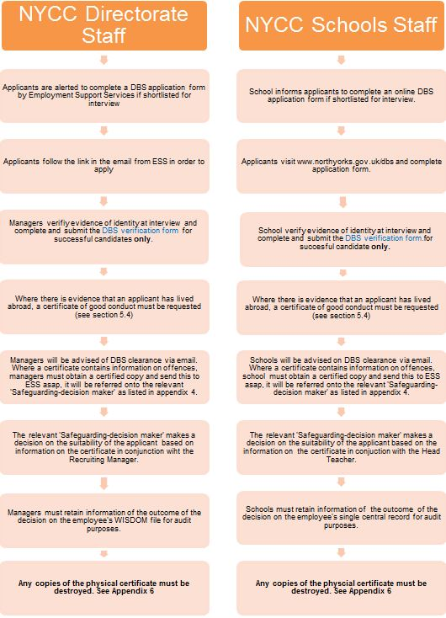

- Rechecks
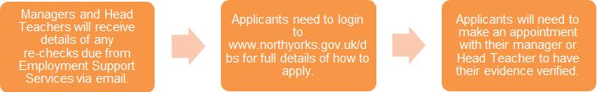
Applicants requested to complete a recheck will follow the standard process as described above once advised. Manager/ School will submit verification form for all staff they receive a request to carry out a DBS recheck for as described above.
- Applicants who have lived abroad
If the applicant has spent time living abroad, the DBS will not cover periods spent outside of the UK. Managers should advise the applicant to provide a certificate of good conduct from the country in which they resided. It is the applicant’s responsibility to obtain and pay for this certificate. Further information is available from the Foreign and Commonwealth website.
- Volunteers
When completing a verification form for a volunteer role, managers must use the specific volunteer verification form only. It is essential to only submit volunteer checks for ‘true’ volunteers that meet the definition as described in section 3. If an ineligible application is submitted for a free check for a volunteer, this may be classed as a fraudulent act and could result in North Yorkshire County Council losing its registered body status. National DBS continuously review the job titles of volunteer applications, in the event that they believe that the job title does not meet the definition of a volunteer, NYCC will be charged for the check and it could be deemed as fraudulent. See section 3.
- Agency workers
NYCC managers (non-schools) must only engage workers through Matrix (see agency policy) and must ensure that they obtain written confirmation of all clearances including a DBS check if appropriate; these documents should be available to you via the Matrix system. Schools choosing to engage agency workers should ensure the agency has obtained the appropriate clearances. It is also essential to check the identity of the person presenting themselves for work in order to ensure that they are the same person for whom checks have been undertaken in compliance with DFE regulations.
- Contractors
Department for Education guidance states: Schools and colleges should ensure that any contractor, or any employee of the contractor, who is to work at the school or college has been subject to the appropriate level of DBS check. Contractors engaging in regulated activity will require an enhanced DBS certificate (including barred list information). For all other contractors who are not engaging in regulated activity, but whose work provides them with an opportunity for regular contact with children, an enhanced DBS check (not including barred list information) will be required. In considering whether the contact is regular, it is irrelevant whether the contractor works on a single site or across a number of sites.
Frequently asked questions

Can NYCC carry out checks of other organisations, in particular academies?
Yes, NYCC is set up as an umbrella body with National DBS and has authorisation to carry out checks for other organisations.
If you have an enquiry or need guidance surrounding the interpretation of this DBS Policy, please contact Employment Support Service on 01609 532190 or by email employmentsupportservice@northyorks.gov.uk
.

Appendices
Appendix 1 – Flowcharts – is it regulated activity (children)?
The following flowcharts are provided as a visual aid to the policy and definitions of regulated activity for children.
Chart 1 – Establishment: is it regulated activity (children)?
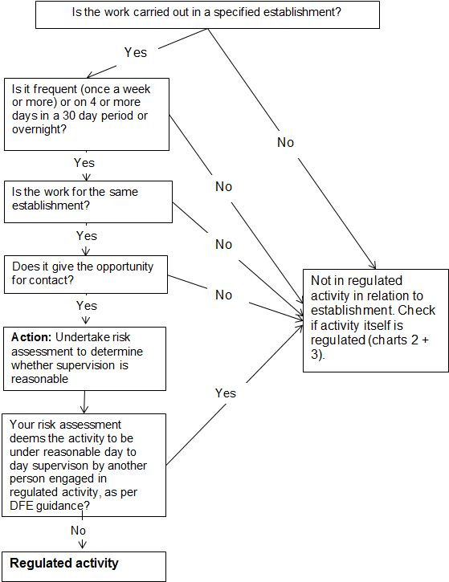
Overnight is any time between 2am and 6am with an opportunity for face to face contact
Chart 2 – activity: is it regulated activity (children)?
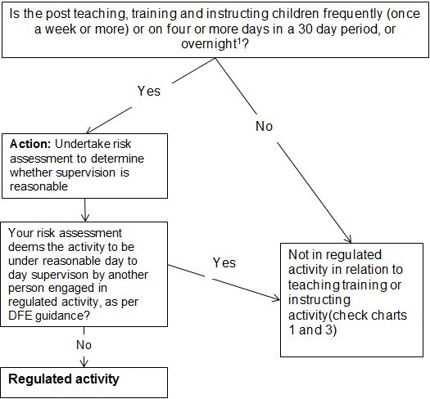
Overnight is any time between 2am and 6am with an opportunity for face to face contact with children

Chart 3 – activity: is it regulated activity (children)?
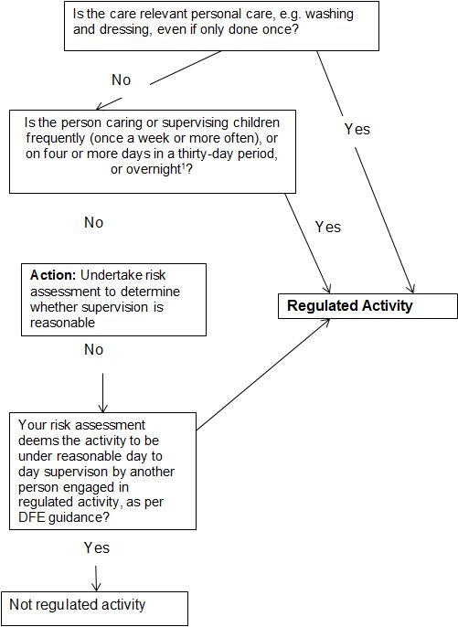
Overnight is any time between 2am and 6am with an opportunity for face to face contact with children

Appendix 2 – Flowchart – is it regulated activity (adults)?
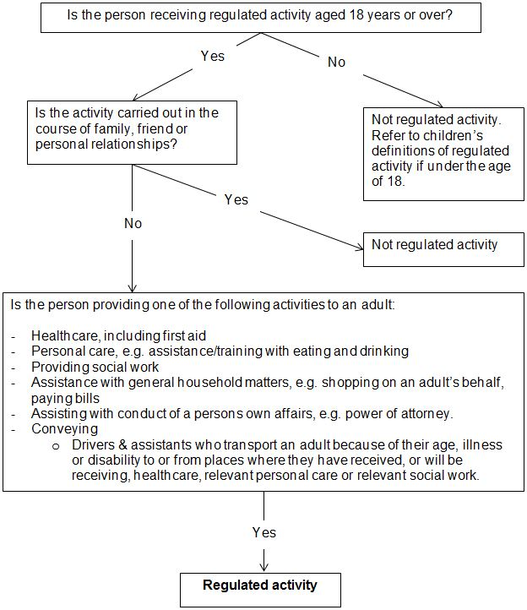

Appendix 3 – Case studies
The following case studies provide an examples of how the flow charts in appendices 1 and 2 above can be applied to everyday scenarios:

Children's
School teacher.
Rob has been successfully appointed to the role of Teacher of English at an NYCC LA secondary school. His work will always be carried out in the school premises, the specified establishment on his contract of employment. Rob will work full time and will be in contact with children when teaching. His teaching will not normally be supervised, which means Rob’s role will entail regulated activity; therefore Rob will need to complete an enhanced DBS Check + Barred list check for children before commencing in post.
Family intervention worker.
Cheryl has been successfully appointed to the post of Targeted family intervention worker, covering families across the Selby district of North Yorkshire. Cheryl works between County Hall, her home and client sites, and therefore is not in regulated activity when it comes to establishment. Her role does not involve teaching, training and instructing children, so the definition of establishment in chart 2 does not apply. Cheryl will be required to supervise children occasionally, likely for more than four days in every thirty as part of her duties, and this will be unsupervised. Therefore Cheryl is undertaking regulated activity and must complete an enhanced DBS Check + Barred list check before commencing in post.
Relief learning disabilities worker.
Stuart has successfully been appointed to the post of Relief learning disabilities worker, working in homes for children with learning disabilities across the Hambleton district on a relief basis. As Stuart will be working across various different sites on a relief basis, his role does not meet the establishment criteria of regulated activity (chart 1). Stuart will not be teaching, training or instructing children, but he will be caring for them. This will be less than once a week and could be less than four days in a thirty day period, so Stuart’s role does not entail regulated activity in relation to frequency. However, the care Stuart will be providing is relevant personal care (e.g. dressing and washing), and requires no frequency and which is defined as regulated activity. Therefore Stuart will need to complete an enhanced DBS Check + Barred list check before commencing in post.
Student – Work experience
Fay is currently undertaking a teacher training course at York St John University and requires work experience as part of her training. She has approached a school in North Yorkshire to ask if they would be willing to provide support with this. School agree to allow Fay to attend school and engage with the children. They request the University to confirm that they have completed a DBS check as part of the course enrolment requirements.
Note – If the circumstances had been different and Fay had approached the school directly for work experience, and she wasn’t completing any official training course; provided the school agreed, Fay would be required to pay for the DBS check herself as this is not a volunteer role.

Adults
Resource worker
Gill has successfully been appointed to the post of Resource Worker, working in homes with elderly people in Scarborough. As the individuals in the home are elderly, they are aged 18 or over. The activity is not carried out in the course of family, friend or personal relationships. Gill will be providing personal care which involves assisting with household matters, which is defined as regulated activity for adults. Therefore Gill will need to complete an enhanced DBS Check + Barred list check before commencing in post.
Relief driver
Bob has been appointed to the role of Relief Driver, transporting vulnerable adults around the Harrogate area. The adults being transported are aged 18 or over, and do not hold a friend, family or personal relationship with Bob. Bob will be transporting adults to doctor’s surgeries where they will be receiving healthcare. These adults are being transported due to their age, illnesses or disabilities. Therefore Bob will need to complete an enhanced DBS Check + Barred list check before commencing in post.
Appendix 4 - list of designated decision makers
Directorate | Service | Job title of decision maker | Name of current post holder
CYPS | Schools | NYHR Principal adviser – in liaison with head teacher | Mairi Reed and Haroon Rashid
CYPS | Fostering and adoption - applicants only | Head of fostering | Alan Tucker
 |  | Head of safeguarding | Vicky Metheringham
 |  | Adoption team manager | Mel Hutchinson
CYPS | CYPS including children centres | Head of HR CYPS | Penny Yeadon
CS | Cleaning corporate property management - contractors only | Property investment and delivery manager | Paula McLean
BES | IPT Integrated Passenger Transport - contractors only | Compliance team leader | Liz Tyerman
CS / BES | All BES and CS staff including County Caterers | Head of HR BES and CS | Andrew Ellis
CS | Library and community services - home library service volunteers only | Assistant director - library and community services | Julie Blaisdale
HAS | All | Assistant director - health and adult services | Ian Spicer and Dale Owens

Appendix 5 - Rehabilitation periods – with effect from 10 March 2014
The rehabilitation period (the length of time before a caution or conviction becomes spent) is determined by the type of disposal administered or the length of the sentence imposed. Rehabilitation periods that run beyond the end of a sentence are made up of the total sentence length plus an additional period that runs from the end of the sentence, which we have called the ‘buffer period’. Other rehabilitation periods start from the date of conviction or the date the penalty was imposed.
The ‘buffer periods’ are halved for those who are under 18 at date of conviction (save for custodial sentences of six months or less where the ‘buffer period’ is 18 months).
The rehabilitation periods for sentences with additional “buffer periods” which run from the end date of the sentence are shown in the table below:
Sentence / disposal | Buffer period for adults  (18 and over at the time of conviction or the time the disposal is administered).  This applies from the end date of the sentence (including the licence period). | Buffer period for young people (under 18 at the time of conviction or the time the disposal is administered). This applies from the end date of the sentence (including the licence period).
Custodial sentence* of over 4 years, or a public protection sentence | Never spent | Never spent
Custodial sentence of over 30 months (2 ½ years) and up to and including 48 months (4 years) | 7 years | 3½ years
Custodial sentence of over 6 months and up to and including 30 months (2 ½ years) | 4 years | 2 years
Custodial sentence of 6 months or less | 2 years | 18 months
Community order or youth rehabilitation order** | 1 year | 6 months
Custodial sentence includes a sentence of imprisonment (both an immediate custodial sentence and a suspended sentence), a sentence of detention in a young offender institution, a sentence of detention under section 91 of the Powers of Criminal Courts (Sentencing) Act 2000, a detention and training order, a sentence of youth custody, a sentence of corrective training and a sentence of Borstal training.
**In relation to any community or youth rehabilitation order which has no specified end date, the rehabilitation period is 2 years from the date of conviction.
The following table sets out the rehabilitation period for sentences which do not have “buffer periods” and for which the rehabilitation period runs from the date of conviction:
Fine | 1 year | 6 months
Conditional discharge | Period of order | Period of order
Absolute discharge | None | None
Conditional caution and youth conditional caution | 3 months of when the caution ceases to have effect if earlier | 3 months
Simple caution, youth caution | Spent immediately | Spent immediately
Compensation order* | On the discharge of the order (i.e. when it is paid in full) | On the discharge of the order (i.e. when it is paid in full)
Binding over order | Period of order | Period of order
Hospital order (with or without a restriction order) | Period of order | Period of order
Referral order | Not available for adults | Period of order
Reparation order | Not available for adults | None
Further information is available rehabilitation-of-offenders-guidance

Appendix 6 – DBS secure storage retention of information
Policy Statement on the Use, Secure Storage, Retention and Disposal of Certificates and Certificate Information (Electronic DBS (CRB) process)
General principles
As an organisation using the Disclosure and Barring Service (DBS) to help assess the suitability of applicants for positions of trust, North Yorkshire County Council complies fully with the Code of Practice regarding the correct handling, use, storage, retention and disposal of Certificates and Certificate information. It also complies fully with its obligations under the Data Protection Act 1998 and other relevant legislation pertaining to the safe handling, use, storage, retention and disposal of Certificate Information and has a written policy on these matters, which is available to those who wish to see it on request.
Storage and access
Certificate information is never kept on an applicant’s personal file and is always kept separately and securely, in lockable, non-portable, storage containers with access strictly controlled and limited to those who are entitled to see it as part of their duties. Electronic certificate information is held on a secure password protected system accessible only to those authorised to view it in the course of their duties.
Handling
In accordance with S.124 of the Police Act 1997, Certificate Information is only passed to those who are authorised to receive it in the course of their duties. We maintain a record of all those to whom Certificates or Certificate information has been revealed and we recognise that it is a criminal offence to pass this information to anyone who is not entitled to receive it.
Usage
Certificate information is only used for the specific purpose for which it was requested and for which the applicant’s full consent has been given.
Retention
Once a recruitment (or other relevant) decision has been made, we do not keep Certificate information for any longer than is necessary whether in electronic or paper format. This is generally for a period of up to six months, to allow for the consideration and resolution of any disputes or complaints. If, in very exceptional circumstances, it is considered necessary to keep Certificate information for longer than six months, we will consult the DBS about this and will give full consideration to the Data Protection Rights and Human Rights of the individual before doing so. Throughout this time, the usual conditions regarding safe storage and strictly controlled access will prevail.
The only exceptions allowed by the DBS are as follows:
- For establishments regulated by the commission for Social Care Inspection (CSCI) then certificates must be destroyed after 12 months
- For staff employed in residential schools certificates must be destroyed after 12 month
- For certificates relating to fostering or adoption, certificates must be destroyed after 36 months
Disposal
Once the retention period has elapsed, we will ensure that any Certificate information is immediately destroyed by secure means, ie by shredding, pulping or burning. While awaiting destruction, Certificate information will not be kept in any insecure receptacle (e.g. waste bin or confidential sack). We will not keep any photocopy or other image of the Certificate Information or any copy or representation of the contents of Certificate Information. However, notwithstanding the above, we may keep a record of the date of issue of Certificate Information, the name of the subject, the type of Certificate requested, the position for which the Certificate Information was requested, the unique reference number of Certificate Information and the details of the recruitment decision taken. For disposal of electronic results and information, the system automatically deletes the record in line with DBS retention guidelines above, automatically archiving only the minimum information as laid out in the DBS Code of Practice and in line with the paper process.
Acting as an umbrella body
Before acting as an Umbrella Body (one which countersigns applications and receives Certificate information on behalf of other employers or recruiting organisations), we will take all reasonable steps to satisfy ourselves that they will handle, use, store, retain and dispose of Certificate information in full compliance with the DBS Code and in full accordance with this policy. We will also ensure that anybody or individual, at whose request applications for Certificates are countersigned, has such written policy and, if necessary, will provide a model policy for that body or individual to use or adapt for this purpose.
Appendix 7 - Definition of regulated activity: Pre Sept 2012
Involves contact with children or vulnerable adults
Of a specified nature  or | “Frequently, intensively and/or overnight”
In a specified place
- No distinction made between paid and voluntary work
In detail

of a specified nature  E.g. teaching, training, care, supervision, advice, treatment or transport  Or | “frequently, intensively and/or overnight”  - once a week for most services, but once a month or more for health and social care services involving personal care  - takes place on 4 days in one month or more  - Overnight: between 2 – 6am
In a specified place
E.g. Schools, Pupil Referral Units, Childcare premises (nurseries), Children’s homes and hospitals, children’s detention facilities, children’s centres, adult care homes
The guidance states that there is only a requirement to check if the frequent / intensive test takes place in a single specified setting or in a specified role
E.g. Directors of Children’s services, members of Youth Justice Board, School Governors.
There is no distinction made between paid and voluntary work.

