MMR Social Media Toolkit

Suggested Text | Image
Parents 1  Measles is more than just a rash and can lead to serious complications including meningitis and blindness, particularly in babies and young children. In fact, 1 in 15 children who contract measles develop serious complications.  Cases are on the rise and the disease is highly infectious.  The best way to protect your children from this serious and preventable disease is to keep their vaccinations up to date. The Measles, Mumps and Rubella (MMR) vaccine is safe and has been used since the early 1980s.  All children should receive their two doses on time at 12 months and again at 3 years and 4 months.  Check your child’s red book and make contact with your practice to catch up on any missing vaccinations.  For more information visit Let’s Get Vaccinated. | 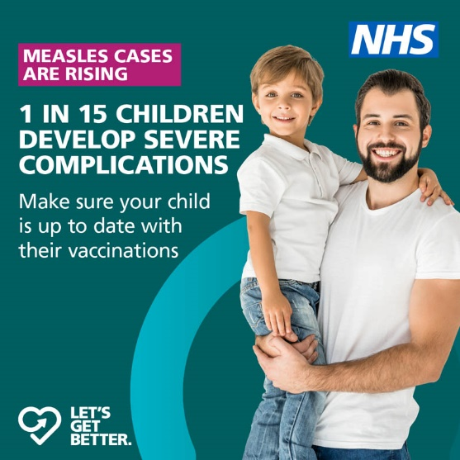
Parents 2  Measles is more than just a rash and can lead to serious complications including meningitis and blindness, particularly in babies and young children. In fact, 1 in 5 children with measles need hospital treatment.  Cases are on the rise and the disease is highly infectious.  The best way to protect your children from this serious and preventable disease is to keep their vaccinations up to date. The Measles, Mumps and Rubella (MMR) vaccine is safe and has been used since the early 1980s.  All children should receive their two doses on time at 12 months and again at 3 years and 4 months.  Check your child’s red book and make contact with your practice to catch up on any missing vaccinations.  For more information visit Let’s Get Vaccinated. | 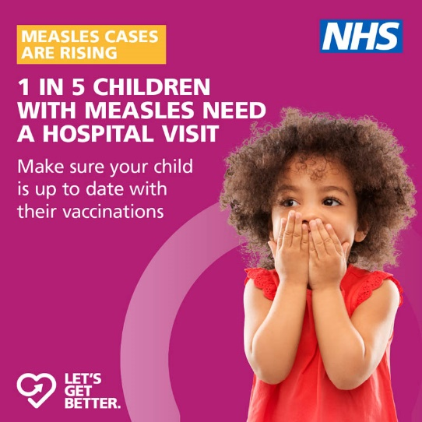
Parents 3  Measles is more than just a rash and can lead to serious complications including meningitis and blindness, particularly in babies and young children.  Cases are on the rise and the disease is highly infectious.  The best way to protect your children from this serious and preventable disease is to keep their vaccinations up to date. The Measles, Mumps and Rubella (MMR) vaccine is safe and has been used since the early 1980s.  All children should receive their two doses on time at 12 months and again at 3 years and 4 months.  Check your child’s red book and make contact with your practice to catch up on any missing vaccinations.  For more information visit Let’s Get Vaccinated. | 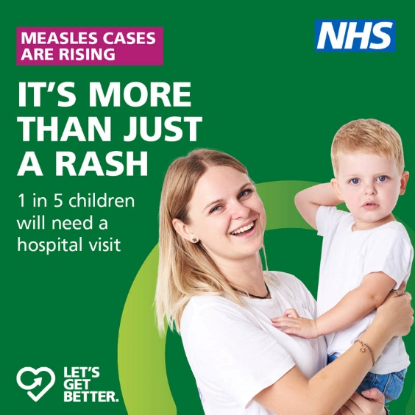
Pregnancy  Measles is more than just a rash and during pregnancy can lead to miscarriage, stillbirth, premature birth and low birth weight.  Cases are on the rise and the disease is highly infectious. There is no treatment or cure for measles but the MMR vaccine protects you against this dangerous disease.  Getting vaccinated isn’t just for children. It is important at any age. So if you are planning a pregnancy and not fully vaccinated, make an appointment with your GP to catch up on any missing vaccinations.  You should avoid getting pregnant one month after the vaccine. If you are pregnant or have just had a baby, you should speak to your GP or practice nurse.  For more information visit Let’s Get Vaccinated. | 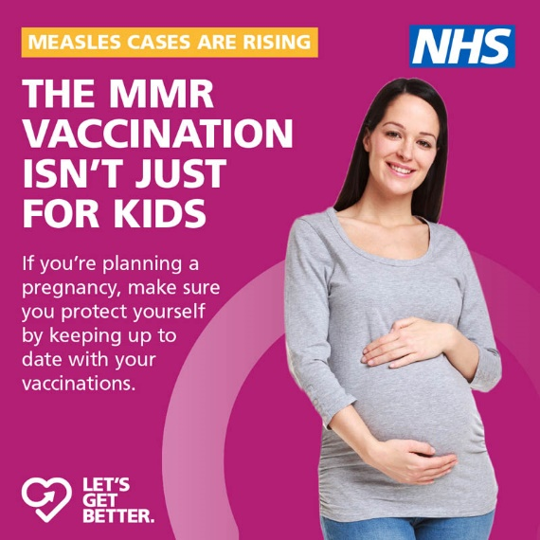
General/LTC  Measles is more than just a rash. It is very infectious and cases are on the rise.  If you are not protected and have even passing contact with someone with measles, the chances are you will be infected too.  There is no treatment or cure for measles but the MMR vaccine protects you against this dangerous disease.  Getting vaccinated isn’t just for children. It is important at any age, particularly if you have a weakened immune system or a long-term health condition. So if you are not fully vaccinated, make contact with your practice to catch up on any missing vaccinations.  For more information visit Let’s Get Vaccinated. | 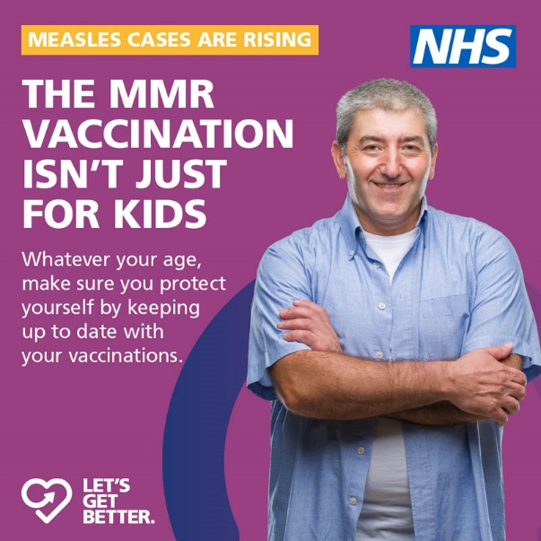
Healthcare  Measles is more than just a rash. It is very infectious and cases are on the rise.  If you are not protected and have even passing contact with someone with measles, the chances are you will be infected too.  There is no treatment or cure for measles but the MMR vaccine protects you against this dangerous disease.  Getting vaccinated isn’t just for children. It is important at any age, particularly if you work in healthcare where you are more likely to come in to contact with an infected person. So if you are not fully vaccinated, make contact with your practice to catch up on any missing vaccinations.  For more information visit Let’s Get Vaccinated. | 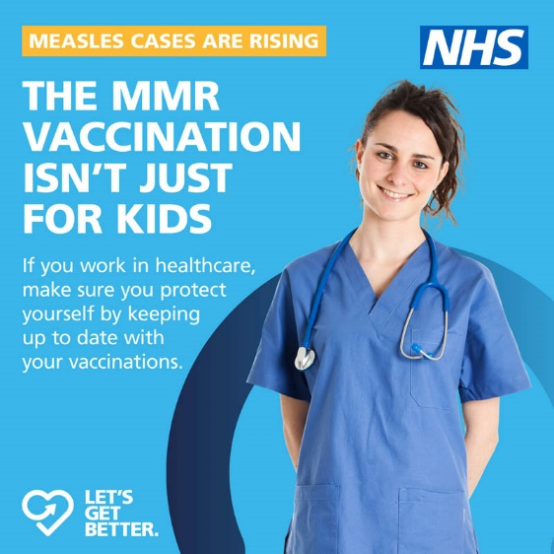
Social Care  Measles is more than just a rash. It is very infectious and cases are on the rise.  If you are not protected and have even passing contact with someone with measles, the chances are you will be infected too.  There is no treatment or cure for measles but the MMR vaccine protects you against this dangerous disease.  Getting vaccinated isn’t just for children. It is important at any age, particularly if you work in social care where you are more likely to come in to contact with an infected person. So if you are not fully vaccinated, make contact with your practice to catch up on any missing vaccinations.  For more information visit Let’s Get Vaccinated. | 

