Early Years Conference Workshops

To view the workshop descriptions
When viewing the course click the arrow on the days / full programme section

This will bring up all workshop options and a brief description.
Please note, the workshops are the same for both workshop 1 and workshop 2 so please select different ones.
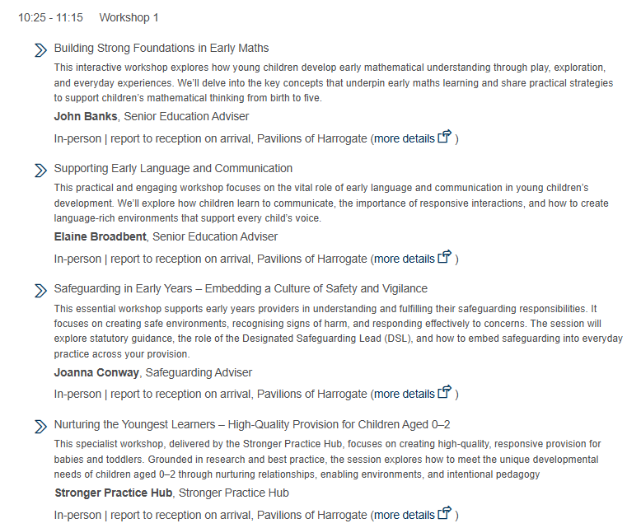

Selecting the workshop options
When you select a delegate to book, you will then be asked to confirm the workshops they want to attend.
Make you select a different workshop for each time, as in the example below and then proceed to confirming the booking.
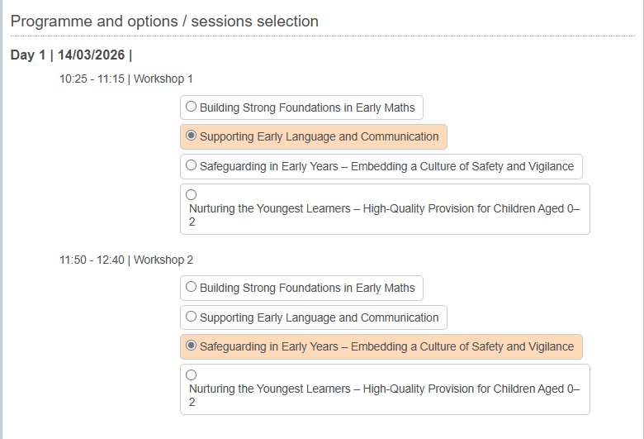
Spaces on the workshops are limited, so book early to secure your place.
Please note: While this event is free to attend, places are limited. If you register but do not attend without prior notice, you may be charged a fee to cover the cost of your reserved place.

