Locality Board Updates
Hambleton and Richmondshire Locality Board
SNAP Hodder – book on training and then you will receive login (to apply complete https://www.surveymonkey.co.uk/r/SNAPHR, see emailed flyer for more details), contact Joanna.lings@northyorks.gov.uk for further support.
Clicker 8 and DocsPlus – PILOT project so places limited (to apply complete https://www.surveymonkey.co.uk/r/Crickhr, see emailed flyer for more details), contact jennie.holt@northyorks.gov.uk for further support.
Talk Boost KS1 and KS2 – training only 12th and 19th October. Book through NYES (NYES Codes: IES-OM-1022-T006 and IES-OM-1022-T007, see emailed flyer for more details) contact jennie.holt@northyorks.gov.uk for further support.
Post Transition Project – Secondary (Yr7 and Yr8) very limited places (to apply complete https://www.surveymonkey.co.uk/r/PTRANSHR, see emailed flyer for more details) contact jennie.holt@northyorks.gov.uk for further support.
SENCO Survey – Have your say in what the locality board will focus on by completing the survey https://www.surveymonkey.co.uk/r/ssurveyhr22 (also emailed)
PLEASE NOTE: All updates from the locality board will come through email
Selby Locality Board
SNAP Hodder – book on training and then you will receive login (to apply complete https://www.surveymonkey.co.uk/r/SNAPSLB, see emailed flyer for more details), contact Joanna.lings@northyorks.gov.uk for more support.
Mental Health First Aid – Training for: Primary 21st and 28th Nov and Secondary 23rd and 24th Feb, , book through NYES (NYES Codes: IES-1122-T001 and IES-0223-T001) - see emailed flyer for more details) contact jennie.holt@northyorks.gov.uk for further support.
SENCO Survey – Have your say in what the locality board will focus on by completing the survey https://www.surveymonkey.co.uk/r/ssurveys22 (also emailed)
Primary Vacancy on the board – an email will be circulated for nominations.
PLEASE NOTE: All updates from the locality board will come through email

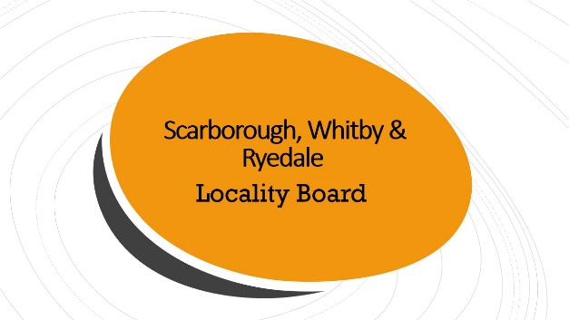
Scarborough, Whitby and Ryedale Locality Board
SNAP – Special Needs Assessment Profile, Specific Learning Difficulties and Behaviour screening tools are available for ALL Primary and Secondary Schools. If you have not contacted us to receive your login, please follow this link. https://www.surveymonkey.co.uk/r/KHVTQRW
Please complete the SWR SEND Survey https://www.surveymonkey.co.uk/r/5Y256SC

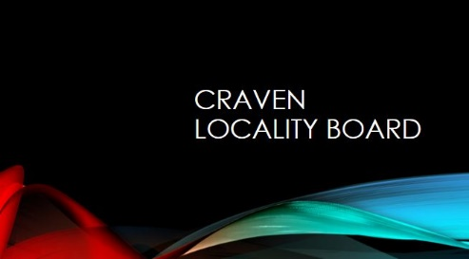
Craven Locality Board
SNAP – Special Needs Assessment Profile, Specific Learning Difficulties and Behaviour screening tools are available for ALL Primary and Secondary Schools. If you have not contacted us to receive your login, please follow this link. https://www.surveymonkey.co.uk/r/5MGHDKN
Free Youth Mental health First Aid Training:
Course 1 -Monday 31st October and Friday 4th November 2022 at Skipton Academy. Lunch and refreshments will be provided.
Course 2 -Wednesday 9th & Thursday 10th November at Craven PRS in Skipton. Refreshments will be provided.
Please sign up by Friday 21st October https://www.surveymonkey.co.uk/r/535DWHW
For further information, please contact Katie.Middleton@northyorks.gov.uk
Please complete the Craven SEND Survey https://www.surveymonkey.co.uk/r/5FYXNBJ

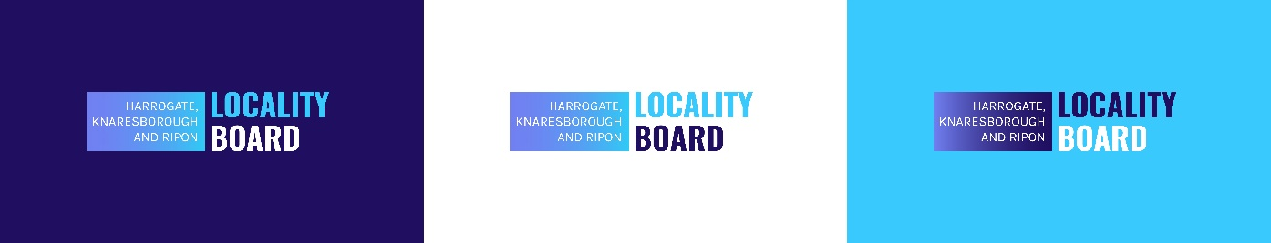
Harrogate, Knaresborough and Ripon Locality Board
ALL Primary, Secondary and Special schools will have access to a 3-year site licence for either Clicker 8 or DocsPlus software from October 1st 2022. To receive your licences that can be used on all laptops, desktops, Chromebook and iPad’s please follow the link: https://www.surveymonkey.co.uk/r/KZLWXKC
Please complete the HKR SEND Survey https://www.surveymonkey.co.uk/r/KGYZBGM
All Locality Board Project Adverts for SWR, Craven and HKR will be circulated via Email from Katie.Middleton@northyorks.gov.uk

