New Virtual School Head
We are please to introduce our new Virtual School Head- Jo Hampshire
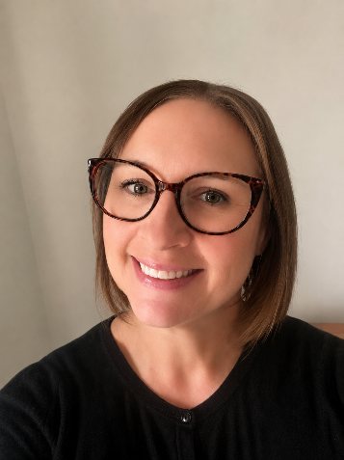
"I am delighted to be joining North Yorkshire as the new Head of the Virtual School.
Throughout my career, I have been passionate about improving outcomes for vulnerable children and young people. Over the last 30 years, I have worked across a range of settings, including mainstream and special schools, children's residential care and inclusion leadership roles, supporting children and families with a wide range of needs and experiences. I have also been fortunate enough to work in different areas of the country; however, as a Scarborough girl, born and bred, North Yorkshire has always had my heart.
What has remained constant throughout my career is a belief that children achieve best when they feel safe, understood, valued and that they belong. I am committed to working collaboratively with schools, social care colleagues, carers and wider partners to ensure that children supported by the Virtual School receive the highest levels of ambition, support and opportunity.
I am really looking forward to meeting colleagues from across North Yorkshire, learning from the excellent work already taking place and building on the strong foundations that exist to further improve outcomes for children and young people. I am excited to begin my new role in September."

