 |  |  | North Yorkshire Council
 |  |  | Admissions, Transport Eligibility & FSM
 |  |  | Racecourse Lane
 |  |  | Northallerton
 |  |  | North Yorkshire
 |  |  | Website: www.northyorks.gov.uk
Date: | 12 October 2025 |  | Email: schooladmissions@northyorks.gov.uk

Dear parent/carer

It’s now time to apply for a Junior school place

As your child approaches the exciting transition to Junior school in September 2026, we’re here to guide you through the application process and make the experience as smooth as possible.

Applications open on 12 October 2025 and the deadline to apply is 15 January 2026. Please apply in good time to make sure your child gets a place.

Applying couldn’t be easier.

Online |  | Smartphone
The quickest and easiest way to apply for a primary school place is online at  www.northyorks.gov.uk/NYC-PRIML |  | 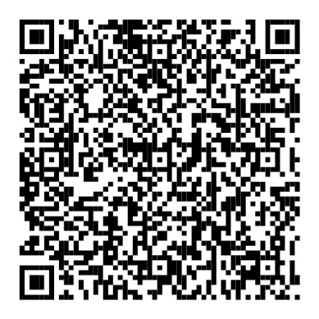

Key Steps for Applying:

- One Application: You only need to submit one application, and this should be done through your Home Local Authority (where you pay your council tax).

- Application Process in North Yorkshire:
- If you live in North Yorkshire, you can list up to five preferred schools.
- Please note that applying to just one school will not improve your chances of getting a place there.
- You are free to apply to any school or academy in North Yorkshire or any other Local Authority area. If you wish to apply for a school in another Local Authority area, list it on your application and we will work with them.

- Helpful Resources:
Before completing the online form, we highly recommend reviewing the important information available on our School Admissions and Transport page: www.northyorks.gov.uk/admissions This guide will answer many of your questions and help you navigate the process.

- Submitting Your Application:
Once you’ve submitted your application online, you’ll receive an acknowledgment email. Then, on 16 April 2026, National Offer Day, you’ll receive another email with a secure link to view your child’s school place offer. Be sure to keep your login details safe as you will need them again to access this information.

Recommendations for a Smooth Application Process:
- We strongly encourage you to include your nearest school as one of your preferences. Not doing so might result in your child being allocated a place at a school farther away, and you would be responsible for any transport arrangements and costs.
- To find out which school is nearest to you, visit www.northyorks.gov.uk/catchmentareas

Remember to save all emails and confirmation messages from us in case you need them in the future.

Should you need any of this information in another language or format, or a paper copy of the application form, please call us.

If you have any questions or need assistance, feel free to contact us.

Business Support, School Admissions Transport & Free School Meals
Postal address: Racecourse Lane, County Hall
Northallerton, DL7 8AE
Website: www.northyorks.gov.uk
Email: schooladmissions@northyorks.gov.uk
Telephone: 01609 533679
Phone lines are open Monday, Tuesday, Thursday & Friday – 10.00 – 15.00 and Wednesday 08.30 – 12.00.

For parents of children moving up to a new school |   https://inourplace.co.uk/moving-up

