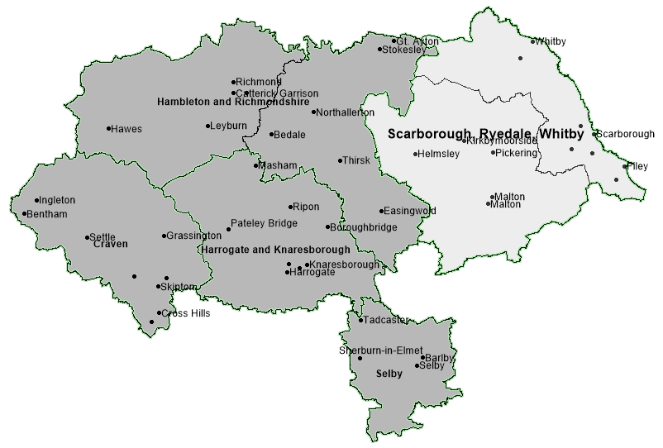
Scarborough, Whitby and Ryedale (SWR)
Locality - performance summary
Schools
355 schools in North Yorkshire
(303 primary, 43 secondary, 10 special)
90 in Scarborough and Ryedale
(74 primary and 12 secondary, 4 special)
School Population
81274 pupils in mainstream schools (primary and secondary) in North Yorkshire, 19829 in Scarborough and Ryedale (24.4%). There has been a 1.5% decrease in the Scarborough and Ryedale school population from 20135 in the previous year. North Yorkshire has seen a very slight decrease from 81340.

0 to 25 Population
SWR: 40775, 24.8% of the population
North Yorkshire: 25.8%
Nationally: 31.0%

Good or Outstanding - SWR
As of October of 2021, proportion of schools with Good/Outstanding Ofsted outcome.
Primary Schools: 81.1% (North Yorkshire rate: 81.8%)
Secondary Schools: 58.3% (North Yorkshire rate: 74.4%)
Academy Schools - SWR
23 of the 74 primary schools in SWR are academies (31.1%), 97 of 302 in North Yorkshire (32.1%).
8 of the 12 secondary schools in SWR n are academies (66%), 26 of 43 in North Yorkshire (60.5%).
% of School population in Good or Outstanding school (most recent overall Ofsted outcome)
 | Sep-21 |  | Sep-20 |  | Sep-19
 | Primary | Secondary | Primary | Secondary | Primary | Secondary
Scar/Whi/Rye | 73.7% | 70.7% | 76.3% | 78.3% | 76.3% | 90.8%
North Yorkshire | 81.1% | 78.4% | 79.9% | 77.5% | 82.7% | 79.9%
National | 88.6% | 79.8% | 87.8% | 79.3% | 87.5% | 79.7%
% of school population in Good or Outstanding school (Ofsted) in locality shown in September of each year 2019 to 2021 by phase shown
Headlines – Scarborough, Whitby and Ryedale Schools Locality
Exclusions from school

- In 2020/2021 there had been a total of 3257 fixed-term exclusions from mainstream schools in North Yorkshire in the academic year. 948 (29.1%) of these occurred in mainstream schools in Scarborough and Ryedale, 34.2% occurred in Scarborough and Ryedale in the same period of 2019/20
- As of the end of October 2021/2022 there had been a total of 569 fixed-term exclusions from mainstream schools in North Yorkshire in the academic year. 182 (32%) of these occurred in mainstream schools in Scarborough, Whitby and Ryedale, 4.7% occurred in Scarborough, Whitby and Ryedale in the same period last year
- The North Yorkshire total of permanent exclusions from mainstream schools in 2020/21 was 26, considerably lower than the 52 in 2019/20
- The North Yorkshire total of permanent exclusions from mainstream schools in 2021/22 to the end of October was 9, higher than the 5 in 2020/21 in the same period. Permanent exclusions from Scarborough, Whitby and Ryedale mainstream schools in 2020/21 represented 31% of the North Yorkshire total (9 of 26), in 2019/20 Scarborough, Whitby and Ryedale permanent exclusions were 17.3% of the total (9 of 52)
Attendance

- Rates of persistent absence from mainstream schools in the locality have been higher than the North Yorkshire rate for all children. In the first two-terms of 2020/21 19.3% of children in secondary schools and 13% of children in primary schools in the locality were recorded as persistently absent i.e. absent for more than 10% of possible sessions. The rate for North Yorkshire was 15.8% and 11.1% respectively.
- Rates of persistent absence amongst children recorded as having Free School Meals in secondary schools in the locality in 2020/21 (first two terms) were considerably higher than the North Yorkshire rate and was the highest rate of the five localities. 37.3% were persistently absent from Scarborough and Ryedale secondary schools compared to 32.7% in North Yorkshire.

Elective Home Education (EHE)

- As of 31st October 2021 there were a total of 827 children recorded as being Electively Home Educated (EHE) in North Yorkshire, 252 of these were formerly in a mainstream school in Scarborough/Whitby and Ryedale.
- A total of 92 children became EHE from mainstream schools in North Yorkshire since the start of the 2021/22 academic year, for any length of time. 33 (36%) were formerly from mainstream schools in Scarborough/Whitby and Ryedale.
- 1.27% is the rate of EHE of the mainstream school population in Scarborough, Whitby and Ryedale as of October 2021, which is much higher than the rate of EHE for the mainstream school population for North Yorkshire (1.02%)
- Whilst the number of EHE is higher than the same point last year, a downward trend is beginning.

SEN in mainstream schools
- 9.9% of children in Scarborough, Whitby and Ryedale schools were recorded as having special educational needs in the January 2021 school census, a much lower rate to the North Yorkshire rate as a whole of 13.2%
- The SEN Support rate (8.4%) of the school population in Scarborough, Whitby and Ryedale is the lowest of the five localities
The EHC plan rate (1.5%) has remained the same as last year’s rate and is now lower than the North Yorkshire average (1.7%). The North Yorkshire rate increased from 1.5% to 1.7%.

Ofsted Outcomes
- As of October of 2021, the rate of primary schools with a ‘Good’ or ‘Outstanding’ outcome in the locality at the most recent Ofsted inspection was 81.1%, slightly lower than the North Yorkshire average of 81.8%. However, the secondary school rate was 58.3%, much lower than the county rate of 74.4%.
SEN Population in Schools
Scarborough/Whitby and Ryedale | - 14.4% of children in Scarborough, Whitby and Ryedale schools recorded as SEN in 2021, a higher rate than North Yorkshire as a whole (13.2%).  - 14.4% is a 0.8 percentage point increase in SEN compared to 2020.  - 1.8% of the Scarborough, Whitby and Ryedale school population have an Education, Health and Care plan (EHCp) compared to the North Yorkshire rate of 1.7%.  - 12.6% of the Scarborough, Whitby and Ryedale school population are recorded as SEN Support compared to the North Yorkshire rate of 11.5%.
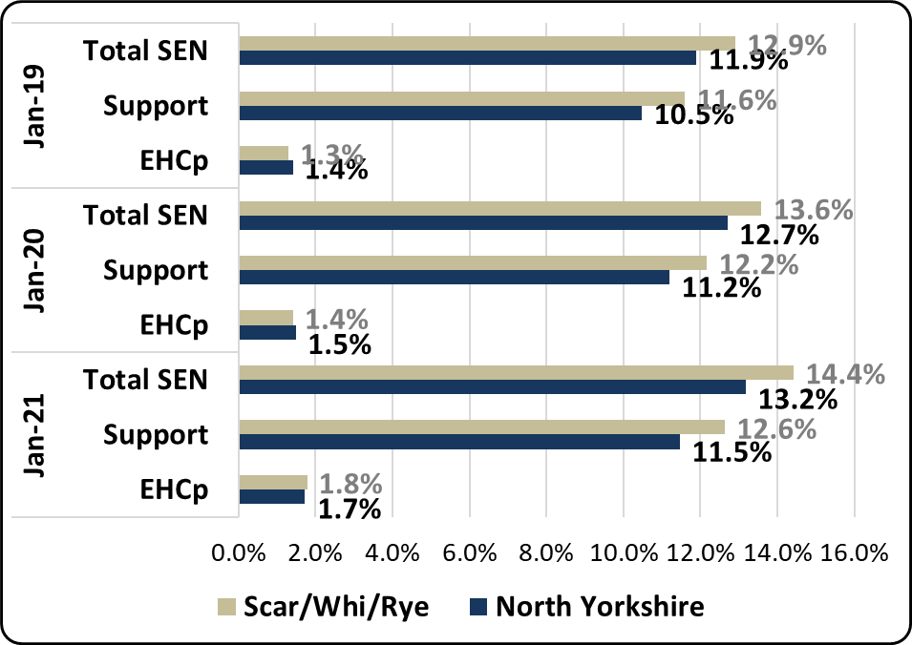
Proportion of mainstream school population with SEN provision (by type of provision) in North Yorkshire and Scarborough, Whitby and Ryedale school locality

 | National | NYCC | SWR
Total SEN (Mainstream) | 14.1% | 13.2% | 14.4%
Total SEN Support (Mainstream) | 12.1% | 11.5% | 12.6%
Total EHC plan (Mainstream) | 2.0% | 1.7% | 1.8%
Proportion of mainstream school population with SEN provision (by type of provision) National comparisons in 2021
- The SEN Support rate (12.6%) of the school population in Scarborough, Whitby and Ryedale is the second highest of the five localities
- The EHC plan rate of 1.8% is a 0.4pp increase on the previous year (1.4%), higher than the North Yorkshire increase of 0.2pp (1.5% to 1.7%)

Requests for Assessment
Scarborough/Whitby and Ryedale | - There were a total of 702 requests for statutory assessment received by North Yorkshire County Council in 2020/21, 172 (24.5%) were received for children in mainstream schools in Scarborough/Whitby and Ryedale.  - The above figure is slightly more than the previous year’s total in the locality. 160, approximately 22.0% of the 726 requests received by NYCC in 2019/20 were for children in mainstream schools in Scarborough/Whitby and Ryedale.  - As of the end of 31st October 2021, there have been 102 requests for statutory assessment, 25 (24.5%) have been received for children in mainstream schools in Scarborough/Whitby and Ryedale.
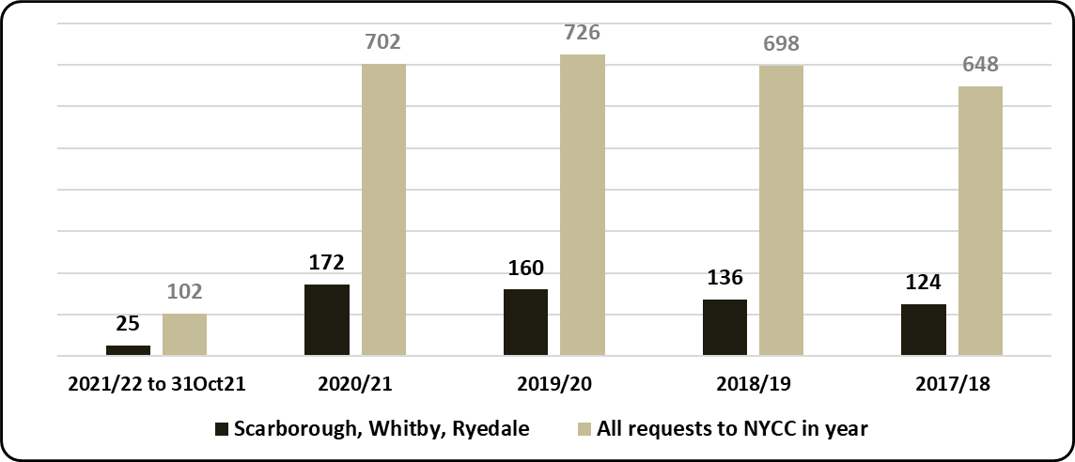
Requests for assessment (EHC plan) based on the mainstream school locality of child - North Yorkshire total received - by academic year
 | National |  | North Yorkshire |  | Yorkshire and the Humber
 | 2019/20 | 2020/21 | 2019/20 | 2020/21 | 2019/20 | 2020/21
Requests (% of Mainstream school population) | 0.94% | 0.98% | 0.75% | 0.75% | 0.79% | 0.86%
% Requests resulting in EHC plan (estimate where decision made) | 70.9% | 75.5% | 70.8% | 76.3% | 71.3% | 75.9%
% requests of school population and % resulting in EHC plan national and regional comparison
- 75% of requests for assessment from Scarborough and Ryedale schools in the 2020 calendar year resulted in an EHC plan (as of September 2021), a slightly higher rate than the North Yorkshire average of 74%. A proportion of requests received in the 2020/21 academic year are yet to be assessed, however, as of September 2021, 31% of requests in North Yorkshire have resulted in an EHC plan, the rate from Scarborough and Ryedale schools is 35%.
- 160 requests in 2020/21 is 0.81% of the mainstream school population, which is much higher than the North Yorkshire rate of 0.60% from mainstream school. It is the highest rate of the five school localities.

Attainment in Schools*
* The publication of results for Early Years Foundation Stage Profile and Key Stage 2 has been cancelled for 2020/21 (Covid-19)
https://www.gov.uk/government/collections/statistics-key-stage-2
Early Years Foundation Stage
 |  | All | Gender |  | SEN |  | EAL |  | Disadvantaged
 |  |  | Girls | Boys | Yes | No | Yes | No | Yes | No
2016/17 | North Yorkshire | 71.8 | 77.6 | 65.8 | 19.6 | 75.6 | 60.9 | 72.8 | 53.1 | 73.7
 | National | 70.7 | 77.7 | 64.0 | 23.0 | 75.9 | 64.5 | 72.6 | 56.6 | 73.3
 | Scar/Whi & Rye | 67.1 | 74.6 | 59.2 | 6.9 | 71.7 | 56.9 | 67.9 | 50.0 | 70.1
2017/18 | North Yorkshire | 72.5 | 79.6 | 65.7 | 22.7 | 77.0 | 61.0 | 73.5 | 50.3 | 74.8
 | National | 71.5 | 78.5 | 65.0 | 23.8 | 77.0 | 66.1 | 73.4 | 57.2 | 74.3
 | Scar/Whi & Rye | 68.6 | 75.0 | 62.7 | 22.7 | 72.4 | 66.3 | 68.9 | 48.1 | 71.9
2018/19 | North Yorkshire | 72.8 | 79.4 | 66.7 | 21.5 | 77.4 | 64.4 | 73.7 | 50.9 | 75.2
 | National | 71.8 | 78.4 | 65.5 | 24.3 | 77.4 | 66.6 | 73.6 | 56.4 | 74.4
 | Scar/Whi & Rye | 70.3 | 76.0 | 65.3 | 20.7 | 74.8 | 57.7 | 71.1 | 48.2 | 73.6
% of children in schools at EYFS achieving a GLD - LA , Scarborough, Whitby and Ryedale locality and national – in years 2016/17 to 2018/19
- pupil characteristics shown
Attainment of all pupils in Early Years Foundation Stage (70.3%) in the locality in 2018/19 was lower than the North Yorkshire rate (72.8%) of children achieving a Good Level of Development (GLD) and continues to be higher than the National rate (71.8%).
As is the case in North Yorkshire and Nationally, attainment of girls in the locality (76%) was considerably higher than that of boys (65.3%). Attainment of Disadvantaged children in the locality (48.2%) has been much lower than the National rate (56.4%) as is the case in North Yorkshire (50.9%).

Early Years Foundation Stage - SEN | - 70.3% of children in Scarborough, Whitby and Ryedale schools achieved a good level of development in 2018/19, a -2.5 percentage point difference from the North Yorkshire rate. This was a 1.7 percentage point increase on the previous year (68.6% in 2017/18).  - 20.7% of the SEN cohort (children recorded with EHC plans or SEN Support) in Scarborough, Whitby and Ryedale schools achieved a good level of development in 2018/19 which was a 2.0 percentage point decrease from the previous year and a lower rate than North Yorkshire as a whole (21.5%).
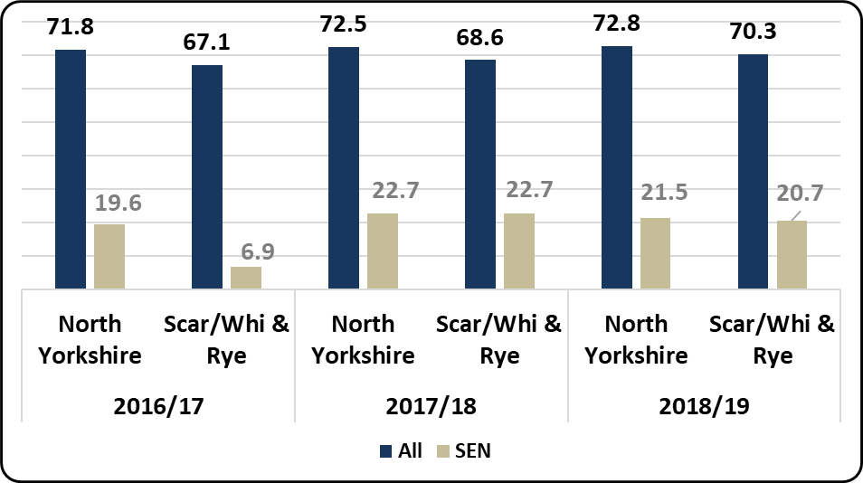
% of children in schools - LA , Scarborough, Whitby and Ryedale locality and national - achieving a Good Level of Development (% GLD) for the SEN cohort and the entire cohort

Key Stage 2
 |  | All | Gender |  | SEN |  | EAL |  | Disadvantaged |  | Mobile
 |  |  | Girls | Boys | Yes | No | Yes | No | Yes | No | Yes | No
2016/17 | North Yorkshire | 59.0 | 62.7 | 55.5 | 13.4 | 67.7 | 54.4 | 59.2 | 38.7 | 64.3 | 45.9 | 60.3
 | National | 61.1 | 65.0 | 57.4 | 18.3 | 70.2 | 58.3 | 61.9 | 47.4 | 67.4 | 43.1 | 62.6
 | Scar/Whi & Rye | 53.1 | 58.7 | 48.4 | 11.2 | 62.6 | 45.2 | 53.8 | 35.5 | 60.9 | 38.3 | 54.9
2017/18 | North Yorkshire | 62.1 | 66.9 | 57.6 | 19.3 | 71.4 | 59.4 | 62.4 | 44.1 | 66.8 | 53.2 | 63.0
 | National | 64.4 | 68.4 | 60.5 | 21.3 | 73.7 | 62.9 | 64.8 | 50.6 | 70.5 | 47.0 | 65.8
 | Scar/Whi & Rye | 58.4 | 63.4 | 53.9 | 16.0 | 67.8 | 56.1 | 58.7 | 44.5 | 64.3 | 53.9 | 59.1
2018/19 | North Yorkshire | 63.4 | 68.8 | 58.3 | 18.1 | 73.0 | 60.1 | 63.6 | 45.6 | 68.5 | 54.6 | 64.2
 | National | 64.9 | 69.7 | 60.2 | 22.3 | 74.3 | 63.8 | 65.3 | 51.3 | 70.8 | 47.2 | 66.3
 | Scar/Whi & Rye | 59.2 | 64.7 | 54.3 | 15.3 | 69.5 | 47.3 | 59.8 | 45.4 | 65.6 | 50.3 | 60.2
% of children in schools at Key Stage 2 achieving the expected standard - LA , Scarborough, Whitby and Ryedale locality and national – in years 2016/17 to 2018/19 - pupil characteristics shown
Attainment of all pupils in Key Stage 2 achieving the expected standard (59.2%) in the locality in 2018/19 was lower than the North Yorkshire rate (63.4%) and lower than the National rate (64.9%).
As is the case in North Yorkshire and Nationally, attainment of girls in the locality (64.7%) was considerably higher than that of boys (54.3%). Attainment of Disadvantaged children in the locality (45.4%) has been much lower than the National rate (51.3%) and the North Yorkshire rate (45.6%).
Key Stage 2 - SEN | - 59.2% of children in Scarborough, Whitby and Ryedale schools achieved the expected standard for reading, writing and maths (%RWM) in 2018/19, this was a 0.8 percentage point increase on the previous year.  - 15.3% of the SEN cohort (children recorded with EHC plans or SEN Support) in Scarborough, Whitby and Ryedale schools achieved the expected standard for reading, writing and maths in 2018/19 which was a 0.7 percentage point drop on the previous year. This was also a lower rate than North Yorkshire as a whole (18.1%).
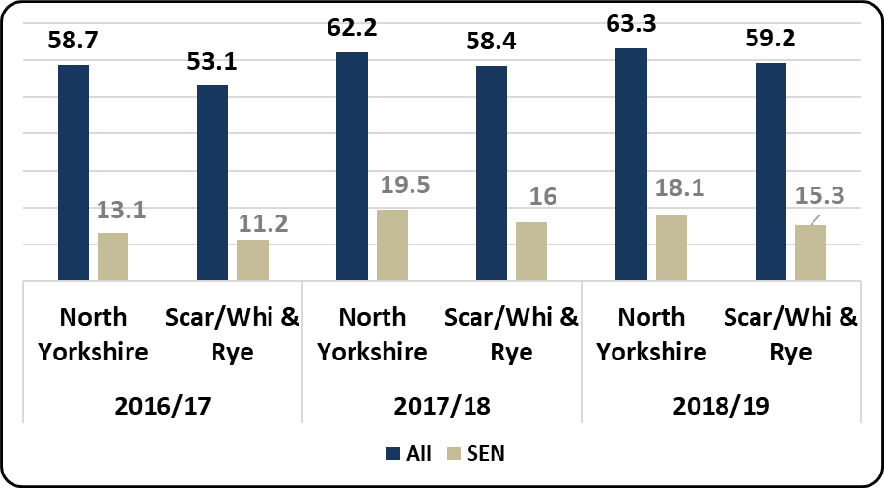

Key Stage 4
 |  | All | Gender |  | SEN |  | EAL |  | Disadvantaged |  | Mobile
 |  |  | Girls | Boys | Yes | No | Yes | No | Yes | No | Yes | No
2016/17 | North Yorkshire | 49.6 | 52.6 | 46.7 | 26.7 | 51.7 | 49.8 | 49.6 | 35.5 | 52.1 | 34.8 | 49.9
 | National | 46.3 | 49.0 | 43.7 | 27.1 | 49.5 | 46.8 | 46.3 | 37.0 | 49.8 | 32.4 | 46.8
 | Scar/Whi & Rye | 43.7 | 46.5 | 40.5 | 23.2 | 46.4 | 41.2 | 43.7 | 31.9 | 47.2 | 24.6 | 44.2
2017/18 | North Yorkshire | 48.5 | 51.3 | 45.8 | 26.6 | 51.3 | 45.9 | 48.5 | 34.4 | 51.2 | 29.6 | 49.3
 | National | 46.5 | 49.3 | 43.8 | 27.2 | 49.8 | 47.2 | 46.5 | 36.7 | 50.1 | 32.1 | 47.1
 | Scar/Whi & Rye | 43.0 | 46.1 | 39.8 | 22.9 | 46.9 | 44.1 | 42.9 | 31.1 | 46.5 | 29.6 | 44.2
2018/19 | North Yorkshire | 48.6 | 51.4 | 46.1 | 26.8 | 51.4 | 48.3 | 48.7 | 34.7 | 51.3 | 30.8 | 49.2
 | National | 46.7 | 49.5 | 44.0 | 27.6 | 49.9 | 47.6 | 46.6 | 36.7 | 50.3 | 31.8 | 47.2
 | Scar/Whi & Rye | 42.5 | 46 | 38.4 | 20.8 | 45.5 | 42.4 | 42.3 | 30.5 | 45.8 | 26.8 | 42.9
Average Attainment 8 score of children in schools at Key Stage 4 - LA , Scarborough, Whitby and Ryedale locality and national
– in years 2016/17 to 2018/19 - pupil characteristics shown
The Average Attainment 8 score of all pupils in Key Stage 4 (42.5) in the locality in 2018/19 has been lower than the North Yorkshire rate (48.6) and the National score (46.7).
As is the case in North Yorkshire and Nationally, average Attainment 8 scores of girls in the locality (46) were higher than that of boys (38.4). Attainment of Disadvantaged children in the locality (37.5) has been considerably lower than that of non-Disadvantaged children (30.5) but slightly higher than the National score for that cohort (36.7) and the North Yorkshire score (34.7).
Key Stage 4 - SEN | - The average Attainment 8 score for children in schools in the Scarborough, Whitby and Ryedale locality was 42.5 in 2018/19, a similar score to the previous year but lower than the average score for North Yorkshire (48.6).  - The average Attainment 8 score for children with SEN in Scarborough, Whitby and Ryedale schools was 20.8, down by 2.1 on the previous year but below the North Yorkshire score of 26.8.
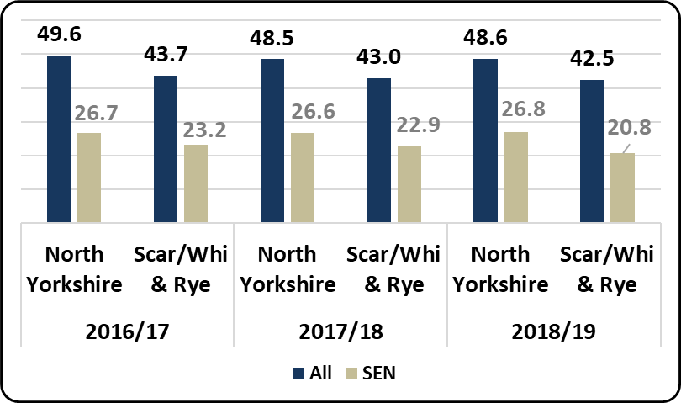
Average Attainment 8 scores at Key Stage 4 in schools - LA , Scarborough, Whitby and Ryedale locality and national - for the SEN cohort and the entire cohort

Fixed-term Exclusions
Primary Schools | Secondary Schools
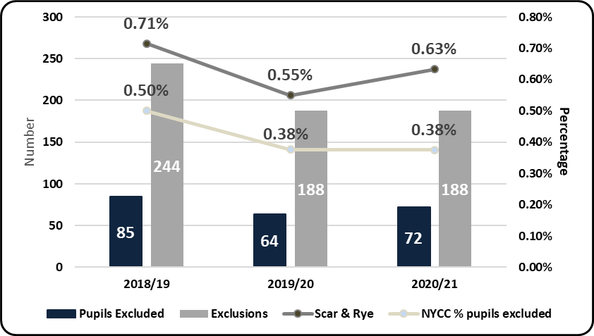 | 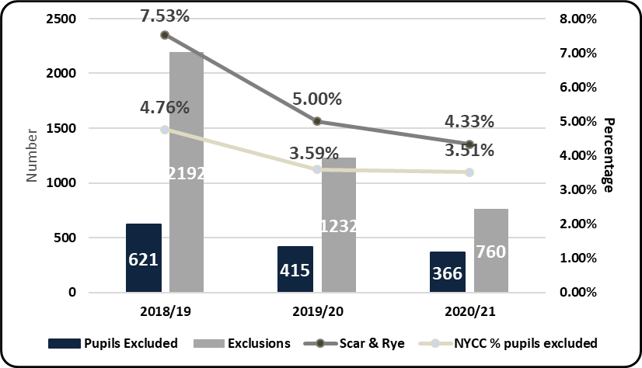
% of children fixed-term excluded at least once in schools in primary and secondary schools in North Yorkshire and Scarborough, Whitby and Ryedale locality in the 2019/20 and 2018/19 academic years

Primary Schools
- 0.24% of pupils (a total of 10 pupils) in Scarborough, Whitby and Ryedale primary schools were fixed period excluded at least once in the 2020/21 academic year, which was lower than the North Yorkshire primary school rate (0.38%). There were 11 pupils excluded from Scarborough, Whitby and Ryedale primary schools in 2019/20.
- There were a total of 22 fixed-period exclusions in Scarborough, Whitby and Ryedale primary schools in 2020/21, a 19% decrease on the previous year (27 exclusions). Fixed-period exclusions from Scarborough, Whitby and Ryedale primary schools formed 5.6% of the North Yorkshire total (391) in 2020/21.

Secondary Schools
- 2.28% of pupils (a total of 110 pupils) in Scarborough, Whitby and Ryedale secondary schools were fixed period excluded at least once in the 2020/21 academic year, which was a lower rate than the North Yorkshire secondary school rate (3.5%). Children fixed-period excluded from Scarborough, Whitby and Ryedale secondary schools formed 8.5% of the total for children fixed-period excluded from secondary schools in North Yorkshire in 2020/21 (1291).
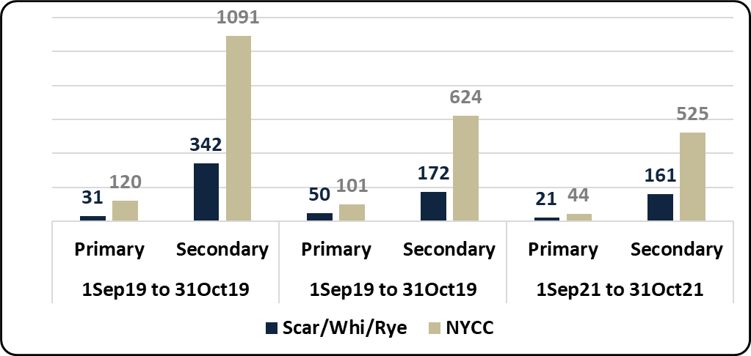
Fixed-Term exclusions in North Yorkshire mainstream schools (Primary and Secondary) - 2018/19, 2019/20 and 2020/21

- As of the end of October 2021/2022 there had been a total of 569 fixed-term exclusions from mainstream schools in North Yorkshire in the academic year. 182 (32%) of these occurred in mainstream schools in Scarborough, Whitby and Ryedale, 4.7% occurred in Scarborough, Whitby and Ryedale in the same period last year.
- There were 27% more fixed-term exclusions in the same period in North Yorkshire in 2019/20 (725). There were 22% more in Scarborough, Whitby and Ryedale in the same period (222).

Permanent Exclusions
2017/18 – 2020/21 Academic Years  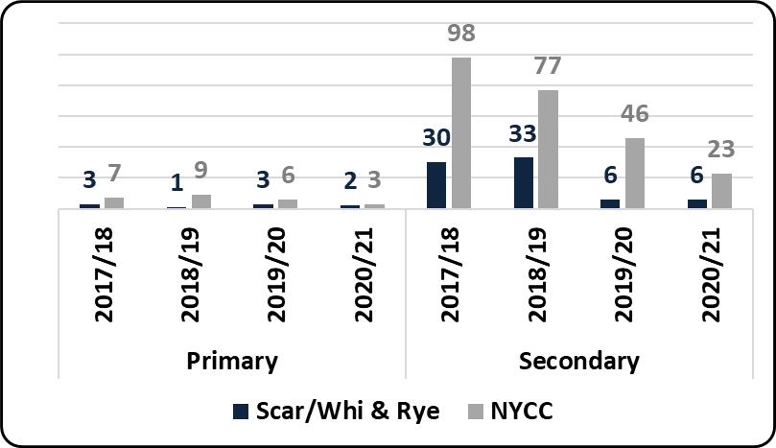 | 2018/19 – 2020/21 Academic Year to November  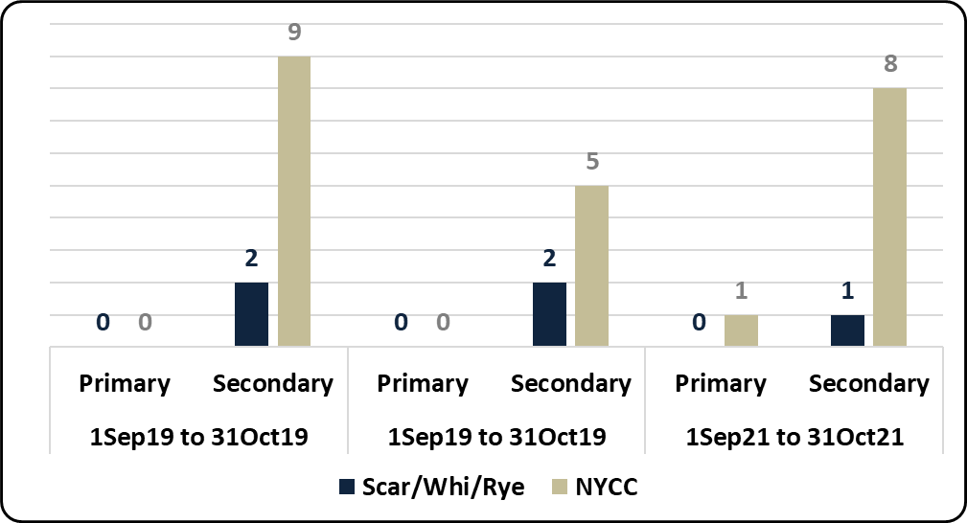
Permanent exclusions in primary and secondary schools in North Yorkshire and Scarborough, Whitby and Ryedale locality

- There have been no permanent exclusion from Scarborough, Whitby and Ryedale primary schools in the 2021/22 academic year to the end of October. In all of 2020/21 there were 2 permanent exclusion from Scarborough, Whitby and Ryedale primary schools and there were 3 in all of 2019/20.
- There was 1 permanent exclusion from Scarborough, Whitby and Ryedale secondary schools in the 2021/22 academic year to the end of October, 12.5% of the North Yorkshire total (8). There were 6 permanent exclusions from Scarborough, Whitby and Ryedale secondary schools in all of 2020/21 and 6 in 2019/20.
- The North Yorkshire total of permanent exclusions from mainstream schools in 2021/22 to the end of October was 9, higher than the 5 in 2020/21 in the same period. Permanent exclusions from Scarborough, Whitby and Ryedale mainstream schools in 2020/21 represented 31% of the North Yorkshire total (9 of 26), in 2019/20 Scarborough, Whitby and Ryedale permanent exclusions were 17.3% of the total (9 of 52).

 | North Yorkshire |  | National | Regional
 | 2020/21 | 2019/20
Fixed Exclusion - child (Secondary) % of school pop | 3.51% | 3.65% | 3.69% | 4.58%
Fixed Exclusion - child (Primary) % of school pop | 0.38% | 0.41% | 0.50% | 0.52%
Perm Exclusions (Secondary) % of school pop | 0.06% | 0.10% | 0.13% | 0.13%
Perm Exclusions (Primary) % of school pop | 0.01% | 0.01% | 0.02% | 0.01%
Table: Fixed exclusion rate and permanent exclusion rate of school population for phases shown – National and Regional comparison in academic years shown

Absence from school
NB: this is unverified data – it will be revised as local and national data is confirmed for 2020/21
Persistent Absence – All Children | - 19.29% of children were recorded as being persistently absent (i.e. attendance being less than 90% of possible sessions) through the 2020/21 academic year up to the end of the Spring-Term in Scarborough and Ryedale secondary schools  - This rate is considerably higher than the North Yorkshire rate for Secondary schools of 15.79%  - Attendance in primary schools is typically better than in secondary schools  - 13.03% of children were persistently absent for the two-term period in 2020/21 in Scarborough and Ryedale primary schools  - Again, this rate is higher than the North Yorkshire rate for Primary schools of 11.12%
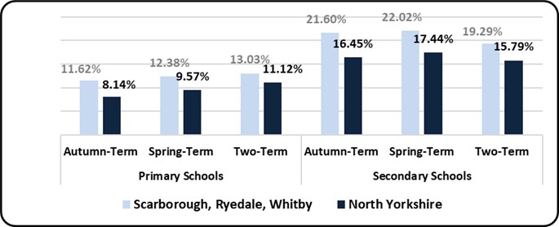
% of children on-roll recorded as being persistently absent in term shown of 2020/21
 | National (%)
 | 2019/20 | 2020/21
Primary | 11.2 | 9.9
Secondary | 15.0 | 16.3
Table - Autumn term persistent absence rate – National – primary and secondary schools
Persistent Absence – SEN (EHC plan, SEN Support) | - Absence from school for vulnerable groups is typically considerably higher than that of the whole school cohort.  - 31.8% of children recorded as SEN (either having an EHC plan or SEN Support) in Scarborough and Ryedale secondary schools were persistently absent in 2020/21 up to the end of Spring-Term. This rate is higher than the 29.5% for this cohort in North Yorkshire secondary schools  - The rate for SEN persistent absence in Scarborough and Ryedale primary schools was 20.6% in this period, similar to the North Yorkshire rate of 20.6%  - 37.31% of children recorded as receiving Free School Meals (on the day of the school census) in Scarborough and Ryedale secondary schools were persistently absent in 2020/21 up to the end of Spring-Term. This rate is considerably higher than the 32.7% for this cohort in North Yorkshire secondary schools  - The rate for FSM persistent absence in Scarborough and Ryedale primary schools was 22.0% in this period, similar to the North Yorkshire rate of 22.5%
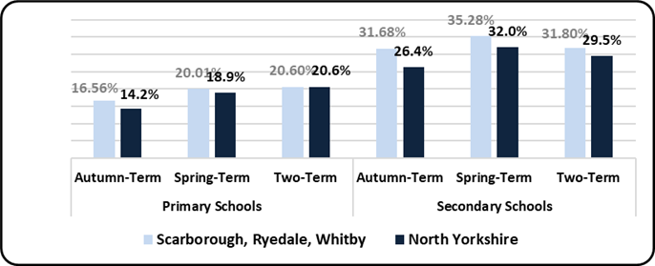
% of children on-roll recorded as being persistently absent in term shown of 2020/21
 | National (%) SEN
 | 2019/20 | 2020/21
Primary | 17.7 | 16.0
Secondary | 23.8 | 25.0
Table - Autumn term persistent absence rate – National – primary and secondary schools
Persistent Absence – FSM (Free School Meal at time of census)
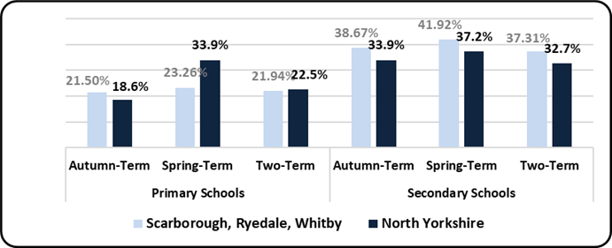
% of children on-roll recorded as being persistently absent in term shown of 2020/21
 | National (%) FSM Eligible
 | 2019/20 | 2020/21
Primary | 20.1 | 19.1
Secondary | 27.9 | 30.2
Table - Autumn term persistent absence rate – National – primary and secondary schools
Elective Home Education
Scarborough, Whitby and Ryedale | - As of 31st October 2021 there were a total of 827 children recorded as being Electively Home Educated (EHE) in North Yorkshire, 252 of these were formerly in a mainstream school in Scarborough/Whitby and Ryedale.  - 827 is a 7.8% increase on the same period in 2020 (767). There has also been a slight increase for children from Scarborough/Whitby and Ryedale. mainstream schools in this period of +8.2% (233 to 252)  - A total of 92 children became EHE from mainstream schools in North Yorkshire since the start of the 2021/22 academic year, for any length of time. 33 (36%) were formerly from mainstream schools in Scarborough/Whitby and Ryedale.  - There has been a 55% decrease (202 to 92) in North Yorkshire for children becoming EHE from mainstream schools in 2021/22, when compared to the same period last year. The % decrease in Scarborough/Whitby and Ryedale. was -54% (71 to 33)  - The figures above are for children recorded as being educated at home and not on the roll of a school.
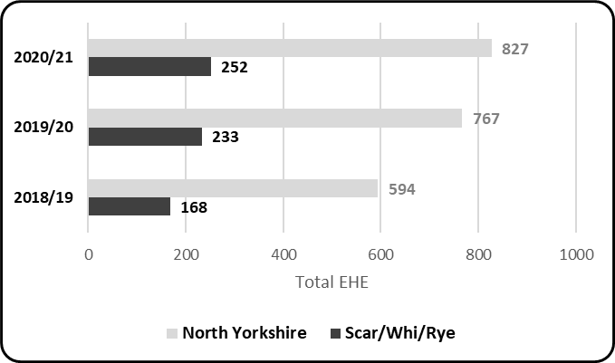
Children previously in a North Yorkshire mainstream school - recorded as Electively Home Educated (EHE) at 31st October in the calendar year shown
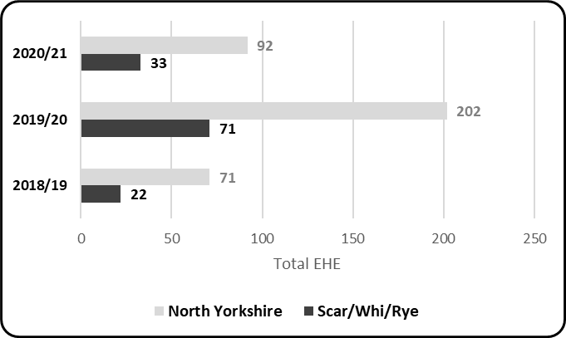
Children previously in a North Yorkshire mainstream school - becoming Electively Home Educated (EHE) 1st September to 31st October in the calendar year shown
- 1.27% is the rate of EHE of the mainstream school population in Scarborough, Whitby and Ryedale as of October 2021, which is much higher than the rate of EHE for the mainstream school population for North Yorkshire (1.02%)
- The above rate is an increase from 1.16% (+0.11pp) at October 2020
- North Yorkshire currently has a higher number of children EHE than at the same point last year but we are witnessing a decreasing trend following a high of 923 EHE in July 2021

Association of Directors of Children’s Services survey (October 2020) – national estimates
To gauge the relative size of the EHE cohort, LAs were asked to compare this to the wider school age population. 128 LAs responded to this question and a majority (80) reported that between 0.5% - 1.0% of their school aged population was being home educated on 1 October 2020. 26 LAs said that 4 the proportion was between 1.1% - 1.5% and 15 LAs said that the proportion of their school aged population being home educated was less than 0.5%. Only two LAs reported this to be more than 4%.

