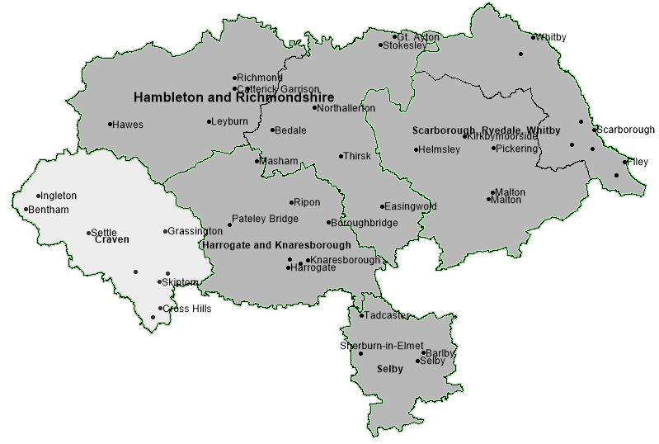
Craven
Locality - performance summary
Academy Schools - Craven
4 of the 31 primary schools in Craven are academies (12.9%), 98 of 302 in North Yorkshire (32.5%).
3 of the 6 secondary schools in Craven are academies (50%), 27 of 43 in North Yorkshire (60.5%).
Schools
355 schools in North Yorkshire
(302 primary, 43 secondary, 10 special)
38 in Craven
(31 primary and 6 secondary, 1 special)
School Population
81865 pupils in mainstream schools (primary and secondary) in North Yorkshire, 9058 in Craven (11.1%). There has been a 1.4% rise in the Craven school population from 8932 in the previous year. North Yorkshire has seen a slight decrease from 81274.

Good or Outstanding - Craven
As of March of 2022, proportion of schools with Good/Outstanding Ofsted outcome.
Primary Schools: 87.1% (North Yorkshire rate: 83.1%)
Secondary Schools: 83.3% (North Yorkshire rate: 72.1%)
0 to 25 Population
Craven: 13914, 24.3% of the population
North Yorkshire: 25.8%
Nationally: 31.0%

% of School population in Good or Outstanding school (most recent overall Ofsted outcome)
 | Mar-22 |  | Sep-21 |  | Sep-20 |  | Sep-19
 | Primary | Secondary | Primary | Secondary | Primary | Secondary | Primary | Secondary
Craven | 80.6% | 93.5% | 74.3% | 93.5% | 73.1% | 93.7% | 72.1% | 92.7%
North Yorkshire | 81.9% | 76.2% | 81.1% | 78.4% | 79.9% | 77.5% | 82.7% | 79.9%
National | 89.4% | 82.0% | 88.6% | 79.8% | 87.8% | 79.3% | 87.5% | 79.7%
% of school population in Good or Outstanding school (Ofsted) in locality shown at beginning of each academic year 2019 to 2021 and March 2022 phase shown
Headlines – Craven Schools Locality
Exclusions from school
- In 2020/2021 there had been a total of 3257 fixed-term exclusions from mainstream schools in North Yorkshire in the academic year. 178 (5.4%) of these occurred in mainstream schools in Craven, 5.3% occurred in Craven in the same period of 2019/20.
- As of the 28th April 2021/2022 there had been a total of 3215 fixed-term exclusions from mainstream schools in North Yorkshire in the academic year. 211 (6.6%) of these occurred in mainstream schools in Craven, 5.1% occurred in Craven in the same period last year.
- The North Yorkshire total of permanent exclusions from mainstream schools in 2020/21 was 26, considerably lower than the 52 in 2019/20.
- There has been 1 permanent exclusion from Craven primary schools in the 2021/22 academic year to the end of April, there have been 3 in North Yorkshire to date. In all of 2020/21 there were no permanent exclusion from Craven primary schools and there was 1 in all of 2019/20.
- There have been 2 permanent exclusions from Craven secondary schools in the 2021/22 academic year to the end of April, 5.5% of the North Yorkshire total (36). There was 1 permanent exclusions from Craven secondary schools in all of 2020/21 and 2 in 2019/20.

Attendance
- As of the end of March, 92% of all children on roll of mainstream schools in Craven were in attendance, a slightly higher proportion than the North Yorkshire total (89%) and similar to the rate at the end of February (92.6%).

Elective Home Education (EHE)
- As of 8th April 2022 there were a total of 902 children recorded as being Electively Home Educated (EHE) in North Yorkshire, 64 of these were formerly in a mainstream school in Craven
- A total of 280 children became EHE from mainstream schools in North Yorkshire since the start of the 2021/22 academic year, for any length of time. 13 (4.6%) were formerly from mainstream schools in Craven
- 0.71% is the rate of EHE of the mainstream school population in Craven as of April 2022, based on January 2022 school populations. This is lower than the rate of EHE for the mainstream school population for North Yorkshire (1.1%)
- Whilst the number of EHE is higher than the same point last year, a downward trend is beginning.

SEN in mainstream schools
- 11.5% of children in Craven schools recorded as SEN in 2022, well below the rate in North Yorkshire as a whole (13.9%).
- The SEN Support rate (9.9%) of the school population in Craven is the lowest of the five localities
- 1.6% of the Craven school population have an Education, Health and Care plan (EHCp) below the North Yorkshire rate of 1.95%.

Ofsted Outcomes
- As of March 2022, the rate of primary schools with a ‘Good’ or ‘Outstanding’ outcome in the locality at the most recent Ofsted inspection was 87.1%, slightly higher than the North Yorkshire average of 83.1%, having been below the rate at the beginning of the academic year. However, the secondary school rate was 83.3%, considerably above the county rate of 72.1%.
SEN Population in Schools
Craven  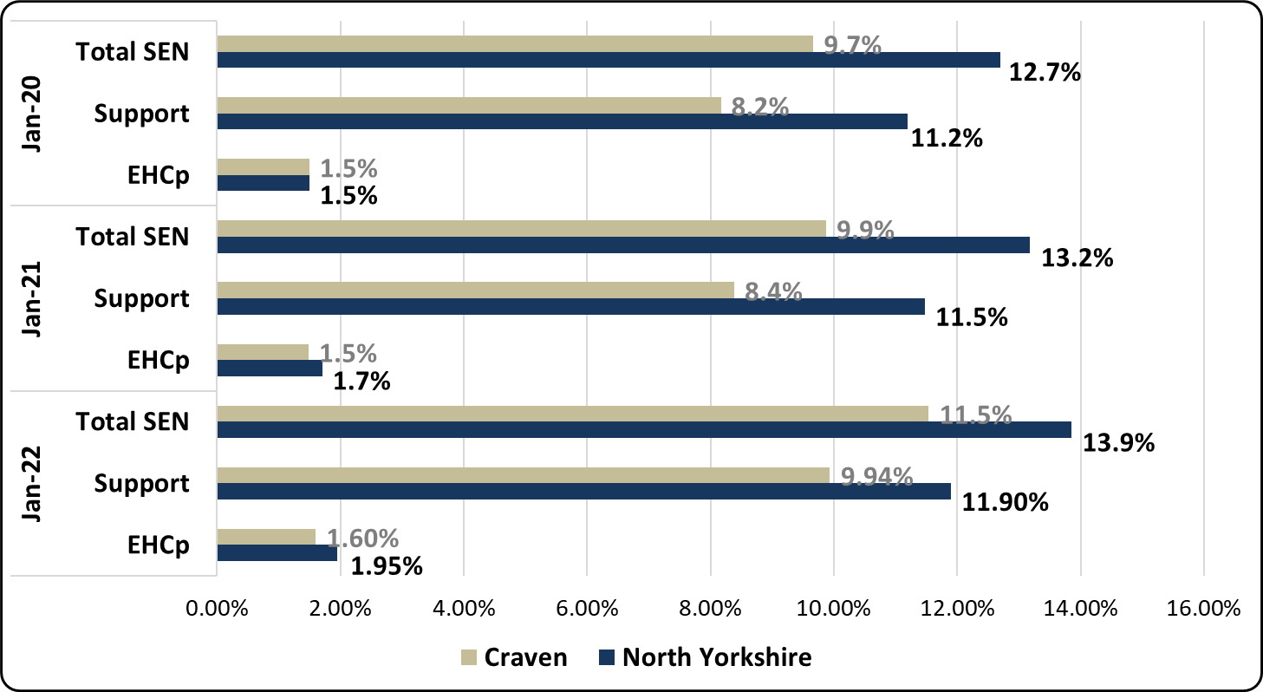 | - 11.5% of children in Craven schools recorded as SEN in 2022, well below the rate in North Yorkshire as a whole (13.9%).  - 11.5% is a 1.6 percentage point increase in SEN compared to 2021.  - 1.6% of the Craven school population have an Education, Health and Care plan (EHCp) below the North Yorkshire rate of 1.95%.  - 9.94% of the Craven school population are recorded as SEN Support well below the North Yorkshire rate of 11.9%.
Proportion of mainstream school population with SEN provision (by type of provision) in North Yorkshire and Craven school locality
 | National (2021) | NYCC 2022 | Craven 2022
Total SEN (Mainstream) | 14.1% | 13.9% | 11.5%
Total SEN Support (Mainstream) | 12.1% | 11.9% | 9.94%
Total EHC plan (Mainstream) | 2.0% | 1.95% | 1.60%
Proportion of mainstream school population with SEN provision (by type of provision) National comparisons in 2021

- The SEN Support rate (9.9%) of the mainstream school population in Craven is the lowest of the five localities.
- The EHC plan rate (1.6%) is slightly higher than last year’s rate (1.5%) and is lower than the North Yorkshire average (1.95%). The North Yorkshire rate increased from 1.7% to 1.95%.

Requests for Assessment
Craven | - There were a total of 702 requests for statutory assessment received by North Yorkshire County Council in 2020/21, 35 (5.0%) were received for children in mainstream schools in Craven.  - The above figures are slightly less than last year’s rates. 43, approximately 5.9% of the 726 requests received by NYCC in 2019/20 were for children in mainstream schools in Craven.  - As of 8th April 2022, there have been 482 requests for statutory assessment, 25 (5.2%) have been received for children in mainstream schools in Craven.
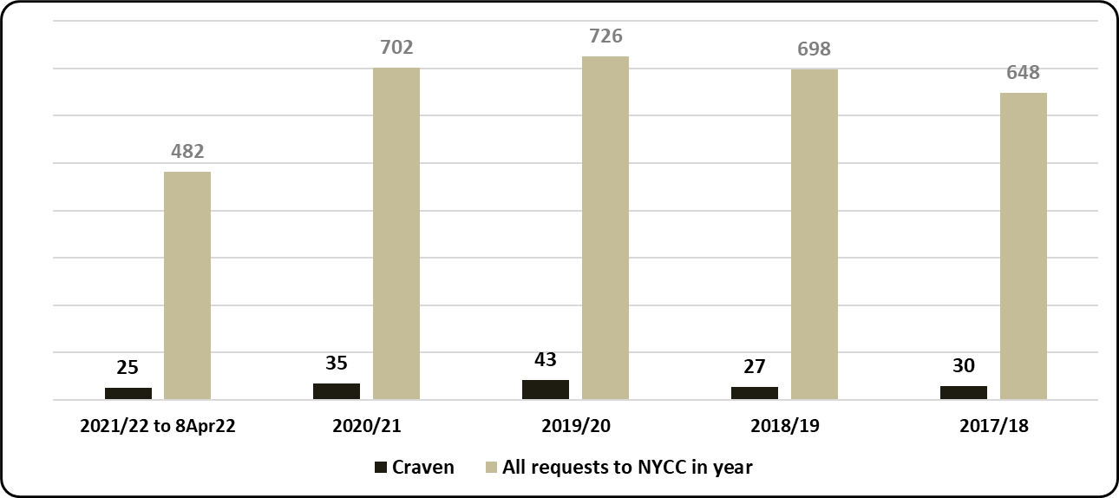
Requests for assessment (EHC plan) based on the mainstream school locality of child - North Yorkshire total received - by academic year
 | National |  | North Yorkshire |  | Yorkshire and the Humber
 | 2019/20 | 2020/21 | 2019/20 | 2020/21 | 2019/20 | 2020/21
Requests (% of Mainstream school population) | 0.94% | 0.98% | 0.75% | 0.75% | 0.79% | 0.86%
% Requests resulting in EHC plan (estimate where decision made) | 70.9% | 75.5% | 70.8% | 76.3% | 71.3% | 75.9%
% requests of school population and % resulting in EHC plan national and regional comparison
- 71% of requests for assessment from Craven schools in the 2020 calendar year resulted in an EHC plan (as of September 2021), a slightly lower rate than the North Yorkshire average of 74%. A proportion of requests received in the 2020/21 academic year are yet to be assessed, however, as of September 2021, 31% of requests in North Yorkshire have resulted in an EHC plan, the rate from Craven schools is 37%.
- 35 requests in 2020/21 is 0.39% of the Craven mainstream school population, which is lower than the North Yorkshire rate of 0.86%. It is also the lowest rate of the five school localities.

Attainment in Schools*
* The publication of results for Early Years Foundation Stage Profile and Key Stage 2 has been cancelled for 2020/21 (Covid-19)
https://www.gov.uk/government/collections/statistics-key-stage-2
Early Years Foundation Stage
 |  | All | Gender |  | SEN |  | EAL |  | Disadvantaged
 |  |  | Girls | Boys | Yes | No | Yes | No | Yes | No
2016/17 | North Yorkshire | 71.8 | 77.6 | 65.8 | 19.6 | 75.6 | 60.9 | 72.8 | 53.1 | 73.7
 | National | 70.7 | 77.7 | 64.0 | 23.0 | 75.9 | 64.5 | 72.6 | 56.6 | 73.3
 | Craven | 71.9 | 77.9 | 65.6 | 20.0 | 74.5 | 55.2 | 73 | 53.8 | 73.2
2017/18 | North Yorkshire | 72.5 | 79.6 | 65.7 | 22.7 | 77.0 | 61.0 | 73.5 | 50.3 | 74.8
 | National | 71.5 | 78.5 | 65.0 | 23.8 | 77.0 | 66.1 | 73.4 | 57.2 | 74.3
 | Craven | 71.9 | 79.5 | 63.4 | 8.1 | 77.0 | 47.4 | 74 | 53.1 | 73.7
2018/19 | North Yorkshire | 72.8 | 79.4 | 66.7 | 21.5 | 77.4 | 64.4 | 73.7 | 50.9 | 75.2
 | National | 71.8 | 78.4 | 65.5 | 24.3 | 77.4 | 66.6 | 73.6 | 56.4 | 74.4
 | Craven | 72.3 | 80 | 66 | 10.7 | 75.9 | 56.5 | 73 | 50 | 74.1
% of children in schools at EYFS achieving a GLD - LA , Craven locality and national – in years 2016/17 to 2018/19
- pupil characteristics shown
Attainment of all pupils in Early Years Foundation Stage (72.3%) in the locality in 2018/19 was slightly lower than the North Yorkshire rate (72.8%) of children achieving a Good Level of Development (GLD) but continues to be higher than the National rate (71.8%).
As is the case in North Yorkshire and Nationally, attainment of girls in the locality (80%) was considerably higher than that of boys (66%). Attainment of Disadvantaged children in the locality (50%) has been lower than the National rate (56.4%) as is the case in North Yorkshire (50.9%).

Early Years Foundation Stage - SEN | - 72.3% of children in Craven schools achieved a good level of development in 2018/19, a -0.5 percentage point difference from the North Yorkshire rate. This was a 0.4 percentage point increase on the previous year (71.9% in 2017/18).  - 10.7% of the SEN cohort (children recorded with EHC plans or SEN Support) in Craven schools achieved a good level of development in 2018/19 which was a 2.6 percentage point increase on the previous year but a lower rate than North Yorkshire as a whole (21.5%).
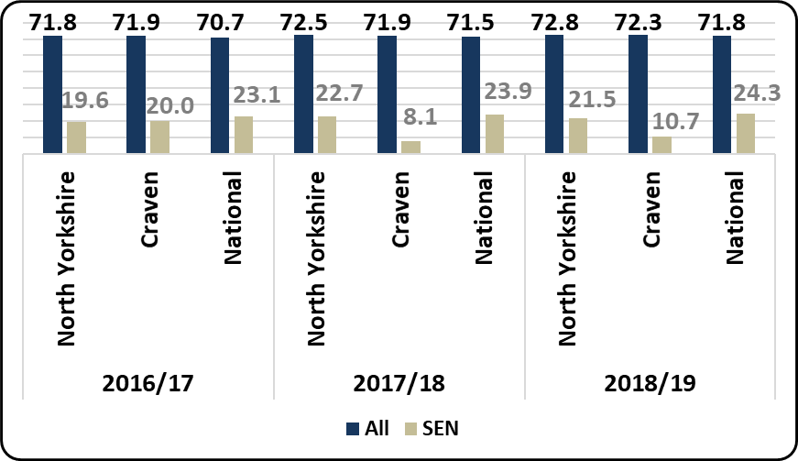
% of children in schools - LA , Craven locality and national - achieving a Good Level of Development (% GLD) for the SEN cohort and the entire cohort

Key Stage 2
 |  | All | Gender |  | SEN |  | EAL |  | Disadvantaged |  | Mobile
 |  |  | Girls | Boys | Yes | No | Yes | No | Yes | No | Yes | No
2016/17 | North Yorkshire | 59.0 | 62.7 | 55.5 | 13.4 | 67.7 | 54.4 | 59.2 | 38.7 | 64.3 | 45.9 | 60.3
 | National | 61.1 | 65.0 | 57.4 | 18.3 | 70.2 | 58.3 | 61.9 | 47.4 | 67.4 | 43.1 | 62.6
 | Craven | 60.8 | 63.0 | 59.0 | 16.9 | 67.9 | 52.4 | 61.2 | 42.5 | 65.4 | 36.4 | 62.8
2017/18 | North Yorkshire | 62.1 | 66.9 | 57.6 | 19.3 | 71.4 | 59.4 | 62.4 | 44.1 | 66.8 | 53.2 | 63.0
 | National | 64.4 | 68.4 | 60.5 | 21.3 | 73.7 | 62.9 | 64.8 | 50.6 | 70.5 | 47.0 | 65.8
 | Craven | 62.2 | 67.1 | 58.5 | 14.0 | 72.5 | 60.9 | 62.8 | 34.0 | 68.8 | 44.3 | 64.9
2018/19 | North Yorkshire | 63.4 | 68.8 | 58.3 | 18.1 | 73.0 | 60.1 | 63.6 | 45.6 | 68.5 | 54.6 | 64.2
 | National | 64.9 | 69.7 | 60.2 | 22.3 | 74.3 | 63.8 | 65.3 | 51.3 | 70.8 | 47.2 | 66.3
 | Craven | 61.8 | 69.5 | 55.2 | 11.8 | 72.0 | 76.9 | 61.3 | 39.3 | 66.6 | 48.9 | 62.9
% of children in schools at Key Stage 2 achieving the expected standard - LA , Craven locality and national – in years 2016/17 to 2018/19 - pupil characteristics shown
Attainment of all pupils in Key Stage 2 achieving the expected standard (61.8%) in the locality in 2018/19 was lower than the North Yorkshire rate (63.4%) and lower than the National rate (64.9%).
As is the case in North Yorkshire and Nationally, attainment of girls in the locality (69.5%) was considerably higher than that of boys (55.2%). Attainment of Disadvantaged children in the locality (39.3%) has been considerably lower than the National rate (51.3%) and the North Yorkshire rate (45.6%).
Key Stage 2 - SEN | - 61.8% of children in Craven schools achieved the expected standard for reading, writing and maths (%RWM) in 2018/19, this was a 0.4 percentage point decrease on the previous year.  - 11.8% of the SEN cohort (children recorded with EHC plans or SEN Support) in Craven schools achieved the expected standard for reading, writing and maths in 2018/19 which was a 2.2 percentage point drop on the previous year. This was also a lower rate than North Yorkshire as a whole (18.1%).
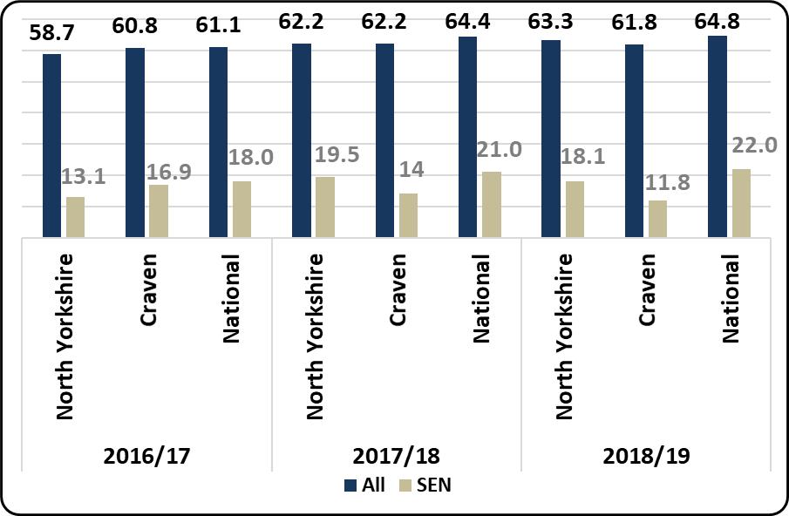

Key Stage 4
 |  | All | Gender |  | SEN |  | EAL |  | Disadvantaged |  | Mobile
 |  |  | Girls | Boys | Yes | No | Yes | No | Yes | No | Yes | No
2016/17 | North Yorkshire | 49.6 | 52.6 | 46.7 | 26.7 | 51.7 | 49.8 | 49.6 | 35.5 | 52.1 | 34.8 | 49.9
 | National | 46.3 | 49.0 | 43.7 | 27.1 | 49.5 | 46.8 | 46.3 | 37.0 | 49.8 | 32.4 | 46.8
 | Craven | 54.4 | 56.3 | 53.7 | 36.0 | 55.9 | 51.5 | 55.2 | 39.2 | 56.8 | 49.1 | 55.0
2017/18 | North Yorkshire | 48.5 | 51.3 | 45.8 | 26.6 | 51.3 | 45.9 | 48.5 | 34.4 | 51.2 | 31.2 | 49.3
 | National | 46.5 | 49.3 | 43.8 | 27.2 | 49.8 | 47.2 | 46.5 | 36.7 | 50.1 | 32.1 | 47.1
 | Craven | 50.5 | 53.4 | 47.1 | 28.5 | 52.6 | 43.9 | 51 | 35.2 | 52.3 | 13.6 | 51.5
2018/19 | North Yorkshire | 48.6 | 51.4 | 46.1 | 26.8 | 51.4 | 48.3 | 48.7 | 34.7 | 51.3 | 30.8 | 49.2
 | National | 46.7 | 49.5 | 44.0 | 27.6 | 49.9 | 47.6 | 46.6 | 36.7 | 50.3 | 31.8 | 47.2
 | Craven | 53.4 | 55.7 | 49.1 | 36.8 | 55.2 | 48.8 | 53 | 37.5 | 54.4 | 8.9 | 53.4
Average Attainment 8 score of children in schools at Key Stage 4 - LA , Craven locality and national
– in years 2016/17 to 2018/19 - pupil characteristics shown
The Average Attainment 8 score of all pupils in Key Stage 4 (53.4) in the locality in 2018/19 was much higher than the North Yorkshire rate (48.6) and the National score (46.7).
As is the case in North Yorkshire and Nationally, average Attainment 8 scores of girls in the locality (55.7) were higher than that of boys (49.1). Attainment of Disadvantaged children in the locality (37.5) has been considerably lower than that of non-Disadvantaged children (54.4) but slightly higher than the National score for that cohort (36.7) and the North Yorkshire score (34.7).
Key Stage 4 - SEN | - The average Attainment 8 score for children in schools in the Craven locality was 53.4 in 2018/19, a 2.9 percentage point increase on the previous year and higher than the average score for North Yorkshire (48.6).  - The average Attainment 8 score for children with SEN in Craven schools was 36.8 up by 8.3 on the previous year and considerably above the North Yorkshire average score of 26.8.
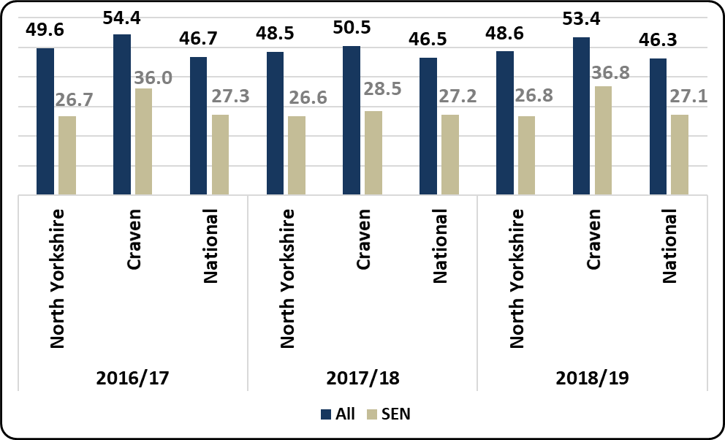
Average Attainment 8 scores at Key Stage 4 in schools - LA , Craven locality and national - for the SEN cohort and the entire cohort

Fixed-term Exclusions
Primary Schools | Secondary Schools
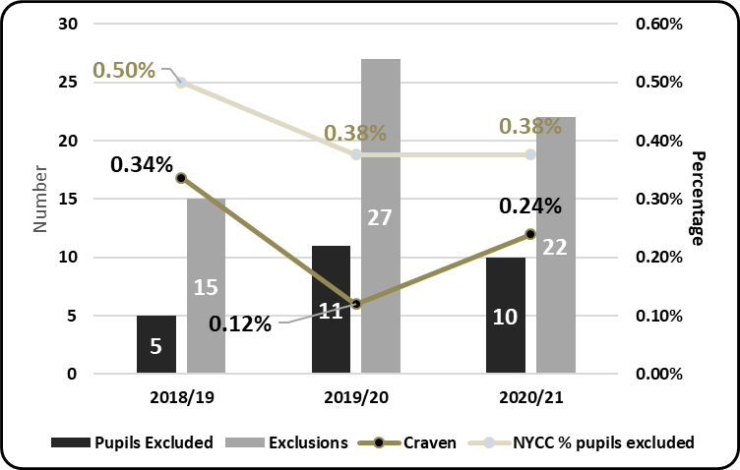 | 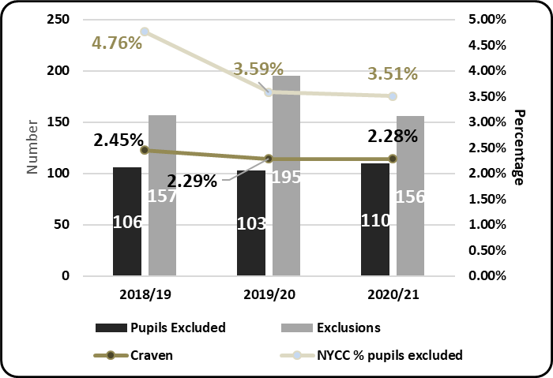
% of children fixed-term excluded at least once in schools in primary and secondary schools in North Yorkshire and Craven locality in the 2020/21, 2019/20 and 2018/19 academic years

Primary Schools
- 0.24% of pupils (a total of 10 pupils) in Craven primary schools were fixed period excluded at least once in the 2020/21 academic year, which was lower than the North Yorkshire primary school rate (0.38%). There were 11 pupils excluded from Craven primary schools in 2019/20.
- There were a total of 22 fixed-period exclusions in Craven primary schools in 2020/21, a 19% decrease on the previous year (27 exclusions). Fixed-period exclusions from Craven primary schools formed 5.6% of the North Yorkshire total (391) in 2020/21.

Secondary Schools
- 2.28% of pupils (a total of 110 pupils) in Craven secondary schools were fixed period excluded at least once in the 2020/21 academic year, which was a lower rate than the North Yorkshire secondary school rate (3.5%). Children fixed-period excluded from Craven secondary schools formed 8.5% of the total for children fixed-period excluded from secondary schools in North Yorkshire in 2020/21 (1291).
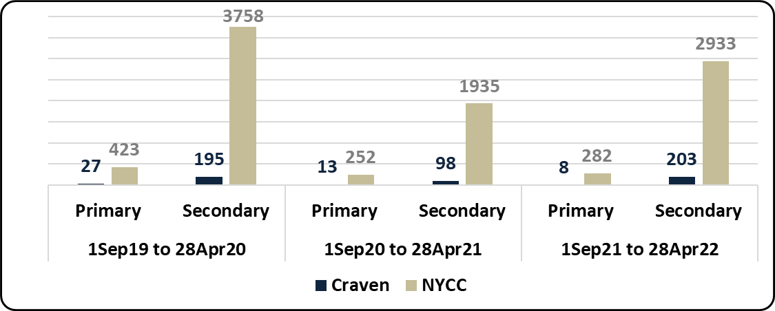
Fixed-Term exclusions in North Yorkshire mainstream schools (Primary and Secondary) - 2018/19, 2019/20 and 2020/21

- As of the 28th April 2021/2022 there had been a total of 3215 fixed-term exclusions from mainstream schools in North Yorkshire in the academic year. 211 (6.6%) of these occurred in mainstream schools in Craven, 5.1% occurred in Craven in the same period last year.
- There were 30% fewer fixed-term exclusions in the same period in North Yorkshire of 2020/21 (when there were 2187 exclusions). There were 47% fewer in Craven in the same period (111).

Permanent Exclusions
2017/18 – 2020/21 Academic Years  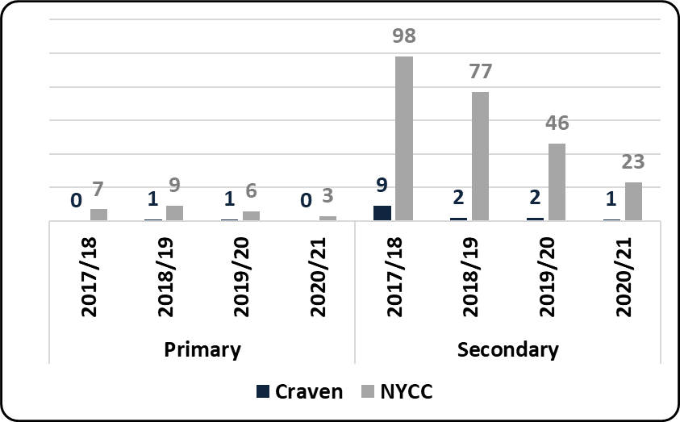 | 2018/19 – 2020/21 Academic Year to April  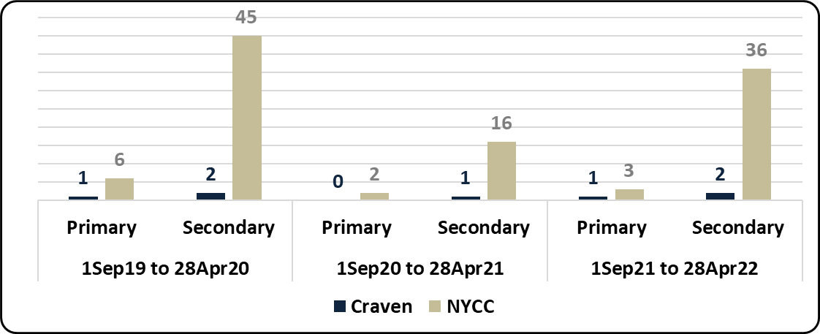
Permanent exclusions in primary and secondary schools in North Yorkshire and Craven locality

- There has been 1 permanent exclusion from Craven primary schools in the 2021/22 academic year to the end of April, there have been 3 in North Yorkshire to date. In all of 2020/21 there were no permanent exclusion from Craven primary schools and there was 1 in all of 2019/20.
- There have been 2 permanent exclusions from Craven secondary schools in the 2021/22 academic year to the end of April, 5.5% of the North Yorkshire total (36). There was 1 permanent exclusions from Craven secondary schools in all of 2020/21 and 2 in 2019/20.
- The North Yorkshire total of permanent exclusions from mainstream schools in 2021/22 to the end of April was 39, much higher than the 18 in 2020/21 in the same period. Permanent exclusions from Craven mainstream schools in 2020/21 represented 3.8% of the North Yorkshire total (1 of 26), in 2019/20 Craven permanent exclusions formed 5.8% of the total (3 of 52).
 | North Yorkshire |  | National | Regional
 | 2020/21 | 2019/20
Fixed Exclusion - child (Secondary) % of school pop | 3.51% | 3.65% | 3.69% | 4.58%
Fixed Exclusion - child (Primary) % of school pop | 0.38% | 0.41% | 0.50% | 0.52%
Perm Exclusions (Secondary) % of school pop | 0.06% | 0.10% | 0.13% | 0.13%
Perm Exclusions (Primary) % of school pop | 0.01% | 0.01% | 0.02% | 0.01%
Table: Fixed exclusion rate and permanent exclusion rate of school population for phases shown – National and Regional comparison in academic year

School Attendance
Craven | - As of the end of March, 92% of all children on roll of mainstream schools in Craven were in attendance, a slightly higher proportion than the North Yorkshire total (89%) and similar to the rate at the end of February (92.6%).  - 82% of children with EHC plans in mainstream schools in the locality were in attendance at the end of March, similar to the 80.5% in the County. This locality rate is lower than previous months, after a high of 91% in January but similar to September.  - 89% of children eligible for free school meals (FSM) in mainstream schools in the locality were in attendance at the end of March, a higher rate than in September and a higher rate than the 86% countywide.
 |  | 2020/21
 | Mainstream school in: | End Sep | End Oct | End Nov | End Dec | End Jan | End Feb | End Mar
All pupils | Craven | 92.3% | 89.5% | 90.2% | 85.4% | 89.0% | 92.6% | 91.9%
 | North Yorkshire | 90.3% | 88.1% | 89.4% | 87.1% | 88.0% | 90.6% | 89.1%
EHC plans | Craven | 81.3% | 82.0% | 85.7% | 80.5% | 91.0% | 86.5% | 81.6%
 | North Yorkshire | 79.5% | 81.7% | 83.7% | 81.6% | 81.7% | 83.6% | 80.5%
Eligible for FSM | Craven | 86.6% | 86.0% | 87.6% | 83.3% | 86.0% | 89.4% | 89.3%
 | North Yorkshire | 85.1% | 85.3% | 85.7% | 83.1% | 84.0% | 86.8% | 85.5%

% of children on-roll recorded as attending at end of month shown 2020/21 (open mainstream schools)

Elective Home Education
Craven | - As of 8th April 2022 there were a total of 902 children recorded as being Electively Home Educated (EHE) in North Yorkshire, 64 of these were formerly in a mainstream school in Craven  - 902 is a 5.9% increase on the same point in 2020 (852). There were 64 from Craven mainstream schools the same as that point last year (64 to 64)  - A total of 280 children became EHE from mainstream schools in North Yorkshire since the start of the 2021/22 academic year, for any length of time. 13 (4.6%) were formerly from mainstream schools in Craven  - There has been a 23% decrease (364 to 280) in North Yorkshire for children becoming EHE from mainstream schools in 2021/22, when compared to the same period last year. The % decrease in Craven was -41% (22 to 13)  - The figures above are for children recorded as being educated at home and not on the roll of a school.
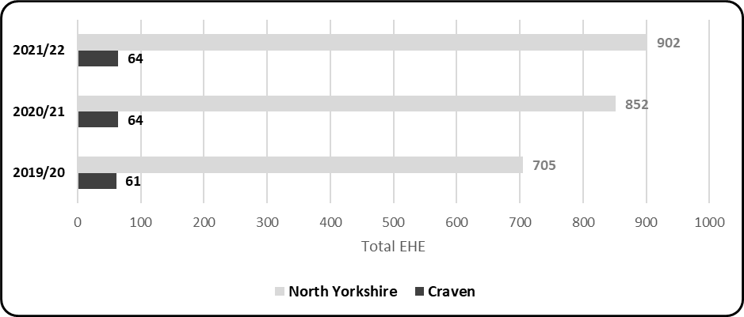
Children previously in a North Yorkshire mainstream school - recorded as Electively Home Educated (EHE) at 8th April in the calendar year shown
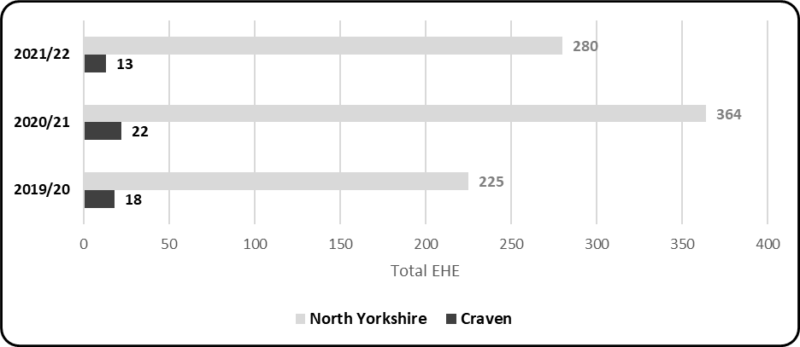
Children previously in a North Yorkshire mainstream school - becoming Electively Home Educated (EHE) 1st September to 8th April in the calendar year shown
- 0.71% is the rate of EHE of the mainstream school population in Craven as of April 2022, based on January 2022 school populations. This is lower than the rate of EHE for the mainstream school population for North Yorkshire (1.1%)
- North Yorkshire currently has a higher number of children EHE than at the same point last year but we are witnessing a decreasing trend following a high of 923 EHE in July 2021

Association of Directors of Children’s Services survey (October 2021) – national estimates
On school census day, 7 October 2021, a total of 67,308 children and young people were known to be electively home educated (EHE) across 126 responding LAs. It is therefore estimated that 81,196 children and young people were EHE across all 152 LAs in England. Approximately 1.0% of the National mainstream school population (8,153,771 pupils as of January 2021).
This represents an increase of approximately 7% from the same school census day in 2020.

