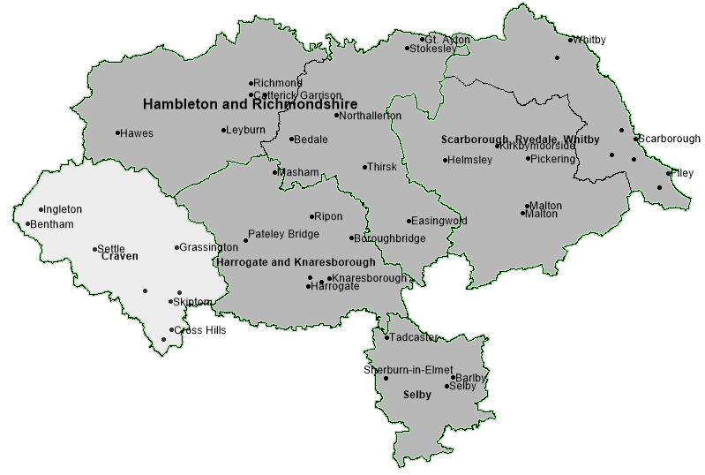
Craven
Locality - performance summary
Academy Schools - Craven
4 of the 31 primary schools in Craven are academies (12.9%), 96 of 303 in North Yorkshire (32.2%).
3 of the 6 secondary schools in Craven are academies (50%), 26 of 43 in North Yorkshire (60.5%).
Schools
356 schools in North Yorkshire
(302 primary, 43 secondary, 10 special)
37 in Craven
(31 primary and 6 secondary, 1 special)
School Population
81274 pupils in mainstream schools (primary and secondary) in North Yorkshire, 8932 in Craven (11.0%). There has been a 1.5% rise in the Craven school population from 8802 in the previous year. North Yorkshire has seen a very slight decrease from 81340.

0 to 25 Population
Craven: 13914, 24.3% of the population
North Yorkshire: 25.8%
Nationally: 31.0%

Good or Outstanding - Craven
As of October of 2021, proportion of schools with Good/Outstanding Ofsted outcome.
Primary Schools: 80.6% (North Yorkshire rate: 81.8%)
Secondary Schools: 83.3% (North Yorkshire rate: 74.4%)

% of School population in Good or Outstanding school (most recent overall Ofsted outcome)
 | Sep-21 |  | Sep-20 |  | Sep-19
 | Primary | Secondary | Primary | Secondary | Primary | Secondary
Craven | 74.2% | 93.5% | 73.1% | 93.7% | 72.1% | 92.7%
North Yorkshire | 81.1% | 78.4% | 79.9% | 77.5% | 82.7% | 79.9%
National | 88.6% | 79.8% | 87.8% | 79.3% | 87.5% | 79.7%
% of school population in Good or Outstanding school (Ofsted) in locality shown in September of each year 2019 to 2021 by phase shown
Headlines – Craven Schools Locality
Exclusions from school
- In 2020/2021 there had been a total of 3257 fixed-term exclusions from mainstream schools in North Yorkshire in the academic year. 178 (5.4%) of these occurred in mainstream schools in Craven, 5.3% occurred in Craven in the same period of 2019/20.
- As of the end of October 2021/2022 there had been a total of 569 fixed-term exclusions from mainstream schools in North Yorkshire in the academic year. 47 (8.3%) of these occurred in mainstream schools in Craven, 4.7% occurred in Craven in the same period last year
- The North Yorkshire total of permanent exclusions from mainstream schools in 2020/21 was 26, considerably lower than the 52 in 2019/20.
- There has been 1 permanent exclusion from Craven primary schools in the 2021/22 academic year to the end of October, the only one in North Yorkshire to date. In all of 2020/21 there were no permanent exclusion from Craven primary schools and there was 1 in all of 2019/20.
- There has also been 1 permanent exclusion from Craven secondary schools in the 2021/22 academic year to the end of October, 11.1% of the North Yorkshire total (9). There were no permanent exclusions from Craven secondary schools in all of 2020/21 and 1 in 2019/20.

Attendance

- Rates of persistent absence from mainstream schools in the locality have been considerably lower than the North Yorkshire rate for all children. In the first two-terms of 2020/21, 11.5% of children in secondary schools and 8.9% of children in primary schools in the locality were recorded as persistently absent i.e. absent for more than 10% of possible sessions. The rate for North Yorkshire was 15.8% and 11.1% respectively.
- Rates of persistent absence amongst children recorded as SEN (EHC plan or SEN Support) in secondary schools in the locality in 2020/21 (first two terms) were considerably lower than the North Yorkshire rate. 21% were persistently absent from Selby secondary schools compared to 29.5% in North Yorkshire.

Elective Home Education (EHE)

- As of 31st October 2021 there were a total of 827 children recorded as being Electively Home Educated (EHE) in North Yorkshire, 65 of these were formerly in a mainstream school in Craven.
- A total of 92 children became EHE from mainstream schools in North Yorkshire since the start of the 2021/22 academic year, for any length of time. 6 (6.5%) were formerly from mainstream schools in Craven
- 0.73% is the rate of EHE of the mainstream school population in Craven as of October 2021, which is lower than the rate of EHE for the mainstream school population for North Yorkshire (1.02%)
- Whilst the number of EHE is higher than the same point last year, a downward trend is beginning.

SEN in mainstream schools
- 9.9% of children in Craven schools were recorded as having special educational needs in the January 2021 school census, a much lower rate to the North Yorkshire rate as a whole of 13.2%
- The SEN Support rate (8.4%) of the school population in Craven is the lowest of the five localities
The EHC plan rate (1.5%) has remained the same as last year’s rate and is now lower than the North Yorkshire average (1.7%). The North Yorkshire rate increased from 1.5% to 1.7%.

Ofsted Outcomes

- As of the beginning of 2021, the rate of primary schools with a ‘Good’ or ‘Outstanding’ outcome in the locality at the most recent Ofsted inspection was 80.6%, slightly lower than the North Yorkshire average of 81.8%. However, the secondary school rate was 83.3%, considerably above the county rate of 74.4%.
SEN Population in Schools
Craven | - 9.9% of children in Craven schools recorded as SEN in 2021, well below the rate in North Yorkshire as a whole (13.2%).  - 9.9% is a 0.2 percentage point increase in SEN compared to 2021.  - 1.5% of the Craven school population have an Education, Health and Care plan (EHCp) below the North Yorkshire rate of 1.7%.  - 8.4% of the Craven school population are recorded as SEN Support well below the North Yorkshire rate of 11.5%.
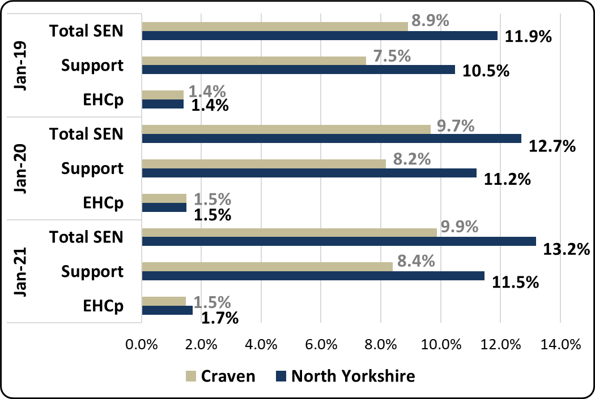
Proportion of mainstream school population with SEN provision (by type of provision) in North Yorkshire and Craven school locality

 | National | NYCC | Craven
Total SEN (Mainstream) | 14.1% | 13.2% | 9.9%
Total SEN Support (Mainstream) | 12.1% | 11.5% | 8.4%
Total EHC plan (Mainstream) | 2.0% | 1.7% | 1.5%
Proportion of mainstream school population with SEN provision (by type of provision) National comparisons in 2021

- The SEN Support rate (8.4%) of the school population in Craven is the lowest of the five localities
- The EHC plan rate (1.5%) has remained the same as last year’s rate and is now lower than the North Yorkshire average (1.7%). The North Yorkshire rate increased from 1.5% to 1.7%.

Requests for Assessment
Craven | - There were a total of 702 requests for statutory assessment received by North Yorkshire County Council in 2020/21, 35 (5.0%) were received for children in mainstream schools in Craven.  - The above figures are slightly less than last year’s rates. 43, approximately 5.9% of the 726 requests received by NYCC in 2019/20 were for children in mainstream schools in Craven.  - As of the end of 31st October 2021, there have been 102 requests for statutory assessment, 7 (6.9%) have been received for children in mainstream schools in Craven.
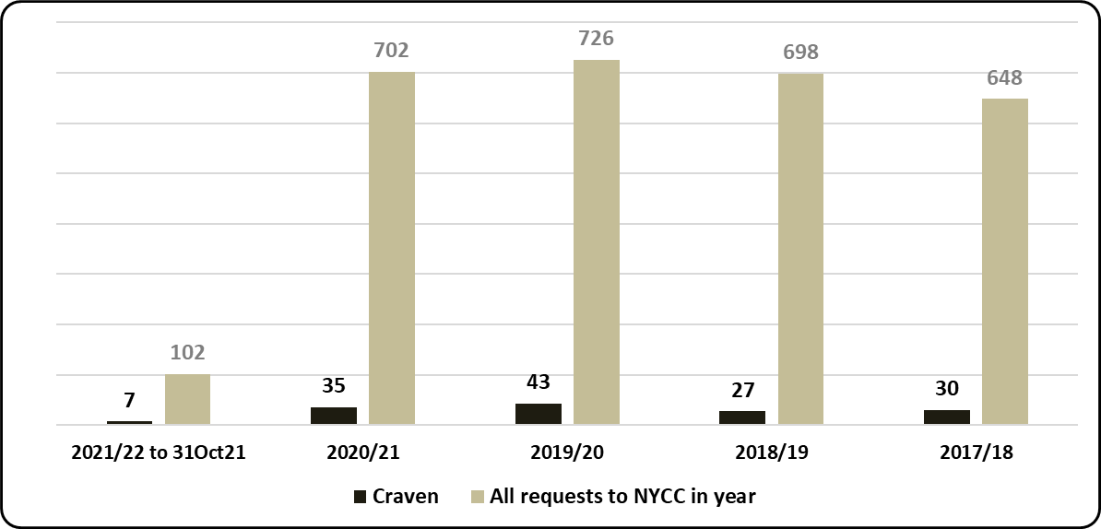
Requests for assessment (EHC plan) based on the mainstream school locality of child - North Yorkshire total received - by academic year
 | National |  | North Yorkshire |  | Yorkshire and the Humber
 | 2019/20 | 2020/21 | 2019/20 | 2020/21 | 2019/20 | 2020/21
Requests (% of Mainstream school population) | 0.94% | 0.98% | 0.75% | 0.75% | 0.79% | 0.86%
% Requests resulting in EHC plan (estimate where decision made) | 70.9% | 75.5% | 70.8% | 76.3% | 71.3% | 75.9%
% requests of school population and % resulting in EHC plan national and regional comparison
- 71% of requests for assessment from Craven schools in the 2020 calendar year resulted in an EHC plan (as of September 2021), a slightly lower rate than the North Yorkshire average of 74%. A proportion of requests received in the 2020/21 academic year are yet to be assessed, however, as of September 2021, 31% of requests in North Yorkshire have resulted in an EHC plan, the rate from Craven schools is 37%.
- 35 requests in 2020/21 is 0.39% of the Craven mainstream school population, which is lower than the North Yorkshire rate of 0.86%. It is also the lowest rate of the five school localities.

Attainment in Schools*
* The publication of results for Early Years Foundation Stage Profile and Key Stage 2 has been cancelled for 2020/21 (Covid-19)
https://www.gov.uk/government/collections/statistics-key-stage-2
Early Years Foundation Stage
 |  | All | Gender |  | SEN |  | EAL |  | Disadvantaged
 |  |  | Girls | Boys | Yes | No | Yes | No | Yes | No
2016/17 | North Yorkshire | 71.8 | 77.6 | 65.8 | 19.6 | 75.6 | 60.9 | 72.8 | 53.1 | 73.7
 | National | 70.7 | 77.7 | 64.0 | 23.0 | 75.9 | 64.5 | 72.6 | 56.6 | 73.3
 | Craven | 71.9 | 77.9 | 65.6 | 20.0 | 74.5 | 55.2 | 73 | 53.8 | 73.2
2017/18 | North Yorkshire | 72.5 | 79.6 | 65.7 | 22.7 | 77.0 | 61.0 | 73.5 | 50.3 | 74.8
 | National | 71.5 | 78.5 | 65.0 | 23.8 | 77.0 | 66.1 | 73.4 | 57.2 | 74.3
 | Craven | 71.9 | 79.5 | 63.4 | 8.1 | 77.0 | 47.4 | 74 | 53.1 | 73.7
2018/19 | North Yorkshire | 72.8 | 79.4 | 66.7 | 21.5 | 77.4 | 64.4 | 73.7 | 50.9 | 75.2
 | National | 71.8 | 78.4 | 65.5 | 24.3 | 77.4 | 66.6 | 73.6 | 56.4 | 74.4
 | Craven | 72.3 | 80 | 66 | 10.7 | 75.9 | 56.5 | 73 | 50 | 74.1
% of children in schools at EYFS achieving a GLD - LA , Craven locality and national – in years 2016/17 to 2018/19
- pupil characteristics shown
Attainment of all pupils in Early Years Foundation Stage (72.3%) in the locality in 2018/19 was slightly lower than the North Yorkshire rate (72.8%) of children achieving a Good Level of Development (GLD) but continues to be higher than the National rate (71.8%).
As is the case in North Yorkshire and Nationally, attainment of girls in the locality (80%) was considerably higher than that of boys (66%). Attainment of Disadvantaged children in the locality (50%) has been lower than the National rate (56.4%) as is the case in North Yorkshire (50.9%).

Early Years Foundation Stage - SEN | - 72.3% of children in Craven schools achieved a good level of development in 2018/19, a -0.5 percentage point difference from the North Yorkshire rate. This was a 0.4 percentage point increase on the previous year (71.9% in 2017/18).  - 10.7% of the SEN cohort (children recorded with EHC plans or SEN Support) in Craven schools achieved a good level of development in 2018/19 which was a 2.6 percentage point increase on the previous year but a lower rate than North Yorkshire as a whole (21.5%).
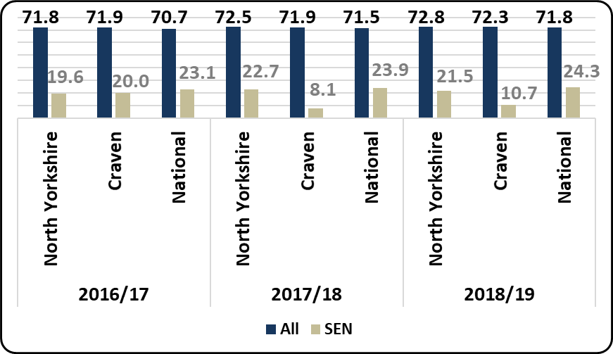
% of children in schools - LA , Craven locality and national - achieving a Good Level of Development (% GLD) for the SEN cohort and the entire cohort

Key Stage 2
 |  | All | Gender |  | SEN |  | EAL |  | Disadvantaged |  | Mobile
 |  |  | Girls | Boys | Yes | No | Yes | No | Yes | No | Yes | No
2016/17 | North Yorkshire | 59.0 | 62.7 | 55.5 | 13.4 | 67.7 | 54.4 | 59.2 | 38.7 | 64.3 | 45.9 | 60.3
 | National | 61.1 | 65.0 | 57.4 | 18.3 | 70.2 | 58.3 | 61.9 | 47.4 | 67.4 | 43.1 | 62.6
 | Craven | 60.8 | 63.0 | 59.0 | 16.9 | 67.9 | 52.4 | 61.2 | 42.5 | 65.4 | 36.4 | 62.8
2017/18 | North Yorkshire | 62.1 | 66.9 | 57.6 | 19.3 | 71.4 | 59.4 | 62.4 | 44.1 | 66.8 | 53.2 | 63.0
 | National | 64.4 | 68.4 | 60.5 | 21.3 | 73.7 | 62.9 | 64.8 | 50.6 | 70.5 | 47.0 | 65.8
 | Craven | 62.2 | 67.1 | 58.5 | 14.0 | 72.5 | 60.9 | 62.8 | 34.0 | 68.8 | 44.3 | 64.9
2018/19 | North Yorkshire | 63.4 | 68.8 | 58.3 | 18.1 | 73.0 | 60.1 | 63.6 | 45.6 | 68.5 | 54.6 | 64.2
 | National | 64.9 | 69.7 | 60.2 | 22.3 | 74.3 | 63.8 | 65.3 | 51.3 | 70.8 | 47.2 | 66.3
 | Craven | 61.8 | 69.5 | 55.2 | 11.8 | 72.0 | 76.9 | 61.3 | 39.3 | 66.6 | 48.9 | 62.9
% of children in schools at Key Stage 2 achieving the expected standard - LA , Craven locality and national – in years 2016/17 to 2018/19 - pupil characteristics shown
Attainment of all pupils in Key Stage 2 achieving the expected standard (61.8%) in the locality in 2018/19 was lower than the North Yorkshire rate (63.4%) and lower than the National rate (64.9%).
As is the case in North Yorkshire and Nationally, attainment of girls in the locality (69.5%) was considerably higher than that of boys (55.2%). Attainment of Disadvantaged children in the locality (39.3%) has been considerably lower than the National rate (51.3%) and the North Yorkshire rate (45.6%).
Key Stage 2 - SEN | - 61.8% of children in Craven schools achieved the expected standard for reading, writing and maths (%RWM) in 2018/19, this was a 0.4 percentage point decrease on the previous year.  - 11.8% of the SEN cohort (children recorded with EHC plans or SEN Support) in Craven schools achieved the expected standard for reading, writing and maths in 2018/19 which was a 2.2 percentage point drop on the previous year. This was also a lower rate than North Yorkshire as a whole (18.1%).
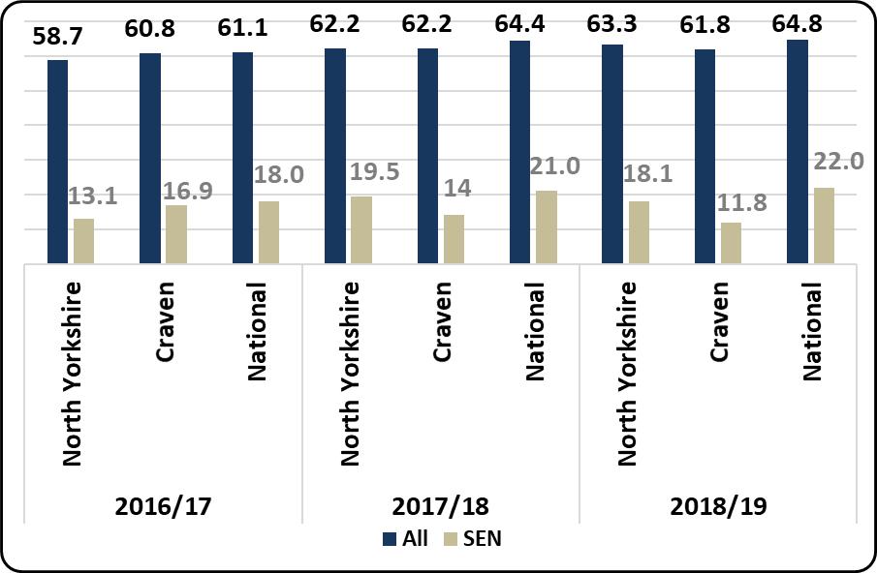

Key Stage 4
 |  | All | Gender |  | SEN |  | EAL |  | Disadvantaged |  | Mobile
 |  |  | Girls | Boys | Yes | No | Yes | No | Yes | No | Yes | No
2016/17 | North Yorkshire | 49.6 | 52.6 | 46.7 | 26.7 | 51.7 | 49.8 | 49.6 | 35.5 | 52.1 | 34.8 | 49.9
 | National | 46.3 | 49.0 | 43.7 | 27.1 | 49.5 | 46.8 | 46.3 | 37.0 | 49.8 | 32.4 | 46.8
 | Craven | 54.4 | 56.3 | 53.7 | 36.0 | 55.9 | 51.5 | 55.2 | 39.2 | 56.8 | 49.1 | 55.0
2017/18 | North Yorkshire | 48.5 | 51.3 | 45.8 | 26.6 | 51.3 | 45.9 | 48.5 | 34.4 | 51.2 | 31.2 | 49.3
 | National | 46.5 | 49.3 | 43.8 | 27.2 | 49.8 | 47.2 | 46.5 | 36.7 | 50.1 | 32.1 | 47.1
 | Craven | 50.5 | 53.4 | 47.1 | 28.5 | 52.6 | 43.9 | 51 | 35.2 | 52.3 | 13.6 | 51.5
2018/19 | North Yorkshire | 48.6 | 51.4 | 46.1 | 26.8 | 51.4 | 48.3 | 48.7 | 34.7 | 51.3 | 30.8 | 49.2
 | National | 46.7 | 49.5 | 44.0 | 27.6 | 49.9 | 47.6 | 46.6 | 36.7 | 50.3 | 31.8 | 47.2
 | Craven | 53.4 | 55.7 | 49.1 | 36.8 | 55.2 | 48.8 | 53 | 37.5 | 54.4 | 8.9 | 53.4
Average Attainment 8 score of children in schools at Key Stage 4 - LA , Craven locality and national
– in years 2016/17 to 2018/19 - pupil characteristics shown
The Average Attainment 8 score of all pupils in Key Stage 4 (53.4) in the locality in 2018/19 was much higher than the North Yorkshire rate (48.6) and the National score (46.7).
As is the case in North Yorkshire and Nationally, average Attainment 8 scores of girls in the locality (55.7) were higher than that of boys (49.1). Attainment of Disadvantaged children in the locality (37.5) has been considerably lower than that of non-Disadvantaged children (54.4) but slightly higher than the National score for that cohort (36.7) and the North Yorkshire score (34.7).
Key Stage 4 - SEN | - The average Attainment 8 score for children in schools in the Craven locality was 53.4 in 2018/19, a 2.9 percentage point increase on the previous year and higher than the average score for North Yorkshire (48.6).  - The average Attainment 8 score for children with SEN in Craven schools was 36.8 up by 8.3 on the previous year and considerably above the North Yorkshire average score of 26.8.
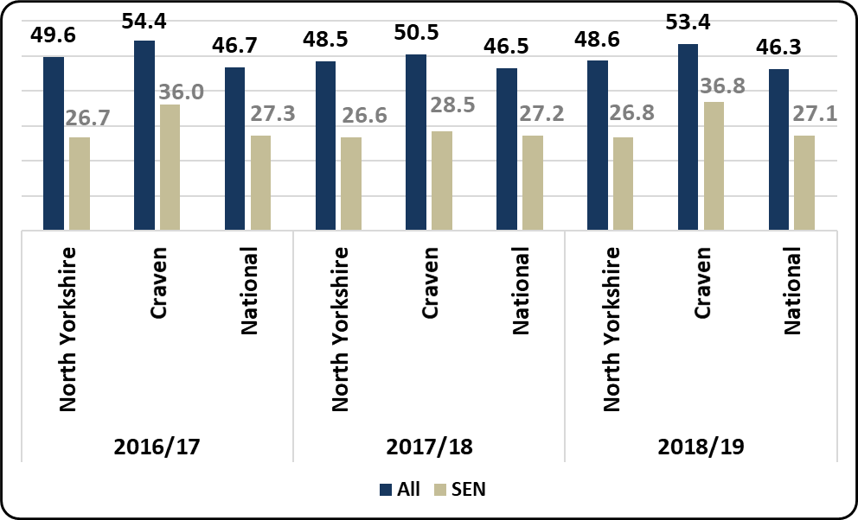
Average Attainment 8 scores at Key Stage 4 in schools - LA , Craven locality and national - for the SEN cohort and the entire cohort

Fixed-term Exclusions
Primary Schools | Secondary Schools
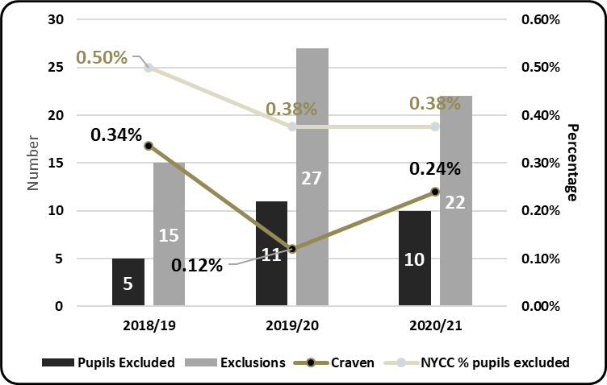 | 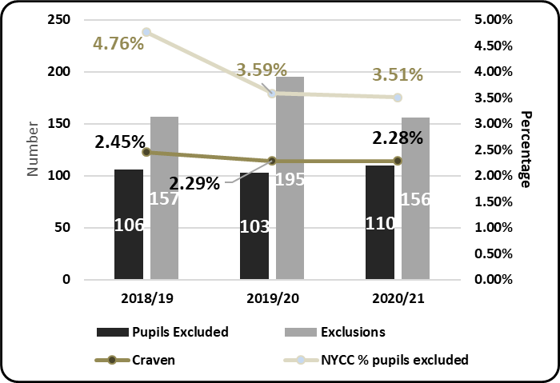
% of children fixed-term excluded at least once in schools in primary and secondary schools in North Yorkshire and Craven locality in the 2019/20 and 2018/19 academic years

Primary Schools
- 0.24% of pupils (a total of 10 pupils) in Craven primary schools were fixed period excluded at least once in the 2020/21 academic year, which was lower than the North Yorkshire primary school rate (0.38%). There were 11 pupils excluded from Craven primary schools in 2019/20.
- There were a total of 22 fixed-period exclusions in Craven primary schools in 2020/21, a 19% decrease on the previous year (27 exclusions). Fixed-period exclusions from Craven primary schools formed 5.6% of the North Yorkshire total (391) in 2020/21.

Secondary Schools
- 2.28% of pupils (a total of 110 pupils) in Craven secondary schools were fixed period excluded at least once in the 2020/21 academic year, which was a lower rate than the North Yorkshire secondary school rate (3.5%). Children fixed-period excluded from Craven secondary schools formed 8.5% of the total for children fixed-period excluded from secondary schools in North Yorkshire in 2020/21 (1291).
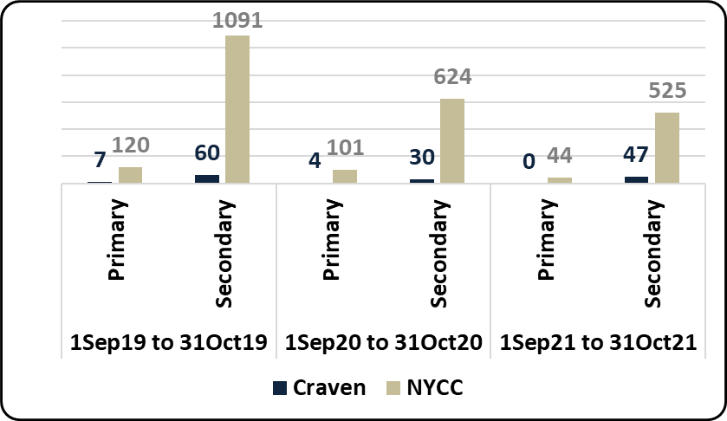
Fixed-Term exclusions in North Yorkshire mainstream schools (Primary and Secondary) - 2018/19, 2019/20 and 2020/21

- As of the end of October 2021/2022 there had been a total of 569 fixed-term exclusions from mainstream schools in North Yorkshire in the academic year. 47 (8.3%) of these occurred in mainstream schools in Craven, 4.7% occurred in Craven in the same period last year.
- There were 27% more fixed-term exclusions in the same period in North Yorkshire in 2019/20 (725). There were 23% fewer in Craven in the same period (34).

Permanent Exclusions
2017/18 – 2020/21 Academic Years  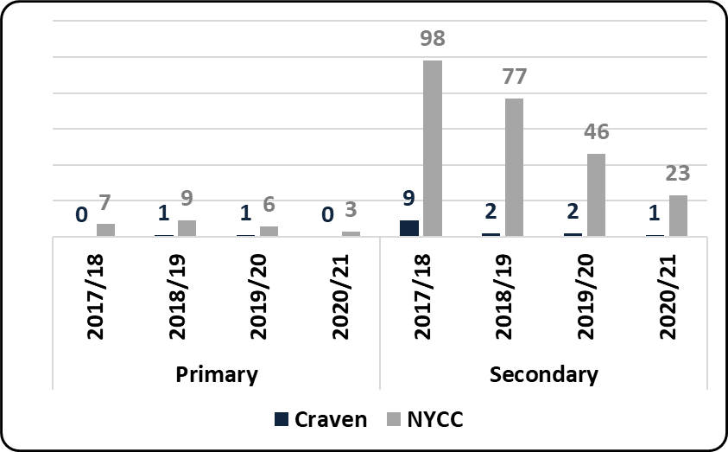 | 2018/19 – 2020/21 Academic Year to November  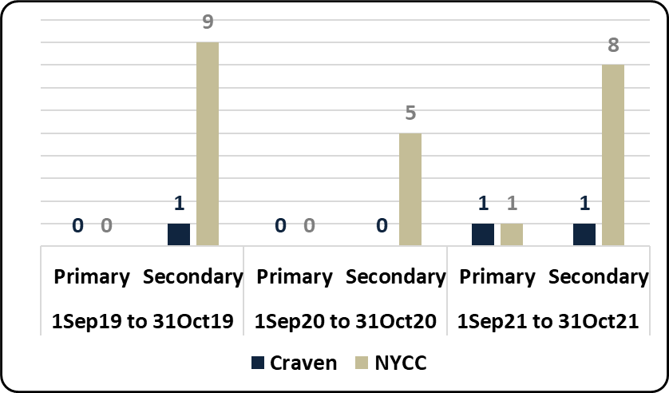
Permanent exclusions in primary and secondary schools in North Yorkshire and Craven locality

- There has been 1 permanent exclusion from Craven primary schools in the 2021/22 academic year to the end of October, the only one in North Yorkshire to date. In all of 2020/21 there were no permanent exclusion from Craven primary schools and there was 1 in all of 2019/20.
- There was 1 permanent exclusion from Craven secondary schools in the 2021/22 academic year to the end of October, 11.1% of the North Yorkshire total (9). There were no permanent exclusions from Craven secondary schools in all of 2020/21 and 1 in 2019/20.
- The North Yorkshire total of permanent exclusions from mainstream schools in 2021/22 to the end of October was 9, higher than the 5 in 2020/21 in the same period. Permanent exclusions from Craven mainstream schools in 2020/21 represented 3.8% of the North Yorkshire total (1 of 26), in 2019/20 it Craven permanent exclusions was 5.8% of the total (3 of 52).

 | North Yorkshire |  | National | Regional
 | 2020/21 | 2019/20
Fixed Exclusion - child (Secondary) % of school pop | 3.51% | 3.65% | 3.69% | 4.58%
Fixed Exclusion - child (Primary) % of school pop | 0.38% | 0.41% | 0.50% | 0.52%
Perm Exclusions (Secondary) % of school pop | 0.06% | 0.10% | 0.13% | 0.13%
Perm Exclusions (Primary) % of school pop | 0.01% | 0.01% | 0.02% | 0.01%
Table: Fixed exclusion rate and permanent exclusion rate of school population for phases shown – National and Regional comparison in academic years shown

Absence from school
NB: this is unverified data – it will be revised as local and national data is confirmed for 2020/21
Persistent Absence – All Children | - 11.48% of children were recorded as being persistently absent (i.e. attendance being less than 90% of possible sessions) through the 2020/21 academic year up to the end of the Spring-Term in Craven secondary schools  - This rate is considerably lower than the North Yorkshire rate for Secondary schools of 15.79%  - Attendance in primary schools is typically better than in secondary schools  - 8.94% of children were persistently absent for the two-term period in 2020/21 in Craven primary schools  - Again, this rate is lower than the North Yorkshire rate for Primary schools of 11.12%
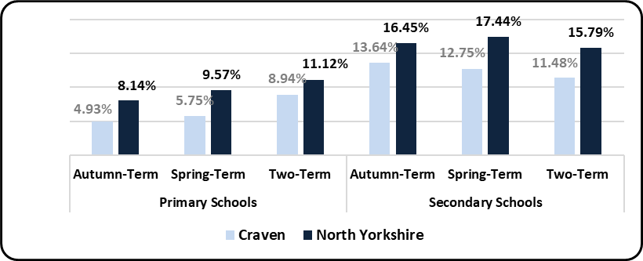
% of children on-roll recorded as being persistently absent in term shown of 2020/21
 | National (%)
 | 2019/20 | 2020/21
Primary | 11.2 | 9.9
Secondary | 15.0 | 16.3
Table - Autumn term persistent absence rate – National – primary and secondary schools
Persistent Absence – SEN (EHC plan, SEN Support) | - Absence from school for vulnerable groups is typically considerably higher than that of the whole school cohort.  - 21.0% of children recorded as SEN (either having an EHC plan or SEN Support) in Craven secondary schools were persistently absent in 2020/21 up to the end of Spring-Term. This rate is considerably lower than the 29.5% for this cohort in North Yorkshire secondary schools  - The rate for SEN persistent absence in Craven primary schools was 20.7% in this period, similar to the North Yorkshire rate of 20.6%  - 18.6% of children recorded as receiving Free School Meals (on the day of the school census) in Craven secondary schools were persistently absent in 2020/21 up to the end of Spring-Term. This rate is considerably lower than the 32.7% for this cohort in North Yorkshire secondary schools  - The rate for FSM persistent absence in Craven primary schools was 22.0% in this period, similar to the North Yorkshire rate of 22.5%
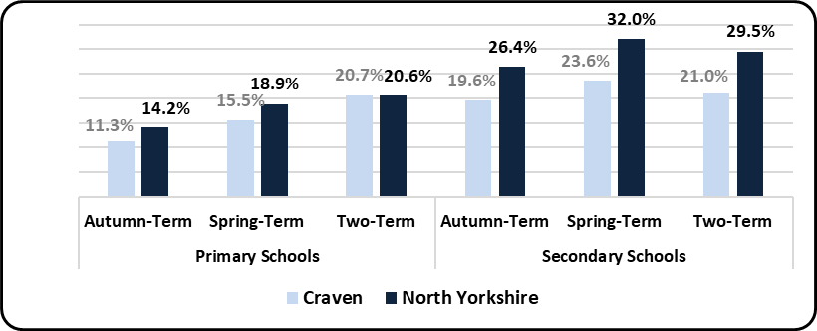
% of children on-roll recorded as being persistently absent in term shown of 2020/21
 | National (%) SEN
 | 2019/20 | 2020/21
Primary | 17.7 | 16.0
Secondary | 23.8 | 25.0
Table - Autumn term persistent absence rate – National – primary and secondary schools
Persistent Absence – FSM (Free School Meal at time of census)
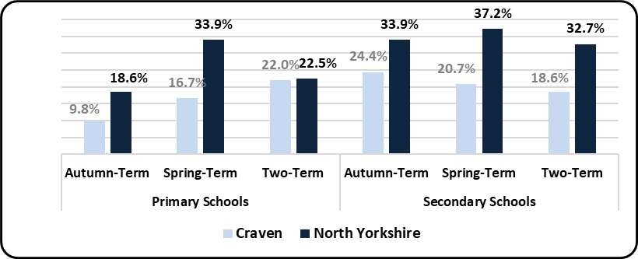
% of children on-roll recorded as being persistently absent in term shown of 2020/21
 | National (%) FSM Eligible
 | 2019/20 | 2020/21
Primary | 20.1 | 19.1
Secondary | 27.9 | 30.2
Table - Autumn term persistent absence rate – National – primary and secondary schools
Elective Home Education
Craven | - As of 31st October 2021 there were a total of 827 children recorded as being Electively Home Educated (EHE) in North Yorkshire, 65 of these were formerly in a mainstream school in Craven.  - 827 is a 7.8% increase on the same period in 2020 (767). There has also been a slight increase for children from Craven mainstream schools in this period of +12% (60 to 67)  - A total of 92 children became EHE from mainstream schools in North Yorkshire since the start of the 2021/22 academic year, for any length of time. 6 (6.5%) were formerly from mainstream schools in Craven  - There has been a 55% decrease (202 to 92) in North Yorkshire for children becoming EHE from mainstream schools in 2021/22, when compared to the same period last year. The % decrease in Craven was -54% (13 to 6)  - The figures above are for children recorded as being educated at home and not on the roll of a school.
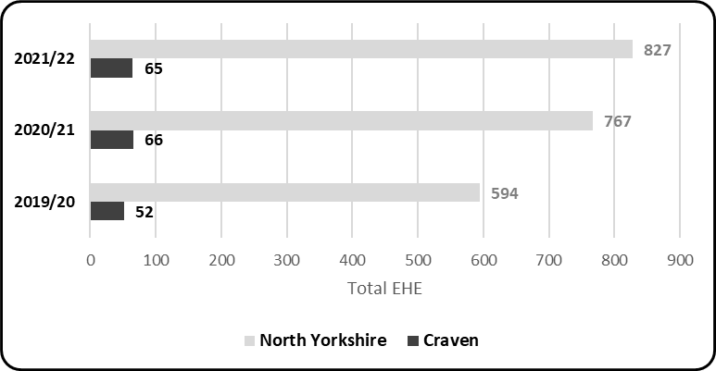
Children previously in a North Yorkshire mainstream school - recorded as Electively Home Educated (EHE) at 31st October in the calendar year shown
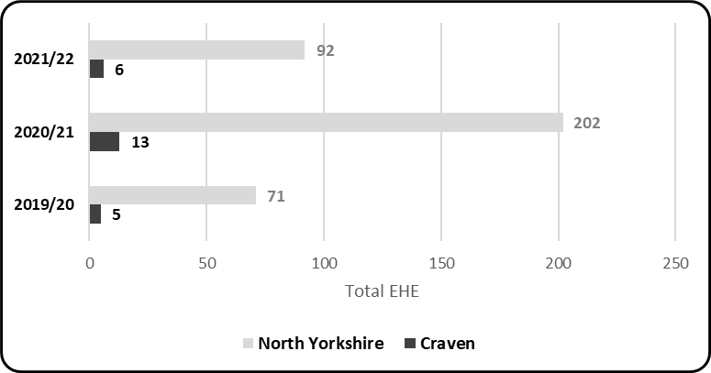
Children previously in a North Yorkshire mainstream school - becoming Electively Home Educated (EHE) 1st September to 31st October in the calendar year shown
- 0.73% is the rate of EHE of the mainstream school population in Craven as of October 2021, which is lower than the rate of EHE for the mainstream school population for North Yorkshire (1.02%)
- The above rate is a slight deccrease from 0.75% (-0.02pp) at October 2020
- North Yorkshire currently has a higher number of children EHE than at the same point last year but we are witnessing a decreasing trend following a high of 923 EHE in July 2021

Association of Directors of Children’s Services survey (October 2020) – national estimates
To gauge the relative size of the EHE cohort, LAs were asked to compare this to the wider school age population. 128 LAs responded to this question and a majority (80) reported that between 0.5% - 1.0% of their school aged population was being home educated on 1 October 2020. 26 LAs said that 4 the proportion was between 1.1% - 1.5% and 15 LAs said that the proportion of their school aged population being home educated was less than 0.5%. Only two LAs reported this to be more than 4%.

