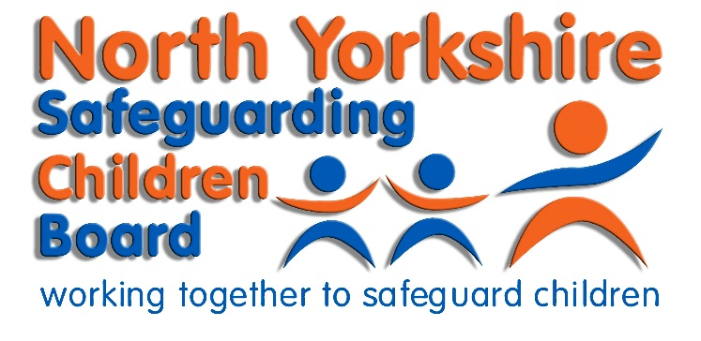
Dr. Maggie Atkinson
Independent Chair – NYSCB
James Parkes
Manager – NYSCB
Room SB216 South Block
County Hall
Northallerton
North Yorkshire
DL7 8AE

Web: www.safeguardingchildren.co.uk
Your Ref: MA/JG/201811
Our Ref: MA/JG/201811

26th November 2018

Dear Headteacher/Chair of Governors/Management Committees/Proprietors,

Schools Safeguarding Audit 2018/2019

North Yorkshire Safeguarding Children Board (NYSCB) has a statutory duty to ensure the effectiveness of what is done by each person or body represented on the Board for the purposes of safeguarding and promoting children in North Yorkshire. These duties are identified in chapter 3: Multi-Agency Safeguarding Arrangements of Working Together to Safeguard Children (2018). Working Together to Safeguard Children (2018) chapter 3, paragraph 25 also requires that all schools, colleges and other educational providers have a pivotal role in safeguarding children and promoting their welfare. Schools and colleges must also have regard to the statutory guidance in Keeping Children Safe in Education (2018) which provides further guidance as to how they should fulfil their duties in respect of safeguarding and promoting the welfare of children in their care.

In response to these requirements the NYSCB is undertaking its assessment of safeguarding arrangements within all schools and colleges across North Yorkshire. The purpose of the audit is to:

- Provide the NYSCB with assurance of the good work carried out by schools to ensure the safety and wellbeing of its pupils and the level of compliance with statutory requirements
- Provide schools with an opportunity to review, evaluate, and update their safeguarding arrangements as part of self-assessment, identify good practice and areas to be developed
- Help schools identify their level of compliance with statutory requirements outlined in Working Together (2018), Keeping Children Safe in Education (2018) and Statutory Guidance Early Years Foundation Stage (2017)
- Assist schools in developing an action plan to address any areas for improvements
- Assist in the monitoring of improvements to safeguarding arrangements by the Board of Governors/Management Committee or Proprietors, Headteacher and Designated Leads, and
- Assist you in the collation of your evidence for inspections.

I have attached the revised safeguarding audit tool, together with a suggested action plan for development by the school. You will note from the audit tool that for each question schools are requested to provide a self-assessment of their level of compliance based on a grading system, together with any supporting evidence they can identify for what arrangements are in place.

The School Safeguarding Audit 2018/2019 is being undertaken in accordance with the statutory functions of the NYSCB and all schools are under a duty to comply with the audit. Failure to comply with this audit would result in a breach of Section 14B of the Children Act 2004 “Supply of information requested by LSCBs”.

Completed audit tools must be submitted electronically, in the Word format provided, please do not submit copies in other formats, e.g. paper or PDF. Returns should be sent to LSCB@northyorks.gov.uk no later than Friday 29 March 2019. The audit should be approved by the school’s Board of Governors, Management Committee or Proprietors prior to submission. A four month window for submission is to enable a robust process of review to take place, engaging key staff and governors prior to governing board approval.

If a school is part of a federation or multi-academy trust, an individual response must be submitted for each school within North Yorkshire that has its own Unique Reference Number.

Action plans resulting from the audit should not be submitted with the completed audit tool. Action plans should be managed in accordance with the school’s governance procedures and remain the responsibility of the Board of Governors, Management Committee or Proprietors to complete.

Following the completion of the audit a report will provided to the NYSCB regarding the current safeguarding arrangements within schools across North Yorkshire. Individual schools will not be identified in this report. A copy of the Executive Summary of this report and any key learning points will be shared with all schools. In addition to this, the information provided will be used by the Board and partners to identify how schools can be better supported and will advise the NYSCB’s Learning and Improvement Subgroup and Education Focus Group for the development of future training programmes as well as the development of priorities for the NYSCB’s to be delivered under the 2016-2020 Business Plan.

If you have any queries regarding the audit you may contact Jonathan Giordano, NYSCB Policy and Development Officer on 01609 535964 or by email at jonathan.giordano@northyorks.gov.uk.

I would also like to inform you that as well as visiting the North Yorkshire Safeguarding Children Board’s website at www.safeguardingchildren.co.uk for up to date news, procedures, practice guidance and information you can also follow us on Twitter @nyscb or www.twitter.com/nyscb.

Yours faithfully,

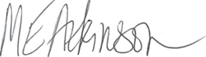

Dr. Maggie Atkinson
Independent Chair
North Yorkshire Safeguarding Children Board

