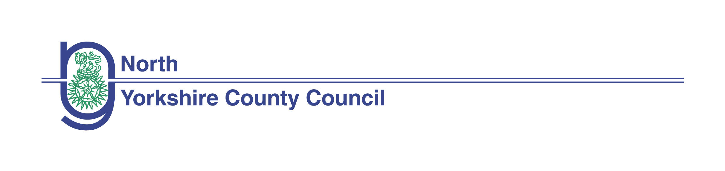 Smoke-free Workplace
Policy

Status: / Implemented 1st June 2006

Reviewed August 2013

Contents Page

Introduction 2
Aims 2
Scope 2
The Law and Regulations 2
Residential establishments 3
Third party premises 4

Access: If you require this information in an alternative format such as large type, audio cassette or Braille, please contact the HRSST 01609 798317

Smoke-free Workplace

Introduction

- North Yorkshire County Council (NYCC) is committed to an effective approach to safeguarding the health and well being of all employees and others involved with the delivery of Council services. To this end NYCC:

- Recognises its duty to provide safe and healthy working conditions and service delivery environments, by prohibiting smoking in all its workplaces, enclosed and substantially enclosed spaces and vehicles
- Recognises the significant evidence detailing the harmful effect on health of smoking including passive smoking

Aims

2. 0 The aim of this policy is to:

- Inform employees and managers of their responsibilities in respect of the policy, and
- Inform employees of the Health Act, 2006 which prohibits smoking in public and substantially enclosed public places/premises
- Protect the health of employees, service users, Elected Members, and others visiting and using North Yorkshire County Council premises and services by applying and enforcing the law

Scope
3.0 This policy applies to all employees of North Yorkshire County Council. School Head teachers and Governing Bodies should adopt this policy or a similar one for all school premises to be legally compliant.
the  In addition, the Health Act, 2006 that prohibits smoking in all public places and substantially enclosed public places sets out a number of offences related to breaches of the regulations. The County Council therefore, has a duty to ensure that elected members, visitors, service users, contractors and agency workers who enter the Council's owned or rented premises or vehicles are made aware of the smoke-free regulations in order to comply with them. Employee breaches will be treated as matter of misconduct ( Disciplinary policy)
3.1 This policy also applies to the use of electronic smoking devices.

The Law and Regulations
4.0 The Health Act, 2006, provides five sets of smoke free regulations (www.legislation.gov.uk/ukpga/2006/28/contents) to which North Yorkshire County Council as an employer, service provider and building and premises owner/user must comply
4.1 The Health Act 2006 also places a legal duty on persons who occupy or manage smoke-free premises to display no-smoking signs that meet requirements set out in the regulations. Under the Health Act 2006 it is against the law not to display the required no-smoking signs

4.2 Where breaches take place, the Health Act, 2006 provides the following which applies to employees, managers, Elected Members, clients, contractors and any other person on NYCC premises in the smoke-free areas:
- The offence of smoking in a smoke-free place will be a summary conviction and fine up to £200 or a fixed penalty notice of £50 to the individual
- Where an employer fails to display no-smoking signs they may receive a summary conviction and a fine of up to £1,000 or a fixed notice penalty of £200
- The offence of failing to prevent smoking in a smoke-free place will be a summary conviction and fine up to £2,500

  - In addition , the following will apply and any breach of the regulations by employees will be treated as a conduct issue:
- Staff are reminded there is no such thing as a smoking break entitlement
- Staff will not take smoking breaks or use the flexi- time scheme during the working day in order to take smoking breaks. Staff will not smoke during claimed working time.
- Employees should not smoke while in NYCC grounds
- Staff who smoke are prohibited from smoking in or near NYCC doorways, entrances and exits to NYCC owned and controlled buildings. Instead staff who smoke are urged to smoke elsewhere (If there is a designated area then this must be used)
- Smoking is prohibited in all NYCC owned /rented/ controlled buildings, with the exception of clearly designated areas and all enclosed or substantially enclosed public places. ( Refer to Residential Establishments for exceptions (6.0))
- Smoking is prohibited in NYCC owned and hired vehicles including pool cars and any vehicle used for NYCC business as a public space, for example mobile libraries
- Where staff have a responsibility to transport staff, other personnel, or clients , smoking in the vehicle is prohibited
- Smoking in an NYCC lease car is prohibited

- Where a building is shared, North Yorkshire County Council will request that the policy is adopted by other organisations and that the policy is applied to communal areas.

- The policy applies to all NYCC employees whether employed directly by the Council or seconded to other organisations. The Policy also applies to staff employed through an agency, by a contractor or by other organisations.

Residential establishments

5.0 NYCC recognises that residential establishments are residents' homes. However, they are also workplaces and the Council has a duty of care to employees and a responsibility not to place them in situations that could risk damage to health.

5.1 Residential services managers will carry out health and safety risk assessments to explore options to minimise risk to employees, service users and others visiting the establishment and will identify local solutions that balance needs and responsibilities. These risk assessments will require Directorate Health and Safety Risk Manager advice and approval.

5.2 Should a designated “smoke room” be necessary in a residential home for the use of people we provide a service for, then it must be kept clean and adequately ventilated. Contaminated air must not enter the rest of the building

5.3 Employees exposure to the exempted area outlined above should be kept to an absolute minimum. Employees should seek advice from their line manager who should take all reasonable steps to protect them from exposure to second hand smoke.

5.4 Day Service facilities will apply a similar approach.

Note: Designated smoking rooms in other establishments (including schools) are not permitted under the Health Act or this Policy.

Third party premises

6.0 Employees required to visit other premises as part of their duties, both commercial and domestic – including the homes of people who use our services, should advise the occupant when arranging a visit of NYCC’s Smoke-free Workplace Policy.

6.1 However, while the Council has a duty of care to protect its employees, it
cannot exert prohibitions in private dwellings. Employees should where possible, request that the occupant arrange for a non-smoking area to be provide for the duration of the visit.

6.2 Where people who use our services or other occupants do not respect this request and a solution cannot be agreed at that point, the employee might, for this reason only, suspend the visit. However, prior to taking this action they should seek the advice and assistance of their line manager.

6.3 If an employee identifies that they have a pre-existing health problem, which is made worse by exposure to smoke they should discuss this with their manager to make alternative arrangements where possible.

Review of the policy

The Policy will be reviewed by North Yorkshire County Council’s HR Portfolio group for Health and Wellbeing every two years

